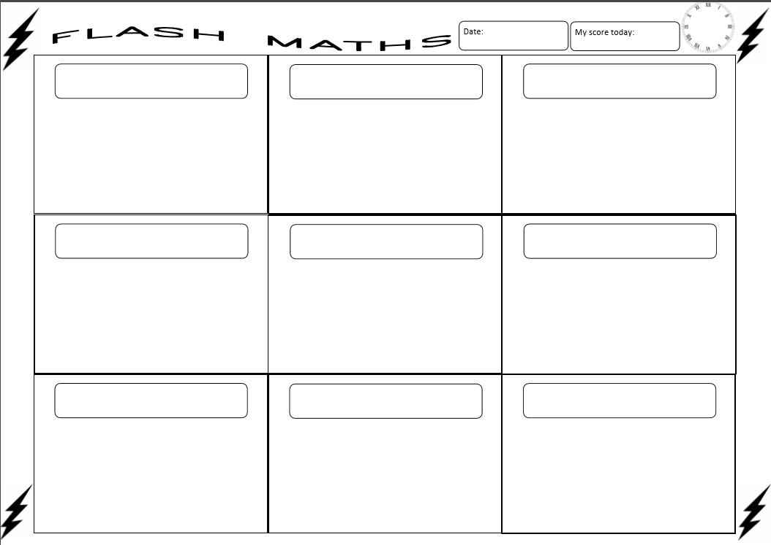

Name: ___________________________________________

Today’s Score:

24 – 6 =

10 – 2 =

35 + 5 =

33 – 3 =

40 – 7 =

41 - 2 =

26 + 4 =

19 + 3 =

17 + 4 =