From KS1 to KS2

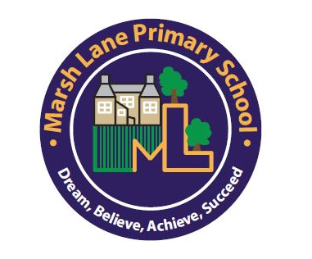

Marsh Lane Primary School

Key stage 2 Transition Booklet
We know that moving to a new year group can cause anxieties for some children. This booklet aims to lessen these anxieties by telling you all you need to know about the transition from Key Stage 1 to Key Stage 2.

Key Stage 2 is made up of 4 year groups, Year 3 (known as The Adventurers), Year 4 (who are split between The Adventurers and The Investigators), Year 5 (known as The Investigators) and Year 6 (known as The Pioneers.)

All Key Stage 2 classrooms are situated in the main school building.

Mr Harling is The Adventurers teacher. Mr D’Souza-Walsh is The Investigators teacher and Mrs Morris is The Pioneers teacher.

Key stage 2 classrooms
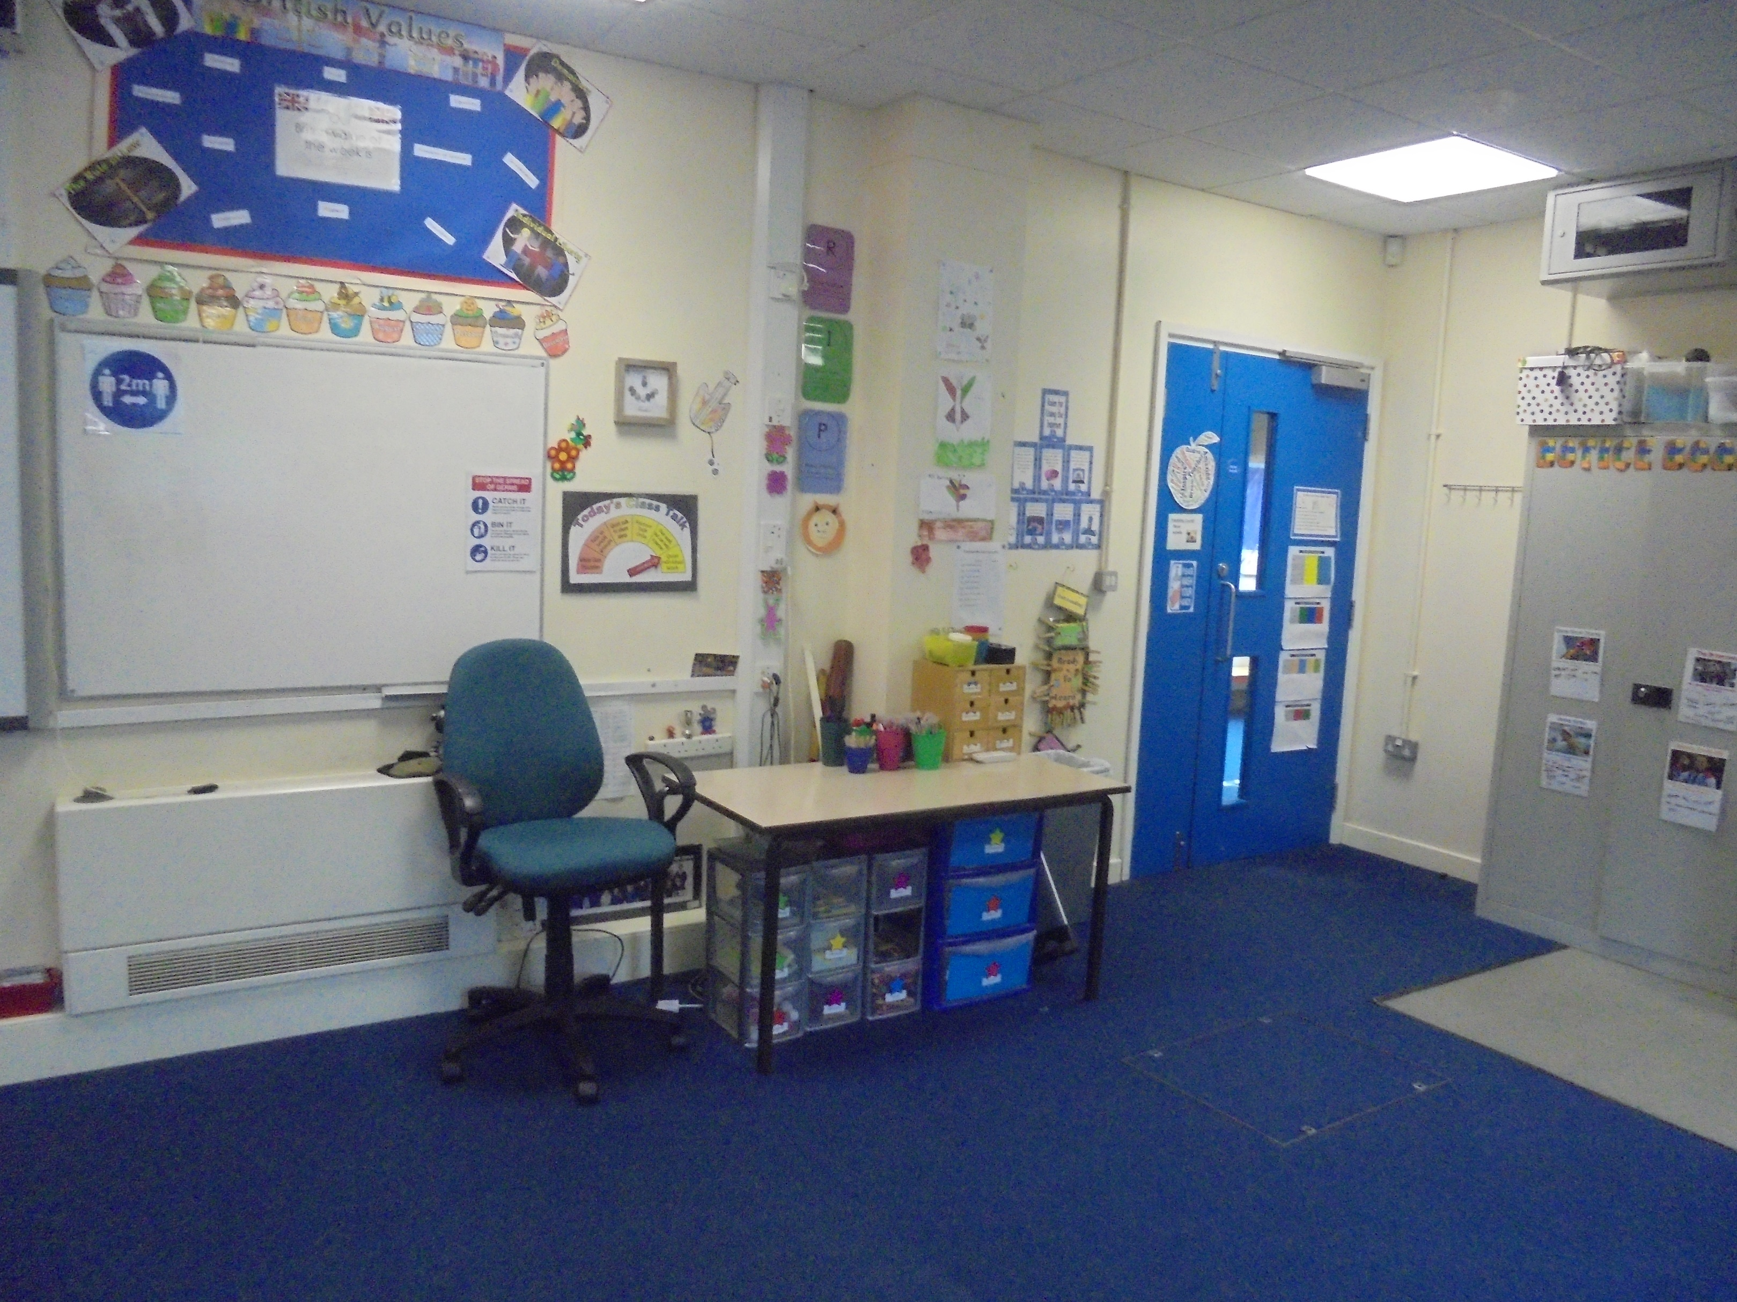
The Adventurers Classroom

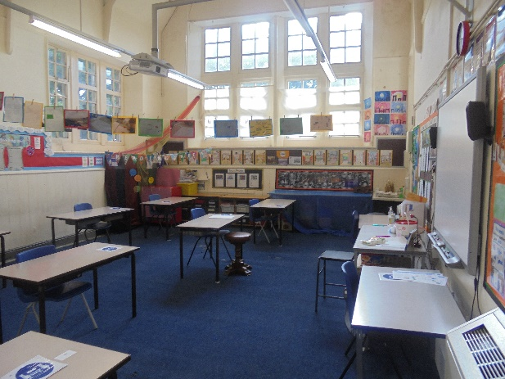
The Investigators Classroom
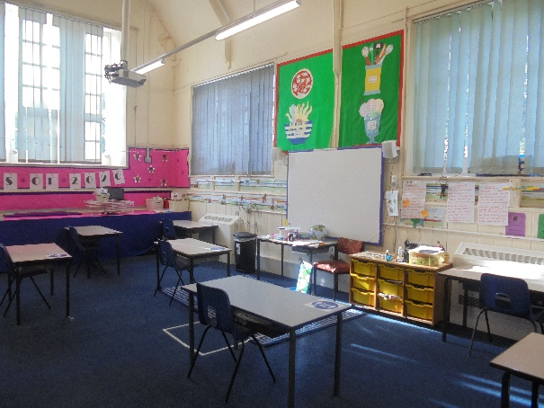
The Pioneers Classroom
Year 2 Classroom
Curriculum changes
In Key Stage 2, the children will start to learn a Modern Foreign Language, a subject not compulsory in Key Stage 1. All the other subjects remain the same in Key Stage 2 as they did in Key Stage 1.

Multiplication Tables Check
In Year 4, your child will sit an on-line Multiplication Tables Check to determine whether they can recall their times tables fluently. The test will be conducted on a 1 to 1 basis with the class teacher. Further information regarding the Multiplication Tables Check will be discussed at a meeting in the new academic year.

End of Key Stage 2 SATs
In Year 6, all the children will do the end of Key Stage 2 SAT’s (Statutory Assessment Tests) in English Grammar, Punctuation and Spelling, Reading and Mathematics. These tests are compulsory for all children and are marked externally. A Key Stage 2 SAT’s meeting will be held in the new academic year.
What will be different from key stage 1?

*School lunches need to be paid for in Key Stage 2 unless you are entitled to Free School Meals. Your child can still continue to bring their own packed lunch if they prefer.

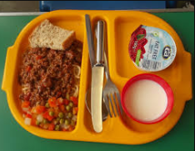
*In Key Stage 2, free fruit will not be provided at break times. If your child wants a snack at break time, you will need to provide them with a healthy snack (i.e. fruit, cheese, fruit bars etc.)
Transition day

To ensure that we care for your child’s emotional well-being at Marsh Lane Primary School, we have put the following in place to ensure a smooth transition to Key Stage 2 for your child and to ensure that they are happy with the forthcoming change.

Over the next few weeks your child will have been spending time completing activities with the Key Stage 2 children and staff including;

*A circle time discussion with the Key Stage 2 children with a question and answer session.

*A Transition morning which this year is on Tuesday 14th July 2020 when all children will spend the morning in their new classroom with their new teacher.

UNFORTUNATELY, DUE TO COVID-19, THE TRANSITION PROCESS DETAILED ABOVE, HAS NOT BEEN POSSIBLE TO DO!

If you wish to discuss anything regarding the transition from Key Stage 1 to Key Stage 2, please see a member of the Key Stage 1 or Key Stage 2 team, who will be happy to help!

