From Reception to KS1

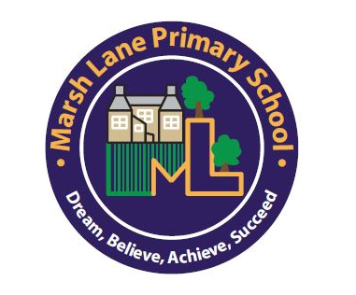

Marsh Lane Primary School
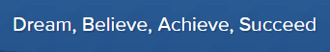

Key stage 1 Transition Booklet
We know that moving to a new year group can cause anxieties for some children. This booklet aims to lessen these anxieties by telling you all you need to know about the transition from Reception to Key Stage 1.

Key Stage 1 is made up of 2 year groups, Year 1 (known as The Navigators) and Year 2 (known as The Inventors.)

The Year 1 classroom is situated in the School House (upstairs to the Reception classroom) and the Year 2 classroom is situated in the main school building.

Miss Marsland is the Year 1 teacher and Mrs Womble is the Year 2 teacher.

Key stage 1 classrooms
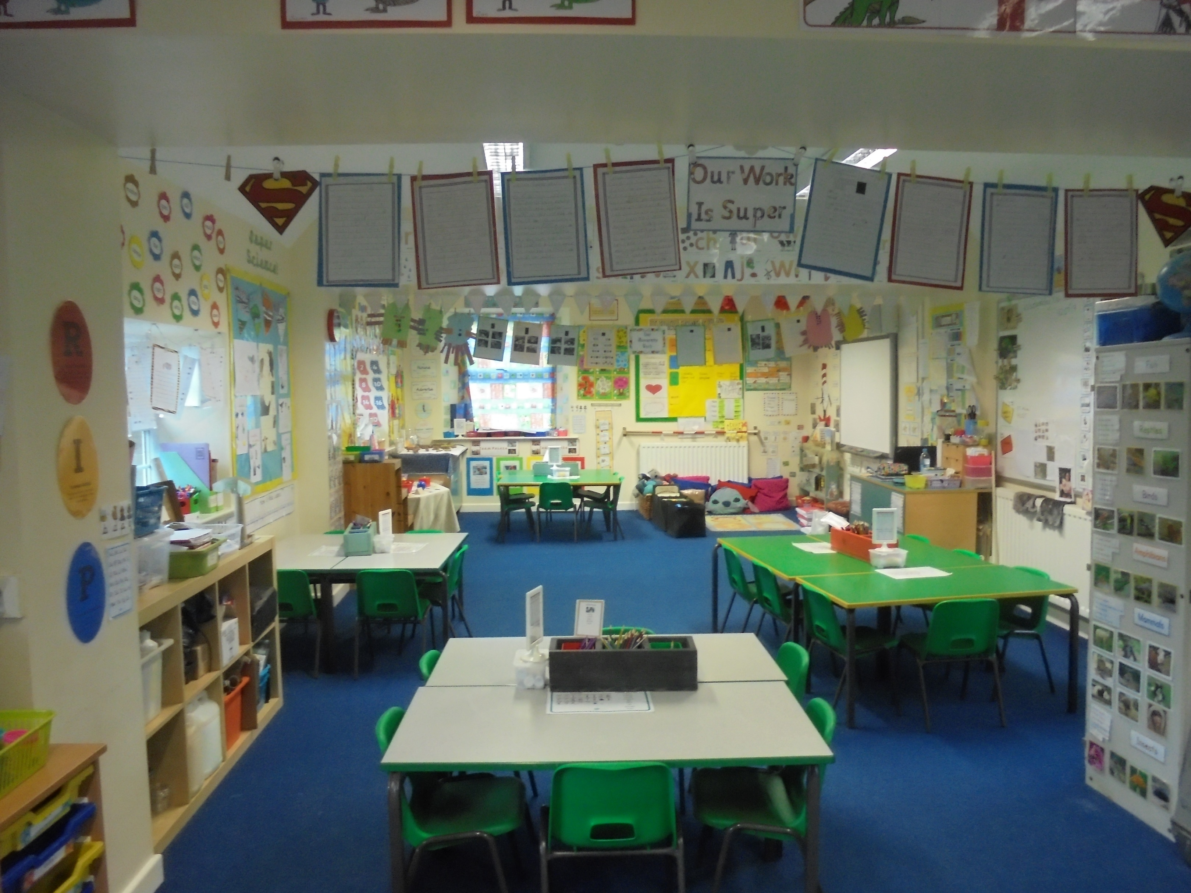
Year 1 Classroom

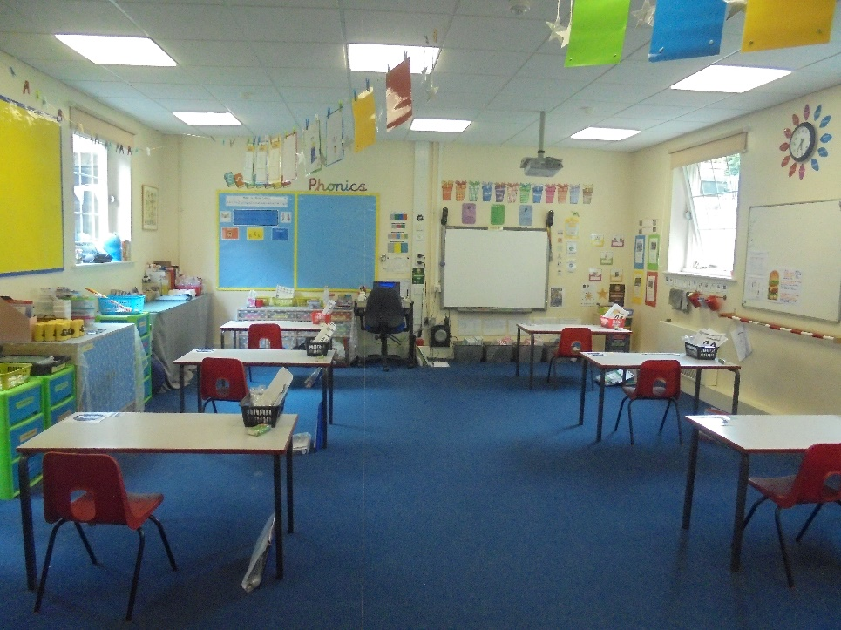
Year 2 Classroom

Curriculum Changes
The main difference between Reception and Key Stage 1 is the change of curriculum. For two years or more, your child has been following the Early Years Foundation Stage Curriculum and have been assessed against the 7 Areas of Learning.

In Key Stage 1, your child will progress from these 7 Areas of Learning, to the National Curriculum subjects.

The curriculum will alter as follows:

Early Years Foundation Stage | National Curriculum
Personal, Social and Emotional Development | Personal, Social and Health Education and Citizenship
Communication and Language Literacy | Literacy
Mathematics – Shape, Space and Measure and Numbers | Maths
Understanding the World | Science, History, Geography, ICT and Religious Education
Physical Development | Physical Education (P.E)
Expressive Art and Design Music and Art | Design and Technology (D & T), Art and Music

What will be different from Reception?

Apart from the change in curriculum, children in Key Stage 1 have to also undergo additional assessments.

Phonics Screening Check
In Year 1, all children have to undertake a Phonics Screening Check. The check is done on a 1 to 1 basis with the class teacher and is made up of 40 decodable words, 20 real words and 20 nonsense words. The check normally takes place in June. The children are unaware of the Phonics Screening Check because they will do practise papers from September so that they are familiar with the format of the check. A meeting regarding the Phonics Screening Check will take place in the new academic year, where this will be discussed further.

End of Key Stage 1 SATs
In Year 2, all the children will do the end of Key Stage 1 SAT’s (Statutory Assessment Tests) in Mathematics and Reading. The children will also sit an optional English Grammar and Punctuation and Spelling Paper. These assessments are not sent to any external board for marking, they are marked in school and support the teacher’s assessments for each core subject area. A meeting will be held in the new academic year for the Year 2’s only.
What will be the same?

*All children in Key Stage 1 are entitled to Universal Free School Meals. However, your child can still bring their own packed lunch if they prefer.

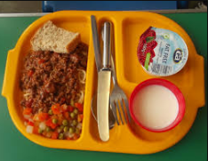
*In Key Stage 1, free fruit will be available at break times for your child. You can provide a healthy snack for your child instead (i.e. fruit, cheese, fruit bars etc.)

Transition day

To ensure that we care for your child’s emotional well-being at Marsh Lane Primary School, we have put the following in place to ensure a smooth transition to Key Stage 1 for your child and to ensure that they are happy with the forthcoming change.

Over the next few weeks your child will have been spending time completing activities with the Key Stage 1 children and staff including;

*A circle time discussion with the Key Stage 1 children with a question and answer session.

*A Transition morning which this year is on Tuesday 14th July 2020 when all children will spend the morning in their new classroom with their new teacher.

UNFORTUNATELY, DUE TO COVID-19, THE TRANSITION PROCESS DETAILED ABOVE, HAS NOT BEEN POSSIBLE TO DO!

If you wish to discuss anything regarding the transition from Reception to Key Stage 1, please see a member of the Reception or Key Stage 1 team, who will be happy to help!

