Hello Year 1!

I hope you have had a lovely Easter break.

Here is an overview for Week 1 of our new topic ‘The Enchanted Woodland’. I really hope this helps with home teaching!
Any questions please comment on the blog or email me through 2Email on Purple Mash and I will get back to you asap.
Missing you lots and lots.
Don’t forget to have fun!

Miss Marsland xx

(see overview below)
NAVIGATORS - YEAR 1 – Summer 1, Week 1
20/4/20
 | 9.00 – 9.15 | 9.15 – 9.35 | 9.35 – 10.00 | 10.00 – 10.35 | 10.35 – 10.50 | 10.55 – 11.55 | 12 - 1 | 12.55 – 2.55
MON | Practice spellings -  https://www.twinkl.co.uk/resource/t-l-4999-new-100-high-frequency-words-list | Phonics  Phase 4  https://new.phonicsplay.co.uk/resources/phase/4/sentences-4  Sentences – Week 2, Monday  Practice reading and writing the sentences. | Reading – read text and discuss https://www.twinkl.co.uk/resource/ks1-go-jetters-characters-reading-comprehension-t-e-2549844  There are 3 different levels of difficulty. | Handwriting – (see more downloads and select precursive)  https://www.twinkl.co.uk/resource/t-l-4089-ks1-key-words-handwriting-practice-worksheets | B R E A K | Maths:  For the next few weeks in Maths we will be learning about multiplication & division. This is a new topic for Year 1 but we have covered multiplication through maths whizzers (10 times table).  Todays lesson will be recapping counting in 10s. Children are already familiar with ‘ten frames’ – this video explains what ‘ten frames’ are and how they are used - https://www.youtube.com/watch?v=p6RaMGDPfJg  See Sheet 4 for a blank ten frame – you can print lots off or draw them yourself. Use objects or stickers or counters to represent different numbers in the ten frames and aks chn to say what number it is. Chn should not have to count every single counter/ object as the ten frames should help them to see what number it is and count in tens. | L U N C H | 1 - 2  Maths –  Maths whizzers – 1 minute timer to answer 10 times table questions. See Sheet 1 below the overview.  Flash maths – addition & subtraction questions. See Sheet 2 below the overview. (Chn can use objects, number lines & numicon if available, I have also included a 100 square - see Sheet 3) |  |  | 2 - 3  OUTDOOR PE –  Get outside if you can. Remember to warm up and cool down. Try and practice different running, jumping, throwing and catching.  This half term we were going to start a simplified version of the team game – Tag Rugby. If you have lots of people at home you could try and play with them – learn the rules here:  https://d2cx26qpfwuhvu.cloudfront.net/premier/wp-content/uploads/2016/09/23114412/STCO-Practical.pdf
TUES | Practice spellings | Phonics  Phase 4  https://new.phonicsplay.co.uk/resources/phase/4/sentences-4  Sentences – Week 2, Tuesday  Practice reading and writing the sentences. | Reading – read text again and spot features used e.g. characters, nouns, adjectives, verbs, conjunctions, punctuation. | Handwriting – carry on from Monday |  | Maths:  Starter - https://www.bbc.co.uk/teach/supermovers/ks1-maths-the-10-times-table-with-webster-the-spider/zm32cqt  Tuesday Maths Sheet – download from blog or ML website.  Encourage chn not to count each picture, use the ten frames to support. Further learning – continue practical learning from Monday – use different objects in ten frames for chn to count and say what number is represented. Ask chn how many tens and ones are in different numbers – e.g. 57 has 5 tens and 7 ones. |  | 1 - 2  History:  Learn about Christopher Columbus –  Twinkl PPT:  https://www.twinkl.co.uk/resource/t-h-023-the-story-of-christopher-columbus  Horrible Histories Video:  https://www.youtube.com/watch?v=9fZnWlt-X-0  Map of journey:  https://www.twinkl.co.uk/resource/au-t2-h-5605-christopher-columbus-explorer-map  If you have a compass at home you can have a look and use it.  On his return to Spain following his first voyage to the New World, Christopher Columbus's ship entered a severe storm. Columbus threw a report of his discovery along with a note asking it to be passed on to the Queen of Spain, in a sealed cask into the sea, hoping the news would make it back even if he did not survive. In fact, Columbus survived and the sealed report was never found, or at least, its discovery never reported.  TASK: On Purple Mash – see 2Dos. Write a letter to the Queen of Spain from Christopher Columbus. |  | 2 - 3  Geography:  Recap: 7 continents  https://www.youtube.com/watch?v=K6DSMZ8b3LE  Introduce: 5 oceans  https://www.youtube.com/watch?v=X6BE4VcYngQ  Twinkl PPT:  https://www.twinkl.co.uk/resource/t-tp-5976-oceans-of-the-world-facts-powerpoint  Talk about which oceans you have been in – seaside, holidays etc.  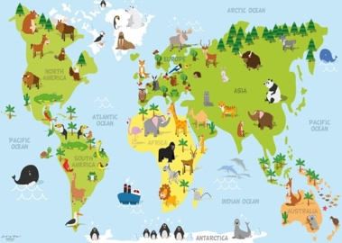  TASK:  Twinkl online activity – labelling continents and oceans  https://www.twinkl.co.uk/go/resource/tg-g-08-continents-and-oceans-labelling-activity  OR  See Sheet 4 & 5 below.  Can you label the 5 oceans?  Sheet 5 – if chn are confident labelling.  Sheet 6 – with prompts.
WED | Practice spellings | Phonics  Phase 4  https://new.phonicsplay.co.uk/resources/phase/4/sentences-4  Sentences – Week 2, Wednesday  Practice reading and writing the sentences. | Reading – read text again and talk about questions, how would you find the answer?  (see different levels of difficulty for harder or easier questions) | Handwriting – carry on from Monday |  | Maths:  Starter - https://www.bbc.co.uk/teach/supermovers/ks1-maths-the-10-times-table-with-webster-the-spider/zm32cqt  Recap on ‘equal’ –  https://www.youtube.com/watch?v=MFrwrh1gEfk Use this fun video to help recap to chn what equal means. Use examples around your house e.g. 2 apples on the left and 4 apples on the right – how can we make both sides equal?  Wednesday maths sheets - download from blog or ML website.  Instead of counters you could use Lego, objects, stickers or cut up bits of paper! |  | 1 - 2  INDOOR PE –  Cosmic Yoga  https://www.youtube.com/user/CosmicKidsYoga  There are lots of different yoga videos. You might want to do one long one or lots of different short ones. | 2 – 2.30  Mindfulness – thanks to Muddy Puddles (& the lovely Sarah Seaman!)  Clearing cloudy minds  Children rarely have brain breaks anymore and spend hardly any time with their own thoughts. In your garden (or outdoor space) lie down on your backs and gaze at the clouds. We bet this is something you definitely did growing up, but how often does your child get to do this? Spend a few minutes just thinking and looking at the clouds. What do they look like?  Finish with a deep breath and a smile. Spend some time slowly getting up and make sure you have a refreshing glass of water. This will help keep your mind fresh.  If your child struggles to relax while doing this, don’t panic! Teaching your child to relax will take some time so don’t give up! It’s a vital skill that all modern children need more than ever.  Reading – after taking time for mindfulness, if the weather is nice read a story together outside.  2.30 – 3  Music – Instruments  https://www.twinkl.co.uk/resource/t-mu-15-starry-eyed-stan-stans-band-music-powerpoint
THURS | Practice spellings -  https://www.twinkl.co.uk/resource/t-l-5155-new-year-1-common-exception-words | Phonics  Phase 4  https://new.phonicsplay.co.uk/resources/phase/4/sentences-4  Sentences – Week 2, Thursday  Practice reading and writing the sentences. | Reading – Write down answers- try to write in full sentences and use text to spell words correctly. | Handwriting – carry on from Monday |  | Literacy –  If you have the story – The Gruffalo – at home then read it together, if not there is a video of the story here: https://www.youtube.com/watch?v=s8sUPpPc8Ws  After reading the story, discuss what happens in the beginning, middle and end (story sandwich). Recap on story sandwich see Sheet 7 (A-D) below. After, act out simple actions for remembering the story. Read the story again whilst acting out the actions. Keep practicing until you remember the actions. It may be easier practicing a section at a time e.g. beginning, middle, end.  End the lesson by helping your grown up to draw a story map like this one:  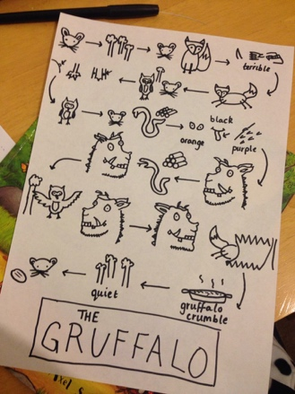 |  | 1 – 1.30  Literacy – after lunch, see if you can remember your actions for The Gruffalo!  Reading – choose a book to read and record in reading record. | 1.30– 3  Art –  Enchanted Forest Small World Project: Can you use ideas from story books, TV programmes and information books to help you create a picture of your own enchanted forest?  (Start collecting natural materials and junk materials, ready for beginning to make next week)  Mrs Williams x
FR I | Practice spellings | Phonics  Phase 4  https://new.phonicsplay.co.uk/resources/phase/4/sentences-4  Sentences – Week 2, Friday – revision of week.  Practice reading and writing the sentences. | Reading – choose a book to read and record in reading record. | Handwriting – carry on from Monday |  | Literacy –  Recap story action for The Gruffalo – see if you can remember them!  Drama focus: can you act out a part of the story of The Gruffalo to your sibling or grown up? Can they guess what part of the story you are acting out? Swap roles – can you guess what part your grown up or sibling is acting out?  Grown ups ask the chn questions about The Gruffalo story – see Sheet 8 for question ideas. Discuss together.  EXTRA TASK: See Sheet 9 – The Gruffalo’s features. |  | 1 - 2  Computing:  Purple Mash – see 2dos – choose an activity! | 2 - 3  Golden Time  Ideas:  - Watch The Gruffalo: https://www.bbc.co.uk/iplayer/episode/b00pk64x/the-gruffalo  - Colour in woodland pictures: https://www.twinkl.co.uk/resource/t-tp-5466-woodland-animal-colouring-pages  - Play a boardgame

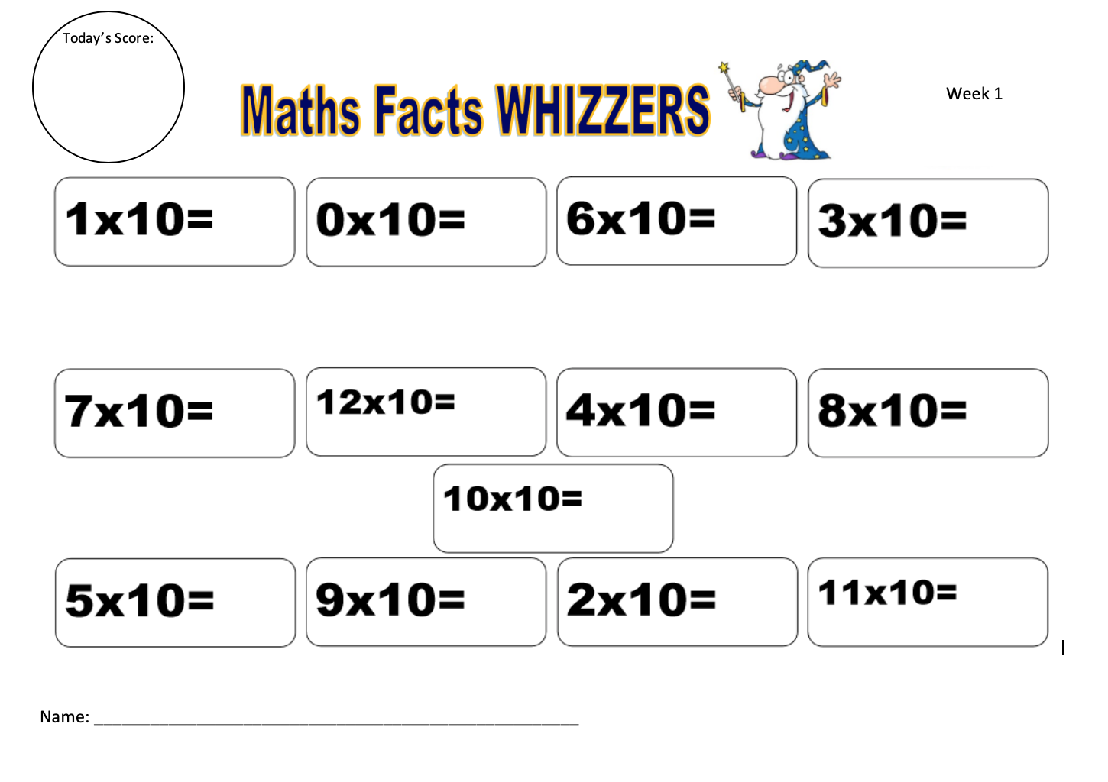
Sheet 1
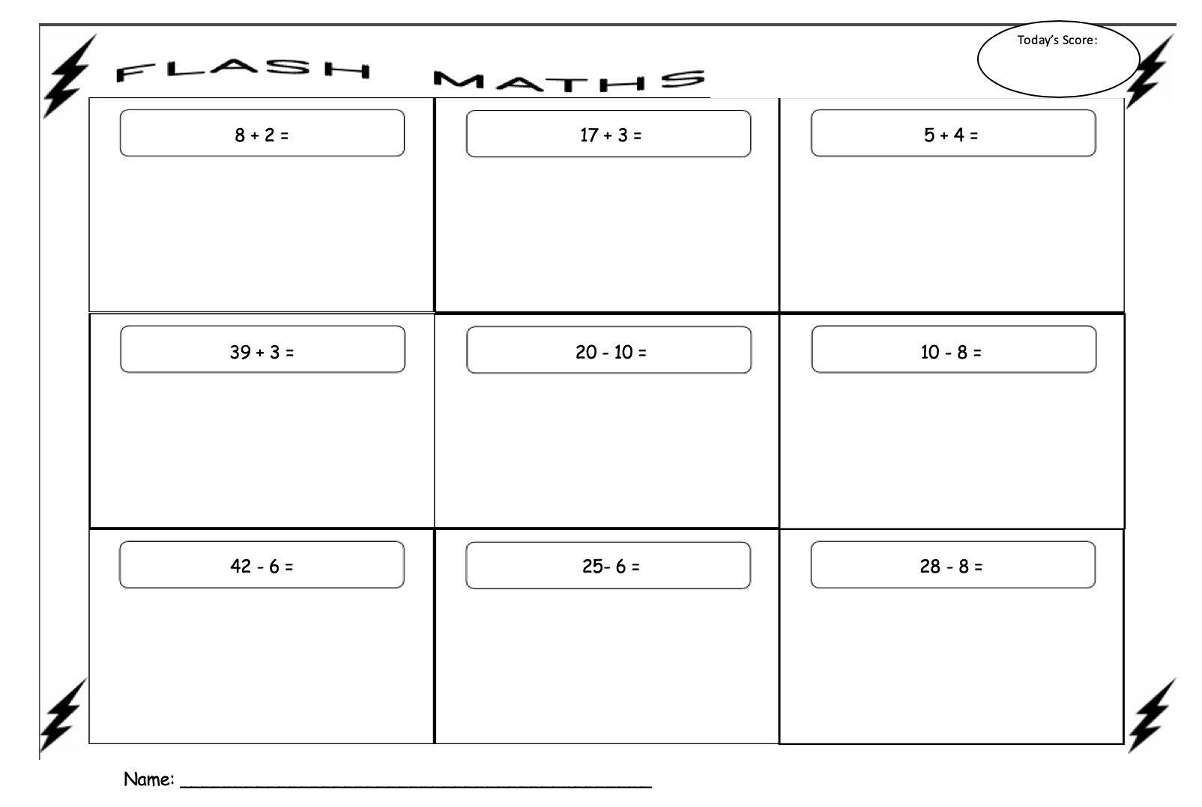
Sheet 2
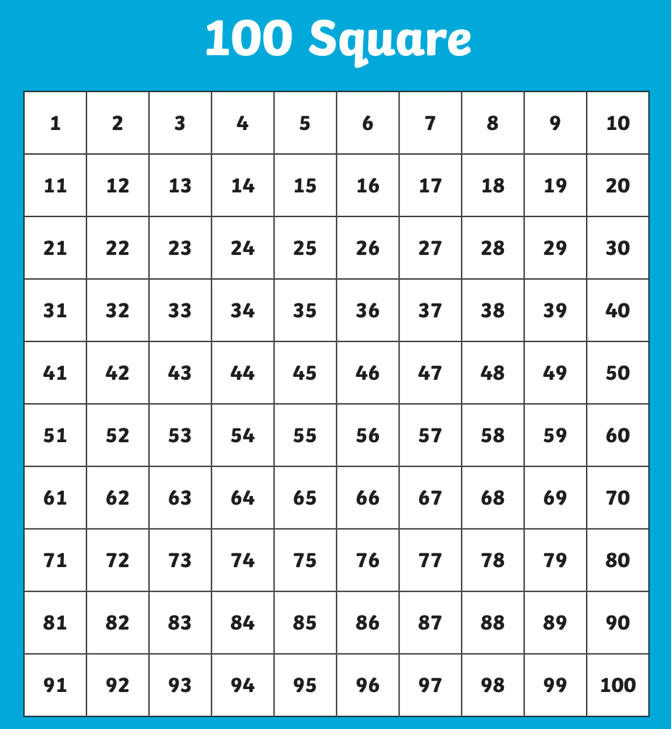
Sheet 3

Sheet 4

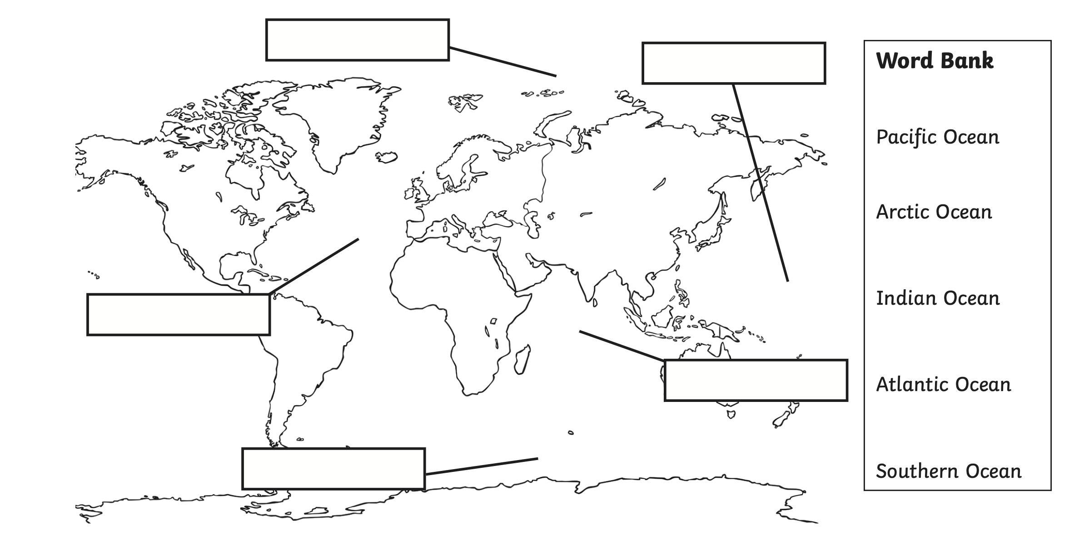
Sheet 5
Sheet 6
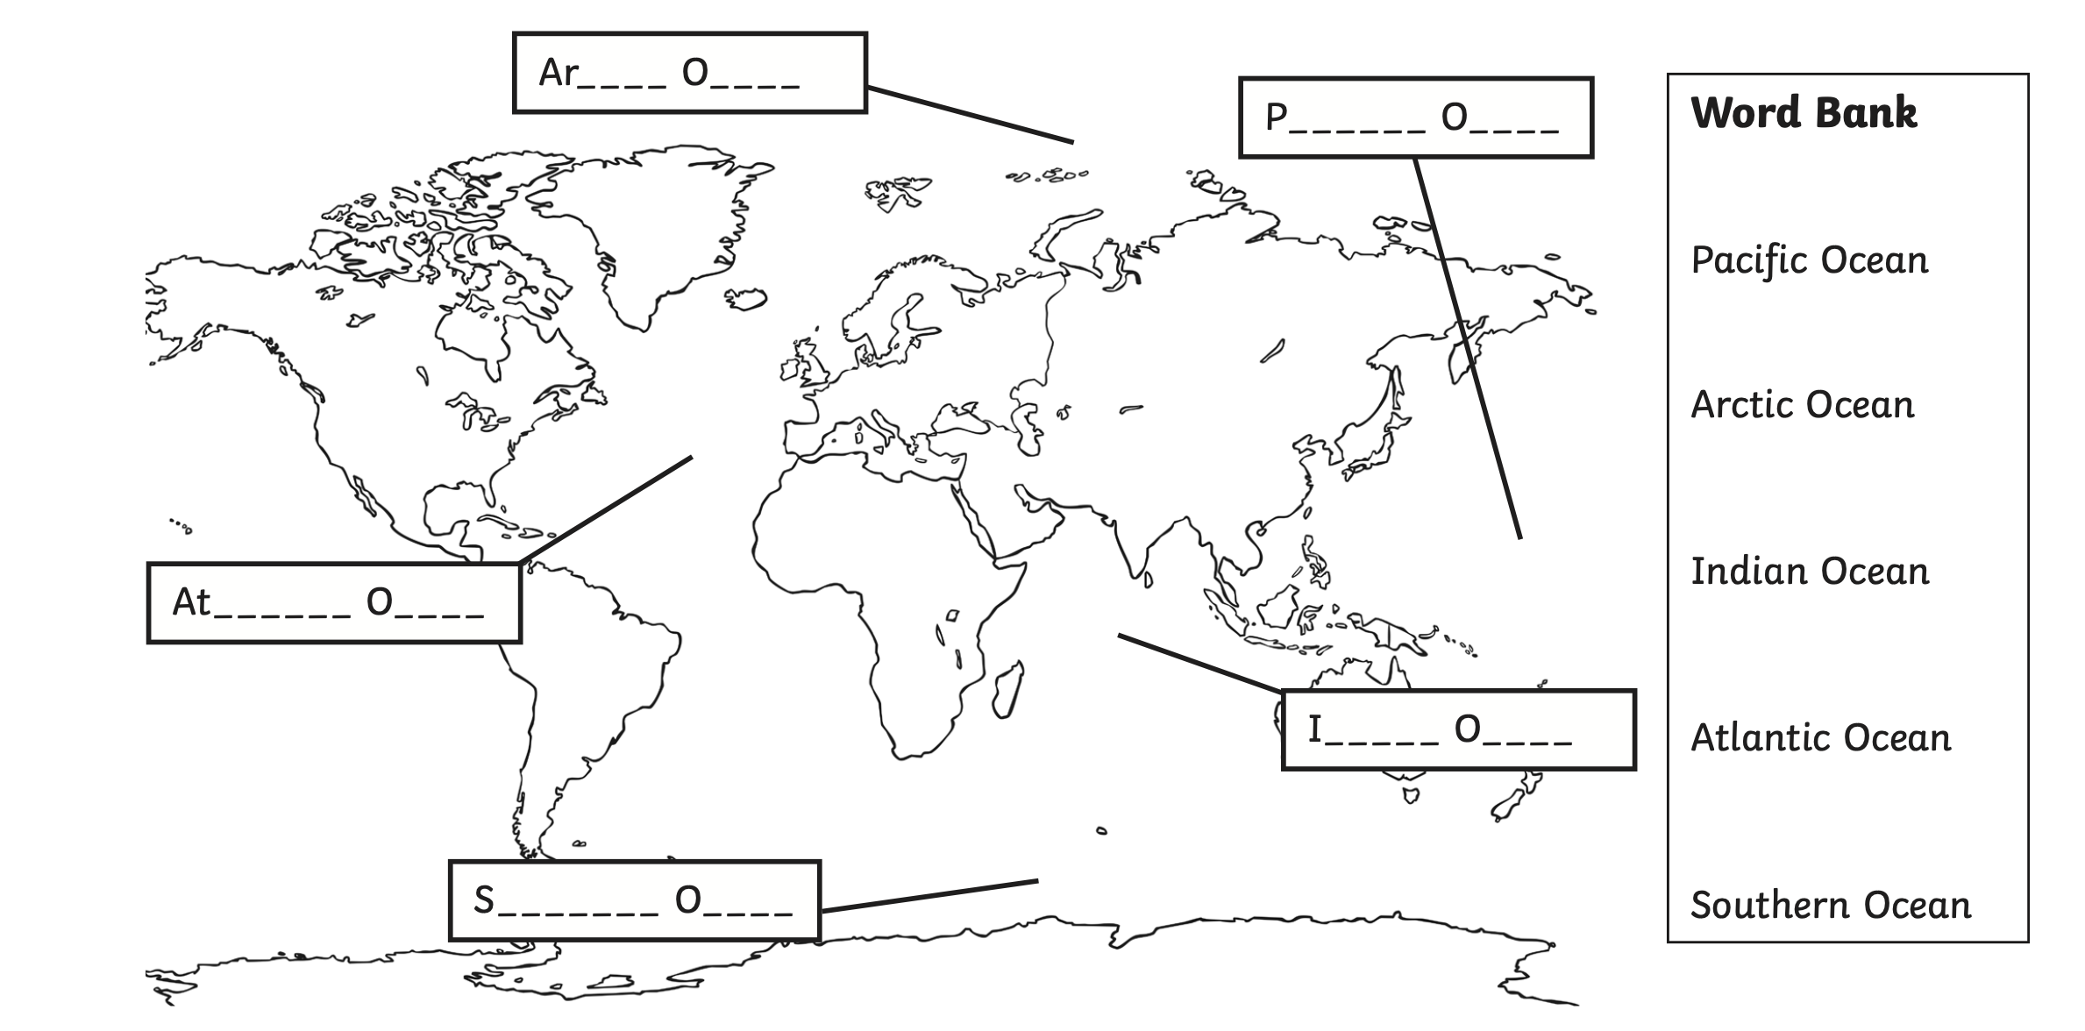
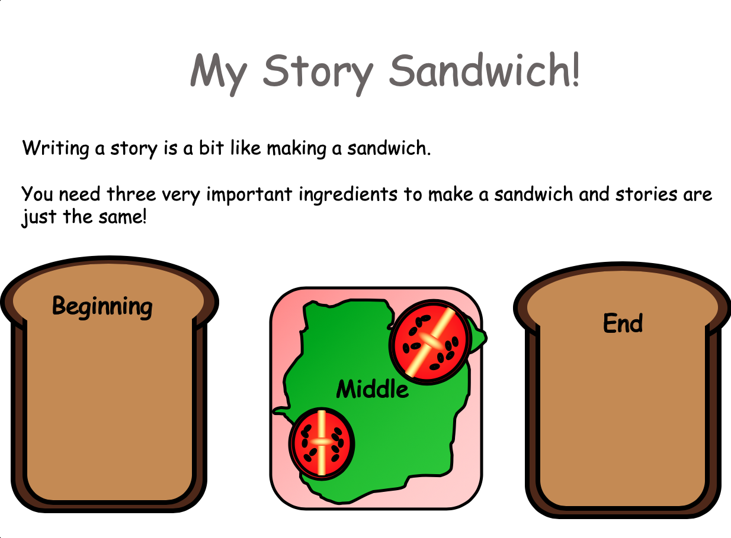
Sheet 7 - A
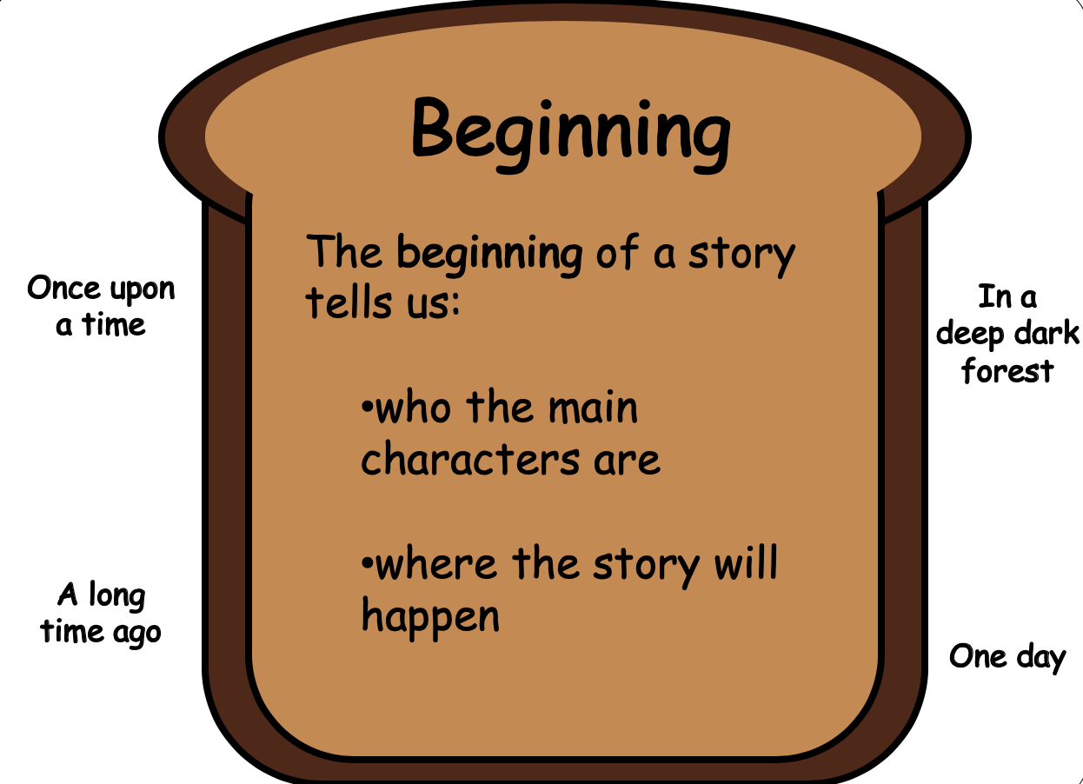
Sheet 7 - B

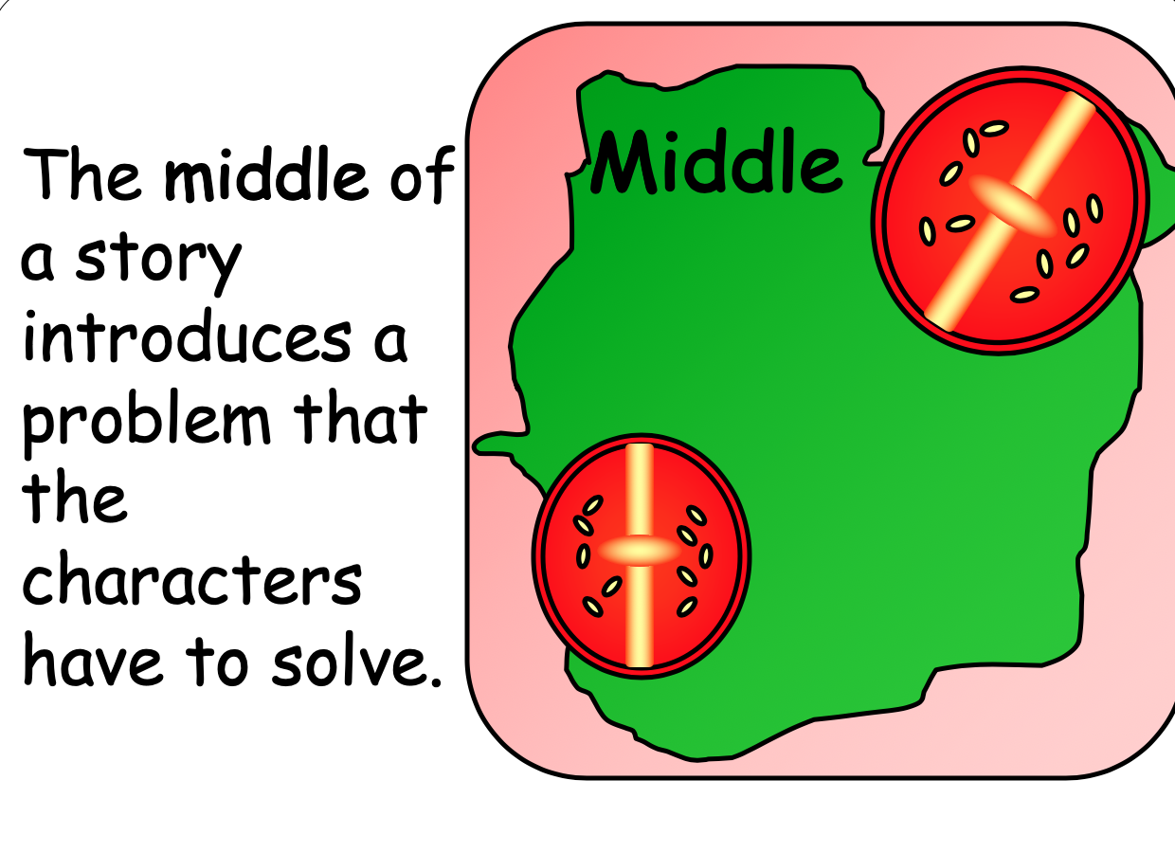
Sheet 7 - C
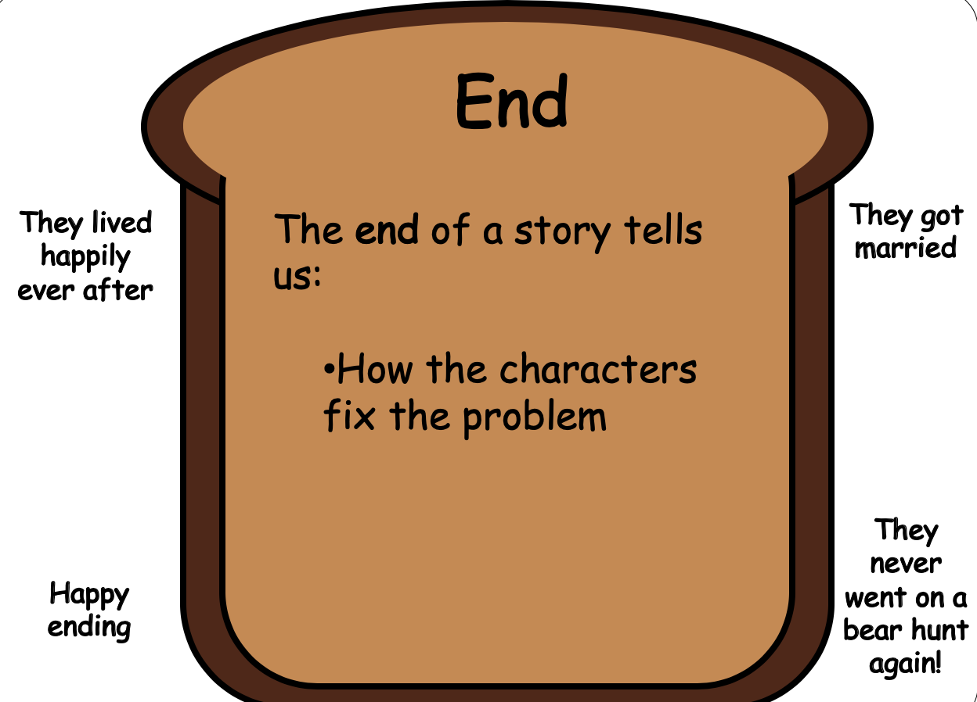
Sheet 7 - D
Sheet 8
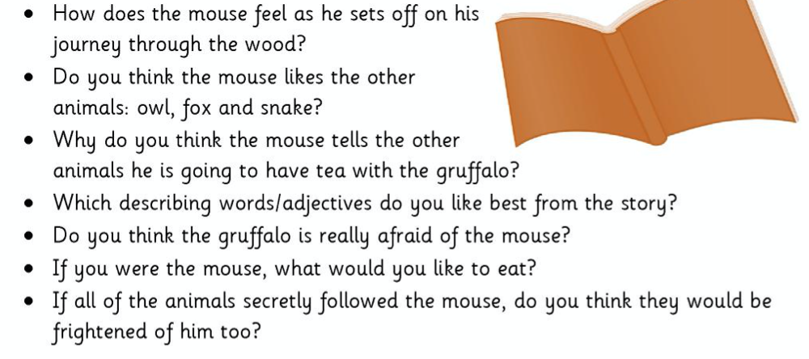
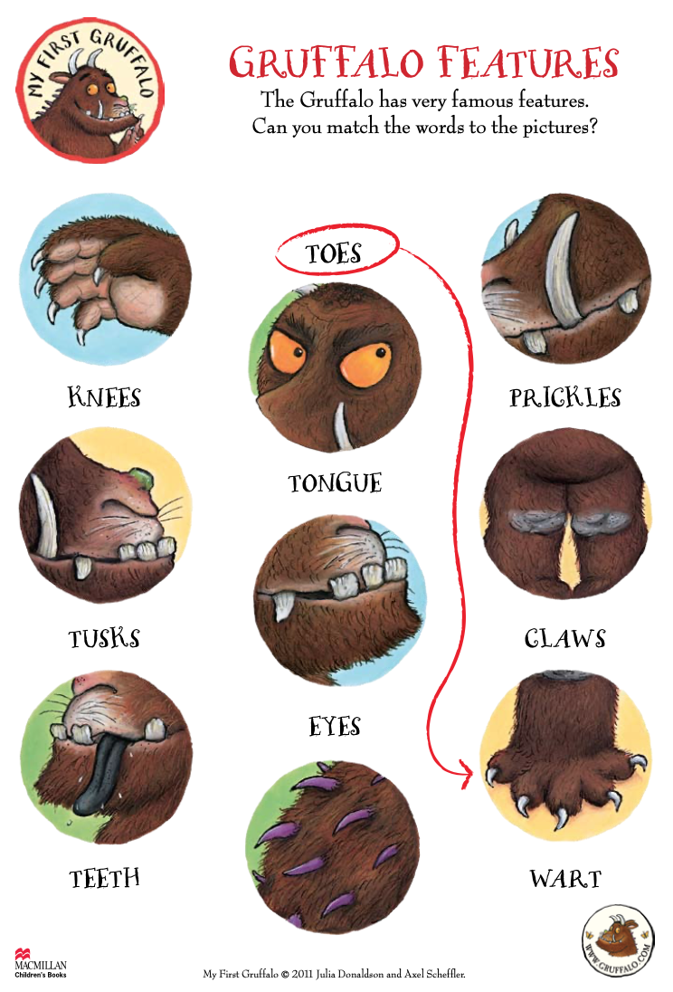
Sheet 9

