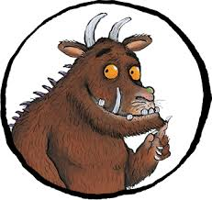
Target: to answer comprehension questions on the Gruffalo by Julia Donaldson
A mouse took a stroll through the deep dark wood. A fox saw the mouse and the mouse looked good. “Where are you going to, little brown mouse? Come and have lunch in my underground house.”
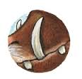
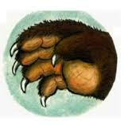
“It’s terribly kind of you, Fox, but no – I’m going to have lunch with a gruffalo.”
“A gruffalo? What’s a gruffalo?”
“A gruffalo! Why didn’t you know?”
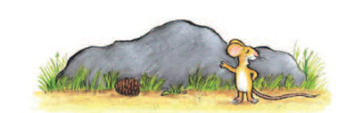
“He has terrible tusks, and terrible claws, And terrible teeth in his terrible jaws.”
“Where are you meeting him?”
“Here, by these rocks, And his favourite food is roasted fox.”
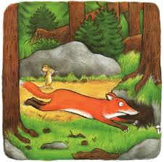
“Roasted fox! I’m off! Fox said. “Goodbye little mouse,” and away he sped.
“Silly old fox! Doesn’t he know, There’s no such thing as a Gruffalo?”
On went the mouse through the deep dark wood. An owl saw the mouse and the mouse looked good. “Where are you going to, little brown mouse? Come and have lunch in my treetop house.”
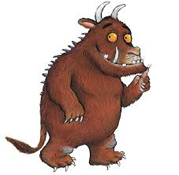
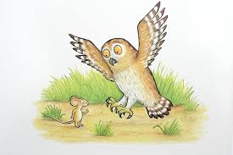
“It’s frightfully nice of you, Owl, but no – I’m going to have tea with a gruffalo.”
“A gruffalo? What’s a gruffalo?”
“A gruffalo! Why didn’t you know?”

Target: to answer comprehension questions on the Gruffalo by Julia Donaldson

- Where did the mouse take a stroll?
____________________________________________________________________________________________
- Where did the fox live?
______________________________________________________________________________________________
- Why could the mouse not have lunch with the fox?
____________________________________________________________________________________________
- How did the mouse describe the gruffalo?
______________________________________________________________________________________________
- Where was the mouse meeting the gruffalo?
____________________________________________________________________________________________
- What did the mouse tell the fox his favourite food was?
______________________________________________________________________________________________
- Why did the fox leave?
____________________________________________________________________________________________
- Would you like to have lunch with a Gruffalo? Why?
________________________________________________________________________________________

