Minion | Tally
Bob
Kevin
Stuart
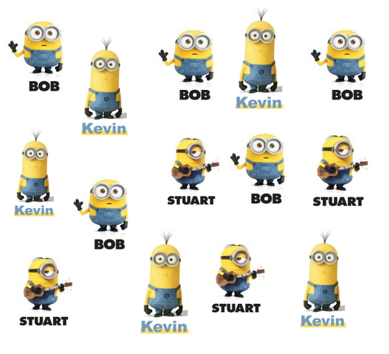
A group of children were asked to vote for their favourite minion. You need to help them count the votes by completing the tally chart below.

- How many children voted for Bob?

______________________________

- How many children voted for Stuart?

______________________________

- Which Minion is the favourite?

______________________________

- Which Minion is the least favourite?

______________________________

- What is the different between Stuart and Bob?

________________________________

