Hello Inventors,

Please find attached the final week of remote learning planning (hopefully!) Next week, week commencing Monday 8th of March, all children will be back in school and I honestly can’t wait to see them all and get back to some sort of learning normality! I would like to take this opportunity to say a massive thank you to all the parents, carers and grown-ups at home who have judged work, home-schooling and life in general. You have been a tremendous support to your child, me and the school, so thank you!

Like always, I will continue to attach the web links and worksheets on a daily basis, along with any videos etc. for that day’s learning onto Class Dojo via the Class Story, as well as, the Portfolios for anyone doing their learning electronically. If you can continue to upload any work to the Portfolio on Class Dojo or alternatively, take a photograph and attach it on an email to s.womble@marshlane.derbyshire.sch.uk or via private message on Class Dojo it would be greatly appreciated.

The first mini celebration of this half-term was held on Monday 22nd February 2021 and the certificate winners were:
TT Rockstar Champion of the Week was Millie, Doodle Maths Champion of the Week was William, Reader of the Week was Gracie, Phonics Star of the Week was Fraser, Remote Learner of the Week was Livvy and the School Learner of the Week was Eden! Well done to you all!

The next and last mini celebration will be held on Friday 5th March 2021 to celebrate the achievements from week 1 and week 2 Spring Term 2. I hope you will, once again, watch, enjoy and clap for the children receiving certificates! I will then send the certificates electronically to the children during the National Lockdown.

The daily challenges will be clearly marked on the weekly planning overview but I will put a reminder on Class Story about these challenges daily. Please note that if your child does attend school, the daily challenge for each day and the planned activities for that day will be done in class.

I will continue to teach phonics remotely via a video link, which I know children are watching and joining in with, so thank you for this. You can continue to access Doodle Maths, TT Rockstars, Epic Books and Purple Mash on a daily basis and I will continue to add on books and activities on a regular basis.

Just a reminder that Thursday 4th March 2021 is World Book Day and all the planned activities for that day will be focusing on reading, books and our star author, Steve Antony. We will be sending out a Zoom link for story time for this day too so please look out for it plus more planned activities to be confirmed too!

If you have any questions or queries regarding any of the above, please message me via Class Dojo or email (see above) and remember to stay safe! See you all on Monday 8th March 2021!

Mrs Womble
MONDAY 1st MARCH 2021
SPAG  Spelling rule of the week – homophones and near homophone words  new, knew, there, their, they’re  High frequency words of the words for phonics are:  have, went, be, like, some  Practise this week’s spelling rule and high frequency words daily using the look, say, cover, write, check method.  Singular and Plurals nouns and verbs (ending in y and adding es)  What does singular mean? What does plural mean? Look at the PowerPoint recapping when to add on (s) and introducing changing nouns and verbs ending with a (y) into plurals using es.  Re-cap capital letters  Why do you use a capital letter? When do you use a capital letter? Watch and listen to the Capital Letters and Full Stop song using:  https://www.bbc.co.uk/teach/supermovers/ks1-english-capital-letters-full-stops/zjmrhbk  Worksheets and activities to be sent  Spelling sheet  Singular and Plurals PowerPoint  Adding es to nouns worksheet  Adding es to verbs worksheet  BBC web link for video  Missing capital letters worksheet  READING  DAILY CHALLENGE OF THE DAY  Who is Predicting Pip? What type of questions does Predicting Pip ask? What reading skills do you think you need to answer predicting questions?  Worksheets and activities to be sent  Daily challenge of the day video lesson link  Predicting Pip PowerPoint  Predicting Pip question sheet (for information only)  The Island reading comprehension | MATHS WHIZZERS  Maths Whizzers focus on times tables (3 different sheets will be sent and you can choose which one you want to do or you might do all 3!)  Also, this could be a great opportunity to go on TT Rockstars.  https://play.ttrockstars.com/  Or alternatively, complete one of the Times Tables games on Purple Mash (set as a 2do called Monster Multiplication or Speed Test.)  Worksheets and activities to be sent  3 differentiated Maths Whizzers sheets (x 10, x 2) (x 10, x 2, x5) (x 10, x 2, x 5, x 3)  Monster Multiplication and Speed Tests are set on Purple Mash  www.purplemash.com  RE/ART  Today it is St David’s Day! Who is St David? What part of the UK is St David the patron saint of? Watch the CBeebies video on St David’s Day using the link below:  https://www.youtube.com/watch?v=1G9gtSBAJII  Have a go at creating an egg box Welsh dragon (on the Welsh flag) or a daffodil pinwheel (the Welsh flower) see web links below:  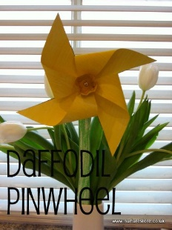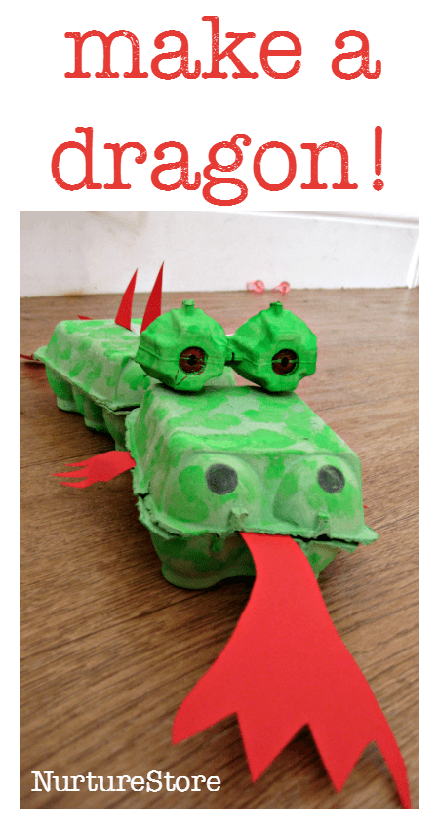  Worksheets and activities to be sent  St David’s Day wordsearch  St David’s Day bake off recipes  Link to Egg box dragon - https://nurturestore.co.uk/egg-box-dragon  Link to Pinwheel daffodil - https://nurturestore.co.uk/daffodils-windmills  Joe Wicks daily workout live at 9am or alternatively watch and join in on You Tube anytime you like!  or alternatively,  Try some Welsh Dancing – watch the video on You Tube first  https://www.youtube.com/watch?v=5_jMCsiYHTE

TUESDAY 2nd MARCH 2021
SPAG  Practise the spelling rule of the week words and the high frequency words of the week on your sheet.  Challenge: Can you write anymore homophone or near-homophone words to add to your word bank this week?  PHONICS  Watch the daily phonics video focusing on phase 5 (alternative graphemes – long vowel U.)  Worksheets and activities to be sent  Phonics lesson video link  Reading activity – Make a cool hot air balloon!  Which oo, ew, ue, u-e or long vowel U spelling activity  Cheeky Chimps game on Phonics Play  https://www.phonicsplay.co.uk/  LITERACY  If you could create your own dragon what would it look like? What strengths would it have (fast flyer, burning hot lava breath?) Would it be a fierce dragon or a nice dragon? Would it have a name? Discuss all these questions and share some ideas before designing and describing your own dragon!  Worksheets and activities to be sent  Example of own dragon with keywords for description activity  Mind map template for sharing ideas  Blank sheet for dragon design | MATHS  DAILY CHALLENGE OF THE DAY  What is mass? What do we use to measure mass? How do we compare mass? What vocabulary do we use to compare mass? Watch the video lesson link for more information and to see today’s challenge!  Worksheets and activities to be sent  Daily challenge of the Day video lesson link  Practical activity to start using scales or alternative become the scales yourself!  Comparing mass worksheet 1  Comparing mass worksheet 2  Extra comparing mass worksheet  TOPIC  What is a castle? What features does a castle have? What else do you know about castles? Look at the Castles PowerPoint on what castles are and their features. Label the diagram of the castle with the correct features using the labels.  Extra activity – to design your own castle. What will it look like? What features will it have? What material would you make it from?  Worksheets and activities to be sent  Castles PowerPoint  Labelling features of a castle activity  Labels for castle activity  Design your own castle worksheet

WEDNESDAY 3rd MARCH 2021
SPAG  Practise the spelling rule of the week words and the high frequency words of the week on your sheet.  Challenge: Can you use at least one high frequency word of the week in a statement sentence.  PHONICS  Watch the daily phonics lesson focusing on the phase 5 alternative graphemes (ow in snow.)  Worksheets and activities to be sent  Phonics lesson video link  Reading activity – The Crow in the Snow!  Spelling activity – oa, ow, oe, o-e  Acorn Adventures on Phonics Play:  www.phonicsplay.co.uk  LITERACY  DAILY CHALLENGE OF THE DAY  Watch the video lesson link on creating a story map on instructions on how to trap a dragon!  Worksheets and activities to be sent  Video lesson link  Story map example  Story map blank worksheet | MATHS  What do you use to measure mass? What do you measure mass in? Watch the You Tube clip which explains how to read scales in grams using the link below:  https://www.youtube.com/watch?v=AW878kgHdqc  If you have some scales at home, practise weighing different objects and read the scales. Move from practical weighing to pictorial weighing using the worksheets.  Worksheets and activities to be sent  Practical activity to start (you will need some weighing scales and some objects to weigh)  Reading scales in grams sheet 1  Challenge sheet 1  Challenge sheet 2  Extra activity Mostly Postie on Topmarks (gram focus only):  https://www.ictgames.com/mobilePage/mostlyPostie/index.html  PE  Joe Wicks daily workout live at 9am or alternatively watch and join in on You Tube anytime you like!  Or  Cosmic Yoga –Cracker the Dragon on You Tube:  https://www.youtube.com/watch?v=TsIMInvEU8A

THURSDAY 4th MARCH 2021 – WORLD BOOK DAY
SPAG  Practise the spelling rule of the week words and the high frequency words of the week on your sheet.  Challenge: Use at least one homophone word in a statement sentence of your own.  Steve Antony – who is he? What books has he done? Watch the video of Steve Antony reading the children The Queen’s Handbag.  https://www.steveantony.com/aboutme  Carousel of activities to include some World Book Day activities:  *Design and make a new handbag for the Queen  *Make some story puppets based on the Queen’s handbag and retell the story with them  *Make a bookmark (Queen’s handbag or a character from a different Steve Antony book)  *World Book Day wordsearch  *Book reviews  *Front cover artwork based on Steve Antony books | MATHS  To follow a set of instructions and use mass skills to weigh and make a non-bake recipe of Rocky Road Bites.  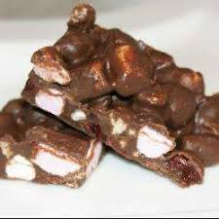  Worksheets and activities to be sent  https://www.bbcgoodfood.com/recipes/easy-rocky-road  For Fun:  World book day bingo!  Scavenger World Book Day Hunt!  World Book Day book quiz!  DAILY CHALLENGE OF THE DAY TO BE ANNOUNCED VIA VIDEO LINK!  (QUICK CLUE – ANOTHER VIDEO!)

FRIDAY 5th MARCH 2021
SPAG  Practise the spelling rule of the week words and the high frequency words of the week on your sheet.  Challenge: Can you use at least one homophone word and one high frequency word of the week  PHONICS  Watch the daily phonics lesson focusing on the phase 5 (alternative graphemes – ie (ee.)  Worksheets and activities to be sent  Video lesson link  Colour by alternative sound sorting activity  Blending bingo page 7 (ai and ee)  https://www.ictgames.com/  LITERACY  To use your story map to write your set of instructions on how to trap a dragon! Remember all the features that instructions need!  Worksheets and activities  Non-negotiable checklist  Writing instruction checklist  READING  Use your reading skills, especially focusing on your Predicting Pip skills to answer questions on the non-fiction text Castles.  Worksheet and activities to be sent  Castles reading comprehension | PSHE  DAILY CHALLENGE OF THE DAY  If you have any concerns, worries or questions about returning to school, please email me or message me via Class Dojo and I will answer them back in a video link later in the day. Remember, we all get worried and have those worry butterflies, even me! Here if you need me for anything!  Golden Time  Friday afternoon means GOLDEN TIME! Top 5 activities for this week are:  - Continue to practise your weighing skills by baking a cake fit for a King or Queen.  - Use Playdough, modelling clay or air-dry clay to make a castle.  - Watch the film Pete’s Dragon.  - Go on a safe walk and look for natural materials (leaves, twigs, sticks etc.) that you could use to set up a dragon trap!  - Design and make yourself a crown fit for a King or Queen and practise your royal wave!  If you do any of the top 5 activities for your golden time, don’t forget to post a picture!  DON’’T FORGET TO WATCH THE FINAL MINI CELEBRATION VIDEO!  ENJOY YOUR WEEKEND AND STAY SAFE!

TTRockstars, Doodle Maths, Epic Books and Purple Mash are accessible daily if you want more learning and challenges to do!

