Hello Inventors,

Welcome to week 5 of the Spring term and the fifth week of remote learning. I know it might be getting progressively more difficult to motivate yourself to learn remotely but we are nearly at the end of Spring Term 1. COME ON, WE CAN DO THIS BECAUSE YOU ARE ALL AMAZING!

I will continue to attach the web links and worksheets on a daily basis, along with any videos etc. for that day’s learning onto Class Dojo via the Class Story, as well as, the Portfolios for anyone doing their learning electronically. If you can continue to upload any work to the Portfolio on Class Dojo or alternatively, take a photograph and attach it on an email to s.womble@marshlane.derbyshire.sch.uk or via private message on Class Dojo it would be greatly appreciated.

The third mini celebration took place on Monday 25th January 2021 and the certificate winners were:
Livvy (TT Rockstar Champion of the Week), James (Doodle Maths Champion of the Week), Archie (Phonics Star of the Week), Ruby (Reader of the Week), William (Remote Learner of the Week) and Rowan (School Learner of the Week.)

I will be holding the next mini celebration on Monday 1st February which I hope you will, once again, watch, enjoy and clap for the children receiving certificates! I will then send the certificates electronically to the children during the National Lockdown.

The daily challenges will be clearly marked on the weekly planning overview but I will put a reminder on Class Story about these challenges daily. Please note that if your child does attend school, the daily challenge for each day and the planned activities for that day will be done in class.

I will continue to teach phonics remotely via a video link daily, which I know children are watching and joining in with, so thank you for this. You can continue to access Doodle Maths, TT Rockstars, Epic Books and Purple Mash on a daily basis and I will continue to add on books and activities on a regular basis.

If you have any questions or queries regarding any of the above, please message me via Class Dojo or email (see above) and remember to stay safe!

Can’t wait to see you all. Stay safe!

Mrs Womble
MONDAY 1ST FEBRUARY 2021
SPAG  Spelling rule of the week – words with the suffixes on ment and ness.  Movement, payment, darkness, sadness  High frequency words of the words for phonics are:  with, all, an, so, we  Practise this week’s spelling rule and high frequency words daily using the look, say, cover, write, check method.  Vocabulary  What is a suffix? Which suffixes have we already looked at? Remind yourself of those first then look at the PowerPoint on the new suffixes ment and ness.  Punctuation  What is a comma? When do you use a comma? Watch the BBC Bitesize video before the activity:  https://www.bbc.co.uk/bitesize/topics/z8x6cj6/articles/zxvcrdm  Worksheets and activities to be sent  Spelling sheet  Suffix PowerPoint  Suffix worksheet 1  Suffix worksheet 2 (challenge)  Suffix wordsearch  BBC Bitesize video link  Commas in a list worksheet  READING  Who is Rex Retriever? What type of questions does he ask? Look at the PowerPoint on Rex Retriever before you do the reading comprehension sheet.  Remote learners only. Reading comprehension in school will be set by Mrs Bakes.  Worksheets and activities to be sent  Rex Retriever PowerPoint  Come and Play (The Gruffalos and Gangster Granny groups)  Toad’s Wish (Mary Poppins, Harry Potter and Fantastic Mr Fox groups) | MATHS WHIZZERS  Maths Whizzers focus on times tables (3 different sheets will be sent and you can choose which one you want to do or you might do all 3!)  Also, this could be a great opportunity to go on TT Rockstars.  https://play.ttrockstars.com/  Or alternatively, complete one of the Times Tables games on Purple Mash (set as a 2do called Monster Multiplication or Speed Test.)  Worksheets and activities to be sent  3 differentiated Maths Whizzers sheets (x 10, x 2) (x 10, x 2, x5) (x 10, x 2, x 5, x 3)  Monster Multiplication and Speed Tests are set on Purple Mash  www.purplemash.com  ART  DAILY CHALLENGE OF THE DAY!  In Art this term, you will be learning about famous artists from the past and now.  Remote learners only. Artist of the week in school will be set by Mrs Bakes.  This week’s famous artist is Georgia O’Keefe an American artist known for your flowers and landscape pictures.  Worksheets and activities to be sent  PowerPoint on Georgia O’Keefe  Joe Wicks daily workout live at 9am or alternatively watch and join in on You Tube anytime you like!

TUESDAY 2ND FEBRUARY 2021
SPAG  Practise the spelling rule of the week words and the high frequency words of the week on your sheet.  Challenge: Can you think of any more words that have the suffix ment? Write them down.  PHONICS  Watch the daily phonics video focusing on phase 5 graphemes (ay, ou, ie, ea)  Worksheets and activities to be sent  Phonics lesson video link  Reading activity – Real and Nonsense words (ou)  Spelling activity – Focusing on (ay)  Yes/No Yeti on:  www.phonicsbloom.com  LITERACY  What does it take to be an ice explorer? Later this week, we will be finding out about Captain Scott’s journey to the South Pole. Today’s activity is to help the penguins advertise for an ice explorer. If Captain Scott show your advertisement, would he have changed his mind?  Worksheets and activities to be sent  Explorers advertisement poster | MATHS  To recognise and use arrays in different ways using pictorial representations.  Worksheets and activities to be sent  BBC Bitesize video on Arrays:  https://www.bbc.co.uk/bitesize/topics/zqbg87h/articles/z3tvcj6  Arrays worksheet 1  Arrays worksheet 2 (challenge)  Geography lesson below for remote learners only today. Children in school on Tuesday will do a lesson planned by Mr Harling.  GEOGRAPHY  DAILY CHALLENGE OF THE DAY  Watch the video lesson link below to find out activity.  Worksheets and activities to be sent  PowerPoint on comparison of 2 countries  Worksheet to compare UK with Arctic

WEDNESDAY 3RD FEBRUARY 2021
SPAG  Practise the spelling rule of the week words and the high frequency words of the week on your sheet.  Challenge: Can you think of anymore words with the suffix ness? Write them down please.  PHONICS  Watch the daily phonics lesson focusing on the phase 5 graphemes (oy, ir, ue, aw.)  Worksheets and activities to be sent  Phonics lesson video link  Reading activity – aw postcard  Spelling activity – which oo or ue?  Buried Treasure on Phonics Play:  www.phonicsplay.co.uk | LITERACY  DAILY CHALLENGE OF THE DAY  To tell the non-fiction story of Captain Scott’s journey to the South Pole. Watch the video lesson for activity.  Worksheets and activities to be sent  Video lesson link  Boxed-up grid for sequencing activity  Sequencing pictures  Missing words for Captain Scott’s journey  Scott of the Antarctica wordsearch and colouring sheet (extra)  MATHS  To use written arrays to answer multiplication number sentences.  Worksheets and activities to be sent  Example of how to use written arrays using squared paper.  Staged number sentences (starting at green then progressing to red.)  Joe Wicks daily workout live at 9am or alternatively watch and join in on You Tube anytime you like!

THURSDAY 4TH FEBRUARY 2021
SPAG  Practise the spelling rule of the week words and the high frequency words of the week on your sheet.  Challenge: Use at least one of your spelling rule of the week words in a sentence of your own. Which type of sentence did you write? (command, question, statement or exclamation?)  PHONICS  Watch the daily phonics lesson focusing on the phase 5 graphemes (wh, ph, ew)  Worksheets and activities to be sent  Video lesson link  Reading activity – read and roll ew  Spelling activity – which wh or w?  Play Forest Phonics on ICT Games.  www.ict.games.co.uk  LITERACY  To use a boxed up diary plan grid (just like we used in One Snowy night) to plan Captain Scott’s diary.  Worksheets and activities to be sent  Writing non-negotiable checklist  Boxed-up diary grid plan | SCIENCE  DAILY CHALLENGE OF THE DAY  To investigate how the shapes of materials can be changed. Watch the video lesson link for activity.  Worksheets and activities to be sent  Video lesson link  PowerPoint  Science investigation sheet  D & T  To continue to make your Arctic/Antarctica scene. If you have done this, look at Spring term 1 homework overview and complete some of the homework activities.  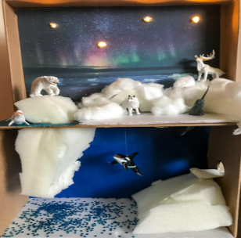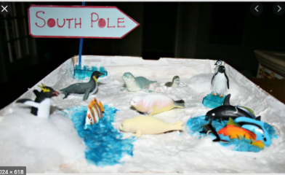

FRIDAY 5TH FEBRUARY 2021
SPAG  Practise the spelling rule of the week words and the high frequency words of the week on your sheet.  Challenge: Use at least one spelling rule of the week word in a different sentence type from yesterday.  PHONICS  Watch the daily phonics lesson focusing on the phase 5 graphemes (oe, au, ey)  Worksheets and activities to be sent  Spelling activity – focusing on ey  Blending bingo page 22 (phase 5 – oe and au)  https://www.ictgames.com/  LITERACY  To use your knowledge of diary writing and your boxed-up grid diary plan to write Captain Scott’s diary.  Worksheets and activities  Non-negotiable checklist  Diary writing checklist | MATHS  DAILY CHALLENGE OF THE DAY  To answer multiplication word problems using written arrays to show working out.  Worksheets and activities to be sent  Video lesson link  Multiplication word problems  Golden Time  Have some time to play and even have a go at some of the Muddy Puddle’s outdoor challenges. See the next 5 below!  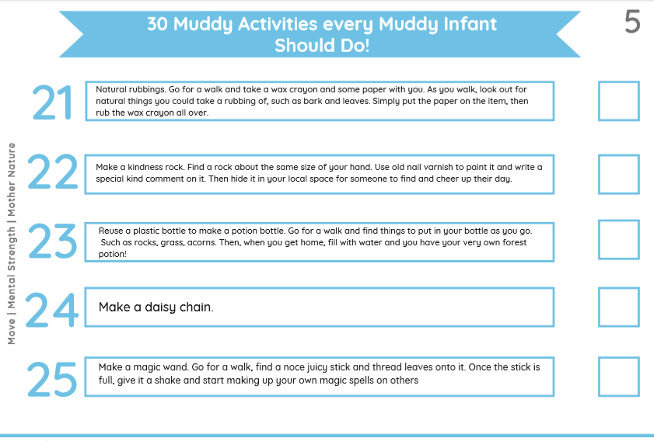  ENJOY YOUR WEEKEND AND STAY SAFE!

TTRockstars, Doodle Maths, Epic Books and Purple Mash are accessible daily if you want more learning and challenges to do!

