Year 1 - Summer 2, Week 5
Home Learning – Wild West Topic

Hello Year 1! I hope you are all well. Below are the different activities we are doing in school (in a different format from the usual overview). I have included activities for Friday when all children are at home.

Literacy  Reading  Writing  Phonics | Literacy: To create a Wild West Hero  - Create a Wild West Hero - name your hero and label with exciting adjectives. Think about what they look like, what they might say and what their personality is like.  - Write a character description of your hero.  Reading: To read a book a day this week and GET CAUGHT READING somewhere interesting.  - We are making a new display in the library to inspire pupils to read more for pleasure. We will be pegging up photographs of the children reading in comfortable, cosy, interesting, unexpected or exciting places. Anywhere goes as long as it’s safe! Please send them via Purple Mash, Class Dojo or the school email.  - Reading daily there are a range of free books available on this website  https://www.oxfordowl.co.uk/for-home/find-a-book/library-page  Phonics: To recap phase 3 & phase 5 sounds  - https://www.phonicsplay.co.uk  - Phonics families – ay, ai, a-e & igh ie, i-e
Mathematics  Time:  - to the hour | - Time to the Hour  - https://www.bbc.co.uk/teach/supermovers/ks1-maths-telling-the-time/zk4t8xs  - Create own clock and practice telling time to the hour (download)  - White Rose worksheet (download)  Times Tables:  - Count daily in 2s, 5s & 10s forwards and backwards  - Our trial is coming to an end for Times Table Rockstars – if this something you have enjoyed please let me know
Science  Predict  Question  Investigate | Sink or Float?  - Design a boat made from different materials (junk modelling)  - Predict whether you think your boat will float or sink  - Test your boat in water – did it sink or did it float? How could you improve?
Art & Design  Wild West | 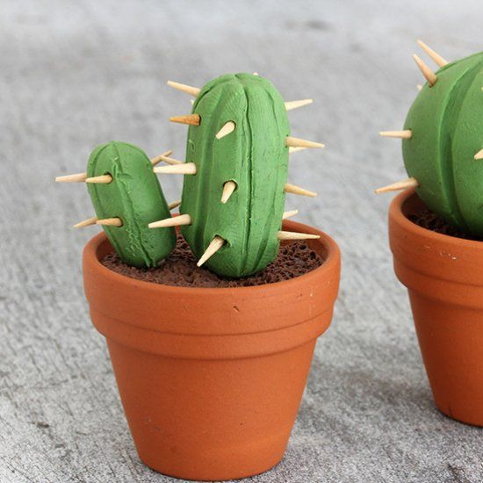  Cactus  - Can you create your own cactus using playdoh/ clay and cocktail sticks? (be careful!)
PE  10-minute shake up | Toy Story  - https://www.nhs.uk/10-minute-shake-up/shake-ups?filter=toy-story

Friday tasks:

- Purple Mash 2Dos
- Flash Maths & Maths Whizzers (download)
- Cosmic Yoga
- Doodle Maths

