Hello Year 1!

I hope you are all really well and for those of you who celebrated VE Day I hope you had a wonderful time.

I am loving seeing all of your hard work. I have seen work from almost all of you on Purple Mash, I am really glad this is proving to be a fun learning resource at home and a good way of communicating on 2Email. Thank you to those children who have sent in photos, they bring a big smile to my face and any photos I receive I will upload to the blog for friends to see as well.

If you would like to send me a photo of home learning or any activities you are doing the best way is to email the school email - enquiries@marshlane.derbyshire.sch.uk - and this will then be passed on to me. If you do email photos I will be posting them to the blog, if you don’t want them on the blog then please let me know.
Any questions please comment on the blog or email me through 2Email on Purple Mash and I will get back to you asap.
A note to parents: Thank you Y1 parents! You are all doing an amazing job. Remember, these overviews are just to give an idea of what children would be learning about if schools were open. A few parents have messaged to say they’re doing a lot of reading and life skills, that is fab! Any and all work at home is brilliant, learning outside is wonderful too.
Missing you all lots and lots.
Don’t forget to have fun!

Miss Marsland xx

(see overview below)
NAVIGATORS - YEAR 1 – Summer 1, Week 4
11/5/20
 | 9.00 – 9.15 | 9.15 – 9.35 | 9.35 – 10.00 | 10.00 – 10.35 | 10.35 – 10.50 | 10.55 – 11.55 | 12 - 1 | 12.55 – 2.55
MON | Practice spellings – focus on days of the week | Phonics  Phase 5  https://new.phonicsplay.co.uk/resources/phase/3/sentence-substitution-ph3  Phase 5 Reading Robots (Phonics Play)  -Read the word on the robot (real and nonsense words)  -Can you explain what the word means?  -Extension – can you use the word in a sentence and write it down?  Login details:  Username: march20  Password: home  OR  Online lessons with Letters & Sounds | Reading –  Captain Tom Moore – Non-Fiction  (download sheet on blog or MLPS website)  Read the story, discuss what happens.  Discuss any words children are unsure of meaning. | Handwriting  https://www.letterjoin.co.uk  Login to Letter-Join  Details on 2Email on Purple Mash. | B R E A K | Literacy – To write a character description  Recap on The Gruffalo – can you remember your actions?  https://www.youtube.com/watch?v=s8sUPpPc8Ws  Today I would like you to write your own character description!  Remember the character description of the Gruffalo and write your own for the character you made last week. As an extension can you describe the setting your character lives in as well.  Remember:  - Capital letters, finger spaces & full stops  - Amazing adjectives  - Conjunctions – and, but, because, so , then  - Punctuation (. , ! ?)  - Neatest handwriting | L U N C H | 1 - 2  Maths –  Maths whizzers – 1 minute timer to answer 10 times table questions. See Sheet 1 below the overview.  Flash maths – addition & subtraction questions. See Sheet 2 below the overview. (Chn can use objects, number lines & numicon if available, I have also included a 100 square - see Sheet 3) |  |  | 2 - 3  OUTDOOR PE –  Get outside if you can. Remember to warm up and cool down.  Try Joe Wick’s 5 minute workouts on Twinkl.  This half term we were going to start a simplified version of the team game – Tag Rugby. If you have lots of people at home you could try and play with them – learn the rules here:  https://d2cx26qpfwuhvu.cloudfront.net/premier/wp-content/uploads/2016/09/23114412/STCO-Practical.pdf
TUES | Practice spellings – focus on days of the week | Phonics  Phase 5  https://new.phonicsplay.co.uk/resources/phase/3/sentence-substitution-ph3  Phase 5 Reading Robots (Phonics Play)  -Read the word on the robot (real and nonsense words)  -Can you explain what the word means?  -Extension – can you use the word in a sentence and write it down?  Login details:  Username: march20  Password: home  OR  Online lessons with Letters & Sounds | Reading –  Captain Tom Moore – Non-Fiction  Read the story again. Spot different features used. | Handwriting  https://www.letterjoin.co.uk  Login to Letter-Join  Details on 2Email on Purple Mash. |  | Literacy – To write a character description  Recap on The Gruffalo – can you remember your actions?  https://www.youtube.com/watch?v=s8sUPpPc8Ws  Continue on from Monday. If you already finished on Monday – read through your work. Can you edit it to make it even better? Could you use more than one adjective? Have you used conjunctions? Have you remembered punctuation?  Once you have edited your work – can you write it up even neater?  After you have completed your character description, why not read out loud to your family? |  | 1 - 2  Music – Make your own instruments & rhythm  Linked to the reading this week – Starry Eyed Stan  (this will continue for the next few weeks)  PowerPoint & sheets available to download on the blog. |  | 2 - 3  Geography: To draw an enchanted forest map and label with a key  I would like you to draw a map of your enchanted forest. This can be the enchanted forest you have been making in art or the setting for your character you created or a new enchanted forest.  I would like you to think carefully about your enchanted forest. Why is it enchanted? What are the special features in your enchanted forest?  Once you’ve drawn a map I would then like you to label your map with a key. We have learnt about maps and keys before so think back to when we learnt about castles for our Once Upon a Time topic.  Remember it’s an enchanted forest so you can be as creative and imaginative as you like!  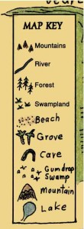
WED | Practice spellings – focus on months of the year | Phonics  Phase 5  https://new.phonicsplay.co.uk/resources/phase/3/sentence-substitution-ph3  Phase 5 Reading Robots (Phonics Play)  -Read the word on the robot (real and nonsense words)  -Can you explain what the word means?  -Extension – can you use the word in a sentence and write it down?  Login details:  Username: march20  Password: home  OR  Online lessons with Letters & Sounds | Reading –  Captain Tom Moore – Non-Fiction  Read the story again and discuss the questions. How can you find the answers? Key words in the question. | Handwriting  https://www.letterjoin.co.uk  Login to Letter-Join  Details on 2Email on Purple Mash. |  | Literacy (link to Geography) – To write directions  Following on from Geography yesterday, I would like to you write directions through your Enchanted Woodland.  Plan your route, where are you going to start? Where are you going to finish?  Try to use directional language in your directions e.g. above, below, left, right, inside, underneath, turn, half-turn, quarter-turn.  Try to use compass directions – North, East, South, West.  Remember your capital letters, finger spaces, full stops and conjunctions! |  | 1 - 2  INDOOR PE –  Cosmic Yoga  https://www.youtube.com/user/CosmicKidsYoga  There are lots of different yoga videos. You might want to do one long one or lots of different short ones. | 2 – 2.30  Mindfulness – thanks to Muddy Puddles (& the lovely Sarah Seaman!)  Worry Leaves  This time can be very anxious to a lot of children (and adults!)  This activity is really lovely for any children who are having any worries. It may be useful for in the future too, in particular when schools reopen as we expect a lot of children to feel anxious at the thought of coming back.  “Get the children outside and ask them to collect lots of evergreen leaves. Children can have lots of fun with this activity and you can make it even more educational by getting them to write and draw on the leaves.  Spend some time talking to the child about their worries and encourage them to write or draw their feelings on the leaves. Then ask the children to put their worries in a line. Or get them to rank their worries, from largest to the smallest. Ask the children to spend some time touching each leaf and tearing it up into tiny pieces. Then get them to take a deep breath and blow the worry away. Encourage them to watch as their worry blows away.  Do this with each and every worry. You may need to do this several times a day if you have children with severe anxiety. For such children, slow down the pace so that they get used to this activity.”  Reading – after taking time for mindfulness, if the weather is nice read a story together outside.  2.30 – 3  Phonics  Extra phonics – try to make your phonics active! Make up your own phonics games around the house or garden. You could hide flashcards or tricky words. Make up your own song and dance using phase 3 or phase 5 sounds.  Sing and dance along –  https://www.youtube.com/watch?v=R087lYrRpgY  https://www.youtube.com/watch?v=3NOzgR1ANc4
THURS | Practice spellings – focus on months of the year | Phonics  FLASHCARDS  https://new.phonicsplay.co.uk/resources/phase/5/flashcards-time-challenge  Practice reading the sounds quickly.  Try flashcards for different phases and also all together.  OR  Online lessons with Letters & Sounds | Reading –  Captain Tom Moore – Non-Fiction  Read the story again and write down answers to questions.  Write down answers- try to write in full sentences and use text to spell words correctly. | Handwriting  https://www.letterjoin.co.uk  Login to Letter-Join  Details on 2Email on Purple Mash. |  | Maths:  Starter - https://www.bbc.co.uk/teach/supermovers/ks1-maths-fractions-with-joe-tracini/zmjy2sg  White Rose Maths is the scheme we follow teaching Year 1 Maths – they have useful videos currently for home schooling: https://whiterosemaths.com/homelearning/year-1/  LI: To find a quarter  Maths sheets are on the ML website and blog – see Thursday’s sheet for today’s activity.  You can try finding a quarter using objects at home – 4 equal groups of toys in a pile, quarter a cake, quarter a pizza etc. |  | 1 – 1.30  Reading – choose a book to read and record in reading record. | 1.30– 3  Art –  Enchanted Forest Small World Project: Can you make and add details to your small world to make it fun to play with? These could be made from junk materials, natural materials, clay or plasticine, whatever you can find at home. You could make trees and plants, pathways, a pond or river, a bridge, a rainbow…use your picture from week one to help you.  Mrs Williams x
FR I | Practice spellings – focus on months of the year | Phonics  FLASHCARDS  https://new.phonicsplay.co.uk/resources/phase/5/flashcards-time-challenge  Practice reading the sounds quickly.  Try flashcards for different phases and also all together.  OR  Online lessons with Letters & Sounds | Reading – choose a book to read and record in reading record. | Handwriting  https://www.letterjoin.co.uk  Login to Letter-Join  Details on 2Email on Purple Mash. |  | Starter - https://www.bbc.co.uk/teach/supermovers/ks1-maths-fractions-with-joe-tracini/zmjy2sg  White Rose Maths is the scheme we follow teaching Year 1 Maths – they have useful videos currently for home schooling: https://whiterosemaths.com/homelearning/year-1/  LI: To find a quarter  Maths sheets are on the ML website and blog – see Friday’s sheet for today’s activity. |  | 1 - 2  Computing:  Purple Mash – see 2dos – choose an activity! | 2 - 3  Golden Time  Ideas:  - Watch the Gruffalo: https://www.bbc.co.uk/iplayer/episode/b00pk64x/the-gruffalo  - Colour in woodland pictures: https://www.twinkl.co.uk/resource/t-tp-5466-woodland-animal-colouring-pages  - Play a boardgame  - Get outside – imagine you’re in an enchanted woodland!  - Have fun and enjoy your weekend

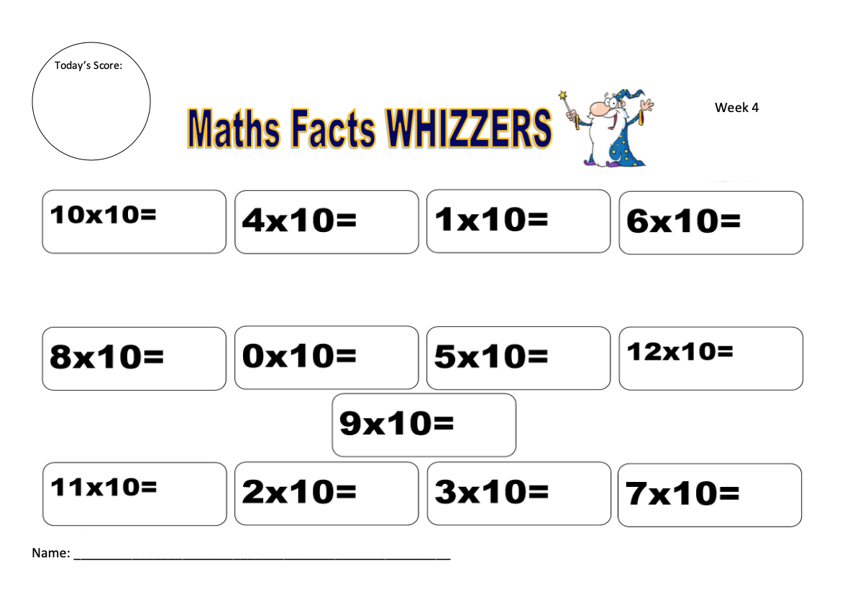
Sheet 1
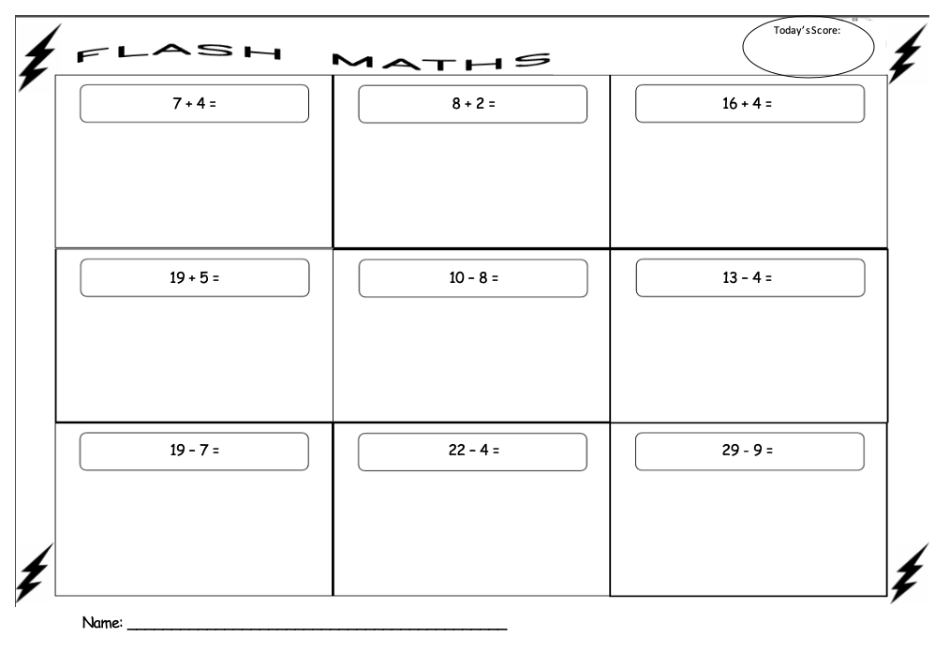
Sheet 2
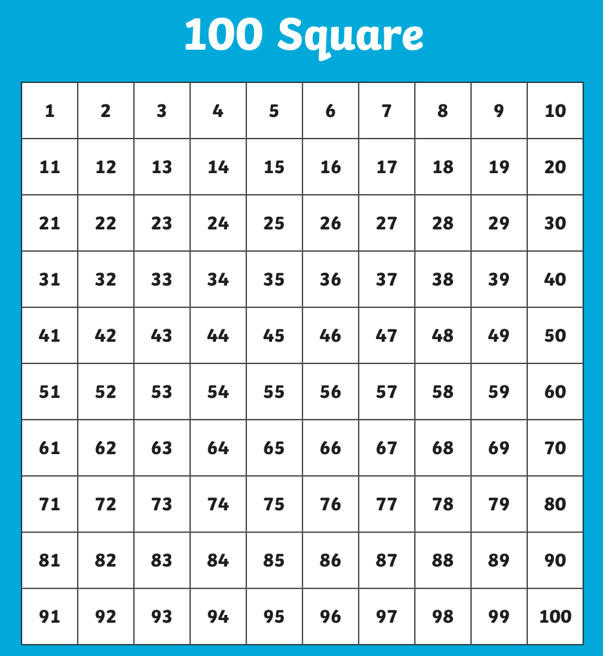
Sheet 3

Sheet 4

