Hello Year 1!

It’s the last week of Summer 1! I hope you are all well, safe and happy.

If you would like to send me a photo of home learning or any activities you are doing the best way is to email the school email - enquiries@marshlane.derbyshire.sch.uk - and this will then be passed on to me. If you do email photos I will be posting them to the blog, if you don’t want them on the blog then please let me know.

Remember there are lots of websites available to help with home learning including Purple Mash, Times Table Rockstars, Doodle Maths and Phonics Play.
Any questions please comment on the blog or email me through 2Email on Purple Mash and I will get back to you asap.
A note to parents: Thank you Y1 parents! You are all doing an amazing job. Remember, these overviews are just to give an idea of what children would be learning about if schools were open. A few parents have messaged to say they’re doing a lot of reading and life skills, that is fab! Any and all work at home is brilliant, learning outside is wonderful too.

Next week is half term so I won’t be sending an overview. Have some time to relax and play and spend time with loved ones. You are all working so hard and I am so proud of you all.
Missing you all lots and lots.
Don’t forget to have fun!

Miss Marsland xx

(see overview below)
NAVIGATORS - YEAR 1 – Summer 1, Week 5
18/5/20
 | 9.00 – 9.15 | 9.15 – 9.35 | 9.35 – 10.00 | 10.00 – 10.35 | 10.35 – 10.50 | 10.55 – 11.55 | 12 - 1 | 12.55 – 2.55
MON | Practice spellings – focus on days of the week | Phonics  Online lessons with Letters & Sounds  OR  Phonics Play:  https://new.phonicsplay.co.uk  Login details:  Username: march20  Password: home | Reading –  Sunflower Plant Life Cycle – Non-Fiction  (download sheet on blog or MLPS website)  Read the story, discuss what happens.  Discuss any words children are unsure of meaning. | Handwriting  https://www.letterjoin.co.uk  Login to Letter-Join  Details on 2Email on Purple Mash. | B R E A K | Literacy – To recap capital letters & full stops  Use your knowledge of capital letters and full stops to complete the booklet.  Download booklet on blog or MLPS website. | L U N C H | 1 - 2  Maths –  Maths whizzers – 1 minute timer to answer 10 times table questions. See Sheet 1 below the overview.  Flash maths – addition & subtraction questions. See Sheet 2 below the overview. (Chn can use objects, number lines & numicon if available, I have also included a 100 square - see Sheet 3) |  |  | 2 - 3  OUTDOOR PE –  See Sheet 4 for P.E. links from Qualitas.
TUES | Practice spellings – focus on days of the week | Phonics  Online lessons with Letters & Sounds  OR  Phonics Play:  https://new.phonicsplay.co.uk  Login details:  Username: march20  Password: home | Reading –  Sunflower Plant Life Cycle – Non-Fiction  Read the story again. Spot different features used. | Handwriting  https://www.letterjoin.co.uk  Login to Letter-Join  Details on 2Email on Purple Mash. |  | Literacy – To write rhyming words  Can you write different rhyming words for the seaside words?  (See sheet 5)  Can you write your own acrostic poem?  (See sheet 6) |  | 1 - 2  Music – Make your own instruments & rhythm  (this will continue for the next few weeks)  PowerPoint & sheets available to download on the blog. |  | 2 - 3  R.E  To reflect on your home-learning adventures.  We are currently in a strange and usual time but with the help and support of your family, you will have made some fantastic memories of your home-learning adventures together.  With this in mind, I have attached separately a ‘Home Learning Memory Book’. Feel free to do all of the book or just parts of it. It will be lovely to look back and reflect on your memories when we get back to school.  However, I am aware that most of you will have some worries and will feel anxious about returning to school, especially having spent so much time at home with your loving family.  To help you to talk about your worries and anxieties, I have attached separately a story called George’s Story that would be nice to share with your grown-up. Hopefully, this story will help you to see that feeling worried and anxious is okay and you won’t be the only one worried about going back to school but there are ways we (at school and at home) can help and support you.
WED | Practice spellings – focus on months of the year | Phonics  Online lessons with Letters & Sounds  OR  Phonics Play:  https://new.phonicsplay.co.uk  Login details:  Username: march20  Password: home | Reading –  Sunflower Plant Life Cycle – Non-Fiction  Read the story again and discuss the questions. How can you find the answers? Key words in the question. | Handwriting  https://www.letterjoin.co.uk  Login to Letter-Join  Details on 2Email on Purple Mash. |  | Literacy – To write a seaside senses poem  Read the poem – Bed in Summer.  (See sheet 7)  Use the poem as inspiration to write your own poem!  I would like you to write a seaside poem using senses to help.  I have attached a sheet to help you write your seaside senses poem.  (See sheet 8) |  | 1 - 2  INDOOR PE –  Cosmic Yoga  https://www.youtube.com/user/CosmicKidsYoga  There are lots of different yoga videos. You might want to do one long one or lots of different short ones. | 2 – 2.30  Mindfulness – thanks to Muddy Puddles (& the lovely Sarah Seaman!)  Shade Slumbers  “Shade is vital to animals and human beings during the heat of the day, and in nature it’s normally the trees that provide us with shade. This activity will encourage your children to be creative and create their own shade!  Ask the children to find a shaded spot to lie in and discuss what shade is. Why do we need it? What happens in the shade? Then ask them to close their eyes and relax without speaking. Whilst the children relax, draw their minds to the here and now by speaking in a calm and low voice. What sounds can they hear? Can they smell anything around them? Get them to focus on these sounds as they relax.  Then encourage them to place their hand in the ground and feel the earth and grass below them. How does it feel? Does it tickle? Is it rough or smooth? Encourage the children to take a deep breath. Allow several minutes where the children relax and repeat.  Finish this activity with a deep breath and a smile. Make sure you give the children enough time to come around and that they don’t rush to get up too quickly. It’s especially important that they sit up slowly and have some water first on hot days.”  Reading – after taking time for mindfulness, if the weather is nice read a story together outside.  2.30 – 3  Phonics  Extra phonics – try to make your phonics active! Make up your own phonics games around the house or garden. You could hide flashcards or tricky words. Make up your own song and dance using phase 3 or phase 5 sounds.  Sing and dance along –  https://www.youtube.com/watch?v=R087lYrRpgY  https://www.youtube.com/watch?v=3NOzgR1ANc4
THURS | Practice spellings – focus on months of the year | Phonics  Online lessons with Letters & Sounds  OR  Phonics Play:  https://new.phonicsplay.co.uk  Login details:  Username: march20  Password: home | Reading –  Sunflower Plant Life Cycle – Non-Fiction  Read the story again and write down answers to questions.  Write down answers- try to write in full sentences and use text to spell words correctly. | Handwriting  https://www.letterjoin.co.uk  Login to Letter-Join  Details on 2Email on Purple Mash. |  | Maths:  Starter - https://www.bbc.co.uk/teach/supermovers/ks1-maths-fractions-with-joe-tracini/zmjy2sg  White Rose Maths is the scheme we follow teaching Year 1 Maths – they have useful videos currently for home schooling: https://whiterosemaths.com/homelearning/year-1/  LI: To recap multiplication & division  Download Multiplication & Division booklet from blog or MLPS website.  (Answer booklet available to download too) |  | 1 – 1.30  Reading – choose a book to read and record in reading record. | 1.30– 3  Art –  Enchanted Forest Small World Project: Can you make the characters that will live in your enchanted forest. Think of names for them and decide where in the forest they will live.  Mrs Williams x
FR I | Practice spellings – focus on months of the year | Phonics  Online lessons with Letters & Sounds  OR  Phonics Play:  https://new.phonicsplay.co.uk  Login details:  Username: march20  Password: home | Reading – choose a book to read and record in reading record. | Handwriting  https://www.letterjoin.co.uk  Login to Letter-Join  Details on 2Email on Purple Mash. |  | Starter - https://www.bbc.co.uk/teach/supermovers/ks1-maths-fractions-with-joe-tracini/zmjy2sg  White Rose Maths is the scheme we follow teaching Year 1 Maths – they have useful videos currently for home schooling: https://whiterosemaths.com/homelearning/year-1/  LI: To recap fractions  Download Fractions booklet from blog or MLPS website.  (Answer booklet available to download too) |  | 1 - 2  Computing:  Purple Mash – see 2dos – choose an activity! | 2 - 3  Golden Time  Ideas:  - Watch the Gruffalo: https://www.bbc.co.uk/iplayer/episode/b00pk64x/the-gruffalo  - Colour in woodland pictures: https://www.twinkl.co.uk/resource/t-tp-5466-woodland-animal-colouring-pages  - Play a boardgame  - Get outside – imagine you’re in an enchanted woodland!  - Have fun and enjoy your weekend

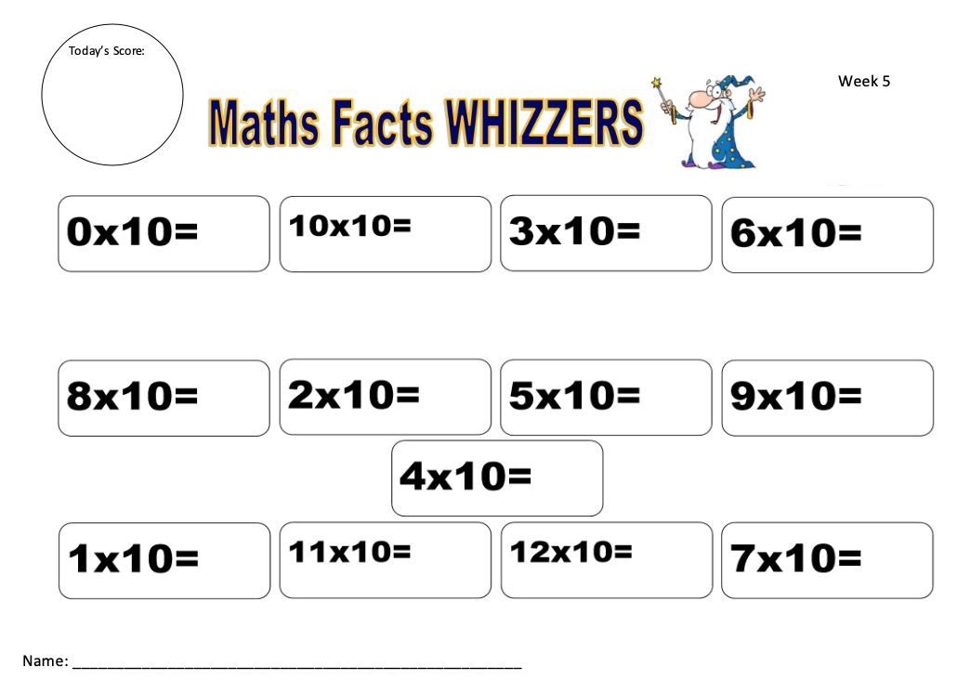
Sheet 1
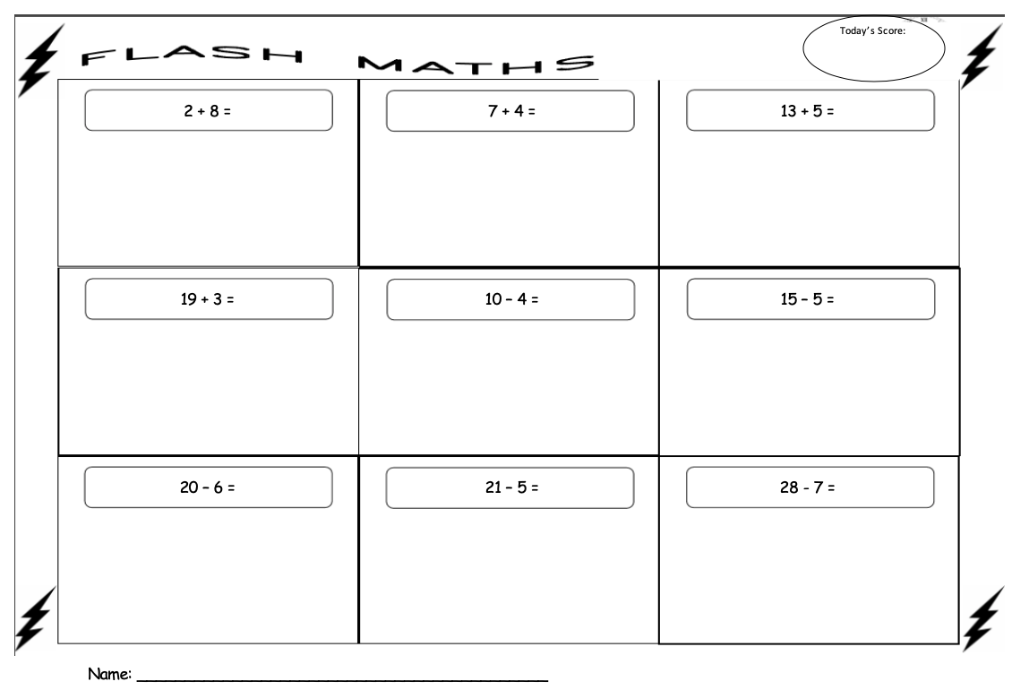
Sheet 2
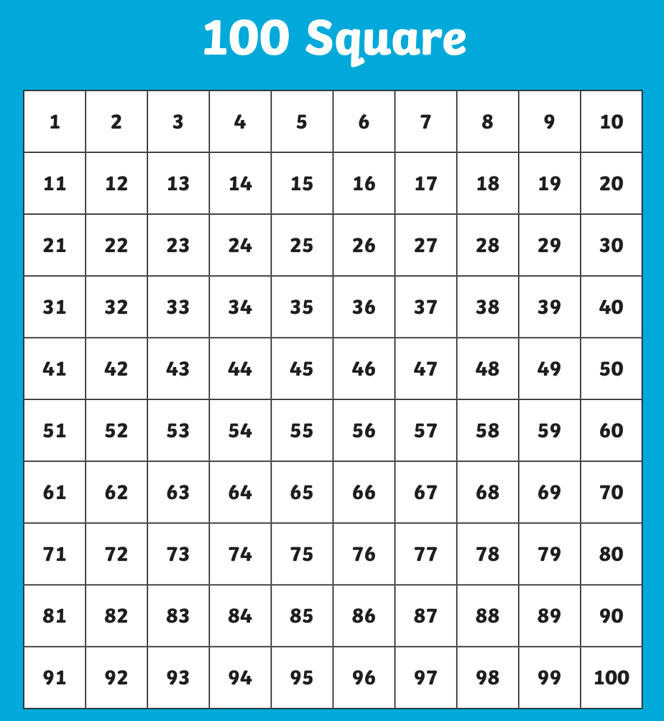
Sheet 3

Sheet 4

Qualitas P.E Links

Qualitas have provided some great P.E. videos to help get you active at home.

YouTube Links:

- Session 4 – Agility - https://www.youtube.com/watch?v=_4SNtCjN0o4
- Session 5 – Power - https://www.youtube.com/watch?v=PJAR1B1EVjk
- Session 6 – Reaction Speed - https://www.youtube.com/watch?v=ivTLii3Zdos
- Session 7 – Netball - https://www.youtube.com/watch?v=6pxLZPKHmFA&feature=youtu.be

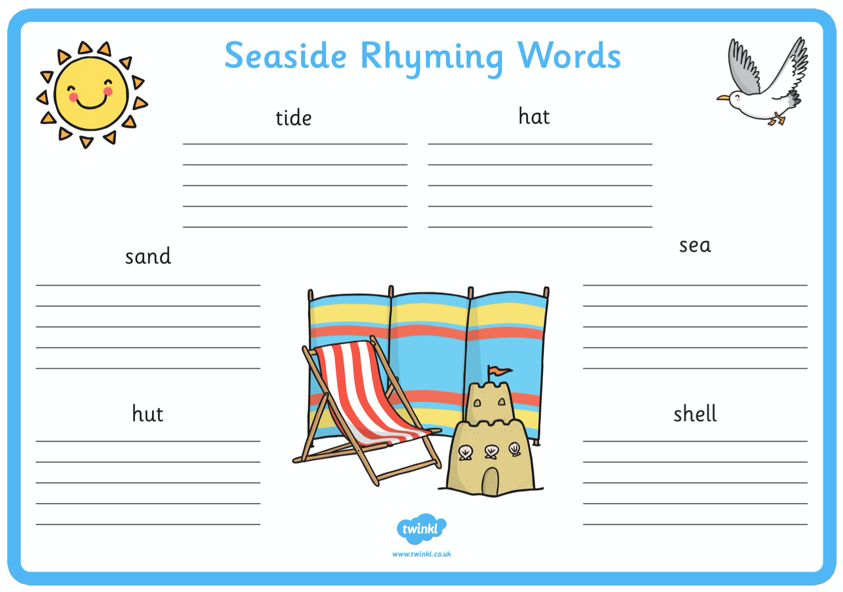
Sheet 5
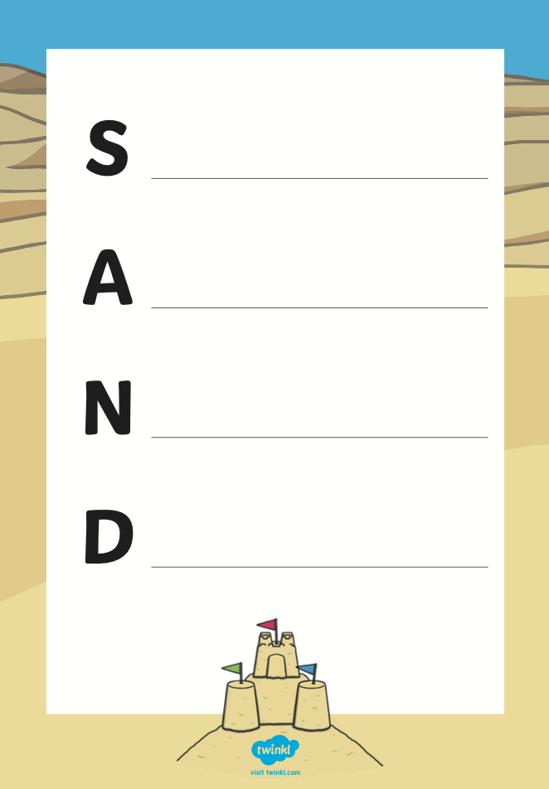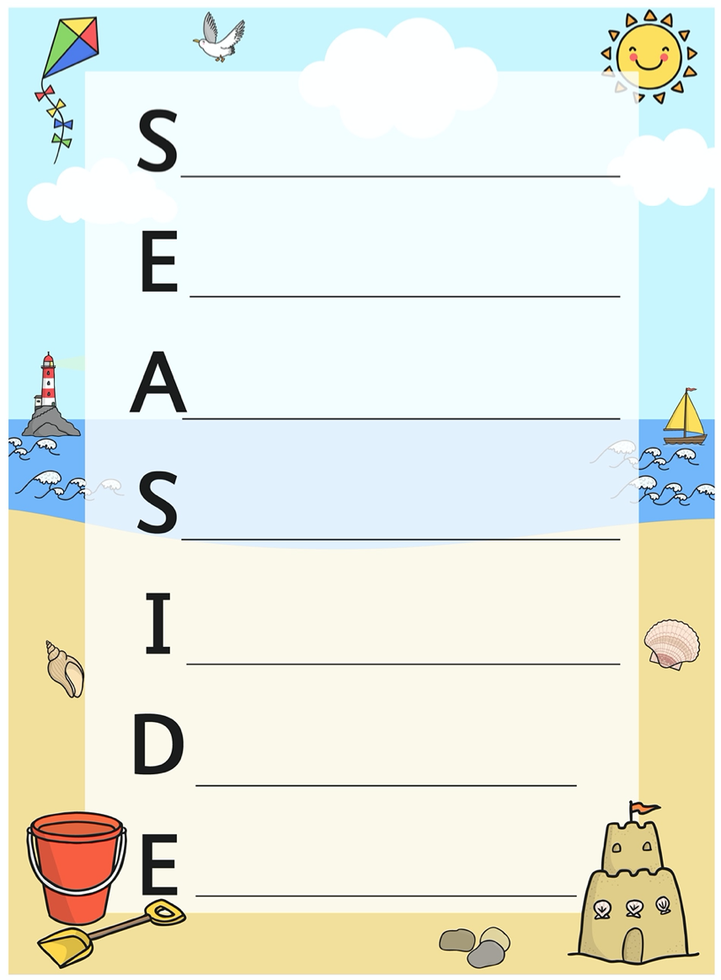
Sheet 6
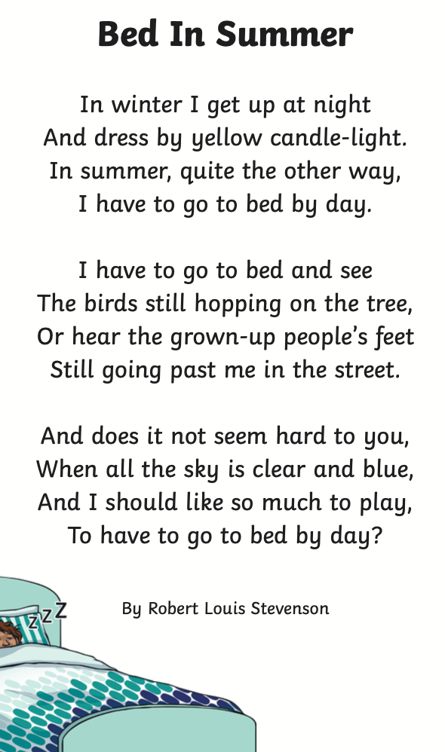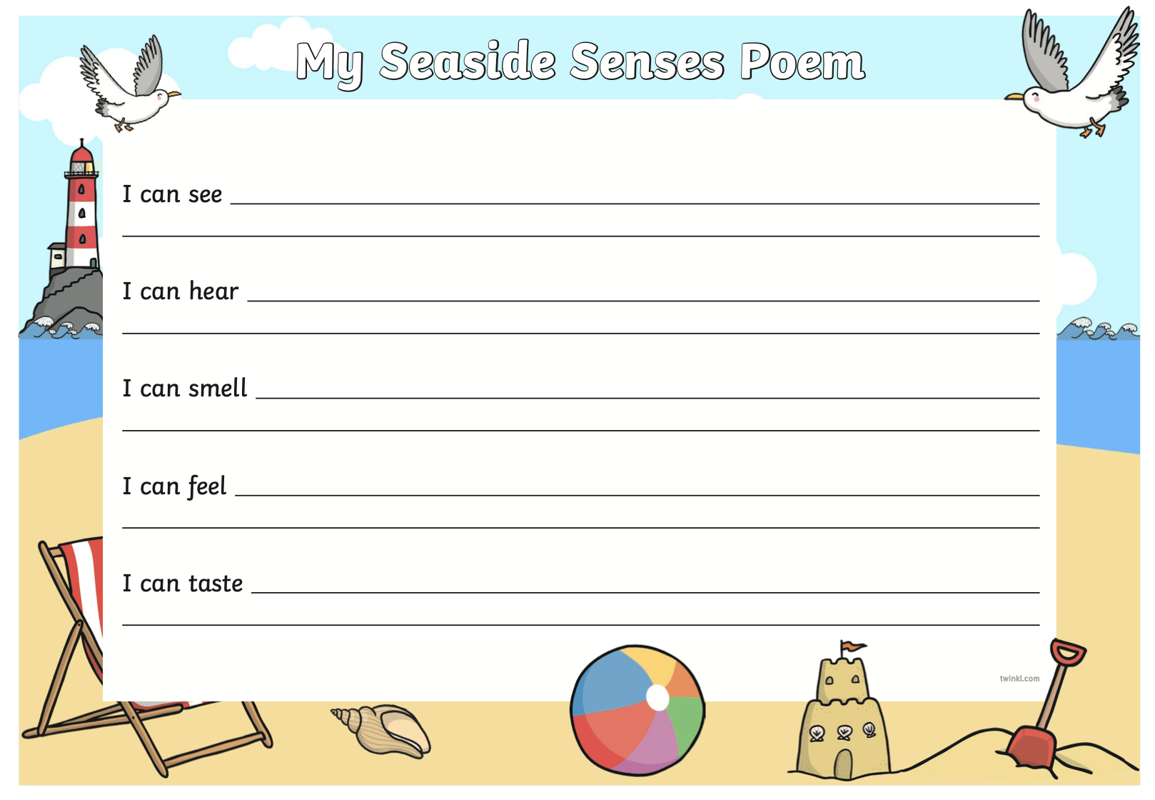
Sheet 7
Sheet 8

