Hello Year 1!

I hope you are all well and have enjoyed Week 1 of our new topic – ‘The Enchanted Woodland’.

Below is the overview for Week 2 – I really hope this gives you ideas for home learning. Please remember this is just a guide, feel free to interpret however you feel appropriate for your own home school!

As well as this overview, on the ML website & blog there is also a link to a phonics letter for you to read. It is all about online lessons for phonics. You can watch videos on their YouTube - https://www.youtube.com/channel/UCP_FbjYUP_UtldV2K_-niWw/videos

I have loved seeing your work on Purple Mash and the photos I have received. If you would like to send me a photo of home learning or any activities you are doing the best way is to email the school email - enquiries@marshlane.derbyshire.sch.uk - and this will then be passed on to me. If you could include if you would like it on the blog or not that would be great!
Any questions please comment on the blog or email me through 2Email on Purple Mash and I will get back to you asap.
I also wanted to say a big thank you to all Y1 parents – you are doing a fab job! I hope your ‘students’ are being superstars at home school.
Missing you all lots and lots.
Don’t forget to have fun!

Miss Marsland xx

(see overview below)
NAVIGATORS - YEAR 1 – Summer 1, Week 2
27/4/20
 | 9.00 – 9.15 | 9.15 – 9.35 | 9.35 – 10.00 | 10.00 – 10.35 | 10.35 – 10.50 | 10.55 – 11.55 | 12 - 1 | 12.55 – 2.55
MON | Practice spellings -  https://www.twinkl.co.uk/resource/t-l-4999-new-100-high-frequency-words-list | Phonics  Phase 3  https://new.phonicsplay.co.uk/resources/phase/3/sentence-substitution-ph3  Sentences Substitution:  1. Read the sentence.  2. Discuss the meaning.  3. Use the mouse to swap words to change the sentence.  4. Write down new sentences on paper or whiteboard.  5. Say your sentence out loud.  Login details:  Username: march20  Password: home | Reading – The Gruffalo  Link to story and questions on ML website & blog.  Read the story, discuss what happens, use actions from Literacy last week.  Discuss any words children are unsure of meaning. | Handwriting – (see more downloads and select precursive)  https://www.twinkl.co.uk/resource/t-l-4089-ks1-key-words-handwriting-practice-worksheets  OR  https://www.letterjoin.co.uk  Login to Letter-Join  Details on 2Email on Purple Mash. | B R E A K | Literacy –  Recap on The Gruffalo – can you remember your actions?  https://www.youtube.com/watch?v=s8sUPpPc8Ws  I have uploaded a new video to YouTube – this is a recipe video on how to make a Gruffalo Crumble.  I would love it if you could write a list of ingredients – remembering exciting adjectives and bullet points.  I would then like you to write a recipe (remembering everything we learnt about instructions when we made our own potions). The recipe can either follow my video (use the steps to help you) or you make up your own Gruffalo Crumble recipe and write the instructions for it.  Recap instructions - PowerPoint  In your instructions you will need:  -Numbers (1. 2. 3.)  - Time conjunctions (First, Second, Next, Finally)  - Write in the Present Tense  - Imperative Verbs (bossy words e.g. put, cut, mix, stir)  See Sheet 6 for recipe template. | L U N C H | 1 - 2  Maths –  Maths whizzers – 1 minute timer to answer 10 times table questions. See Sheet 1 below the overview.  Flash maths – addition & subtraction questions. See Sheet 2 below the overview. (Chn can use objects, number lines & numicon if available, I have also included a 100 square - see Sheet 3) |  |  | 2 - 3  OUTDOOR PE –  Get outside if you can. Remember to warm up and cool down.  Try Joe Wick’s 5 minute workouts on Twinkl.  This half term we were going to start a simplified version of the team game – Tag Rugby. If you have lots of people at home you could try and play with them – learn the rules here:  https://d2cx26qpfwuhvu.cloudfront.net/premier/wp-content/uploads/2016/09/23114412/STCO-Practical.pdf
TUES | Practice spellings | Phonics  Phase 3  https://new.phonicsplay.co.uk/resources/phase/3/sentence-substitution-ph3  Sentences Substitution:  1. Read the sentence.  2. Discuss the meaning.  3. Use the mouse to swap words to change the sentence.  4. Write down new sentences on paper or whiteboard.  5. Say your sentence out loud.  Login details:  Username: march20  Password: home | Reading – The Gruffalo  Link to story and questions on ML website & blog.  Read the again with and without actions. Spot different features used – speech, punctuation, adjectives etc. | Handwriting – carry on from Monday |  | Literacy –  Recap on The Gruffalo – can you remember your actions?  https://www.youtube.com/watch?v=s8sUPpPc8Ws  Continue writing your recipe. If finished, why not type it up on Purple Mash? I would love to see your recipes! I have set a template on 2dos for you to have a go at typing your recipe. |  | 1 - 2  RE: To understand why Ramadan is celebrated  Video all about Ramadan: https://www.bbc.co.uk/bitesize/topics/zpdtsbk/articles/zjc2bdm  Ramadan PowerPoint  Make some Ramadan crafts:  Moon & star decoration  OR  Ramadan lantern |  | 2 - 3  Science: To understand how to grow a flower  Thank you for watching my planting seeds video! I am so happy to hear so many of you have been planting your own seeds at home! Remember to keep checking your plants and watering them.  I have included below a cut & stick activity; you will need to put the images in order on how to grow a flower. You could also draw your own pictures instead.  (Sheet 5)  As well as the activity, go outside in your garden or on your daily walk and see what plants and flowers you spot – you could make a list or draw pictures of ones you see.  There are lots of plant & flower activities on Purple Mash too.
WED | Practice spellings | Phonics  Phase 3  https://new.phonicsplay.co.uk/resources/phase/3/sentence-substitution-ph3  Sentences Substitution:  1. Read the sentence.  2. Discuss the meaning.  3. Use the mouse to swap words to change the sentence.  4. Write down new sentences on paper or whiteboard.  5. Say your sentence out loud.  Login details:  Username: march20  Password: home | Reading – The Gruffalo  Link to story and questions on ML website & blog.  Read the story again and discuss the questions. How can you find the answers? Key words in the question. | Handwritng– carry on from Monday |  | Maths:  Starter - https://www.bbc.co.uk/teach/supermovers/ks1-maths-the-10-times-table-with-webster-the-spider/zm32cqt  White Rose Maths is the scheme we follow teaching Year 1 Maths – they have useful videos currently for home schooling: https://whiterosemaths.com/homelearning/year-1/  LI: To make arrays  This video explains to parents what arrays are.  Maths sheets are on the ML website and blog – see Wednesday’s worksheet for today’s activity.  Arrays – BBC video explaining what arrays are to children |  | 1 - 2  INDOOR PE –  Cosmic Yoga  https://www.youtube.com/user/CosmicKidsYoga  There are lots of different yoga videos. You might want to do one long one or lots of different short ones. | 2 – 2.30  Mindfulness – thanks to Muddy Puddles (& the lovely Sarah Seaman!)  Leaf Love  “Ask each child to find a leaf. At Muddy HQ, we believe that picking a leaf from a tree is fine as long as doing so will serve a purpose and we're not simply being destructive.  Then get the children to sit down and look carefully at the leaves that have been picked. Encourage the children to focus on the colours of the leaves and turn them over, observing the texts closely. Draw their attention to the lines running through the leaf. How does the leaf feel? Is it waxy or is it rough?  Get the children to swap leaves and notice any differences. Then ask the children to carefully brush their leaf against their face before moving onto their hands and feet. Ask the children to lift the leaf up into the sunlight and observe the light shining through it. Finish this activity by asking the children to take a deep breath, have a good smell of the leaf and smile.”  Reading – after taking time for mindfulness, if the weather is nice read a story together outside.  2.30 – 3  Music – Instruments  https://www.twinkl.co.uk/resource/t-mu-15-starry-eyed-stan-stans-band-music-powerpoint
THURS | Practice spellings -  https://www.twinkl.co.uk/resource/t-l-5155-new-year-1-common-exception-words | Phonics  FLASHCARDS  https://new.phonicsplay.co.uk/resources/phase/5/flashcards-time-challenge  Practice reading the sounds quickly.  Try flashcards for different phases and also all together. | Reading – The Gruffalo  Link to story and questions on ML website & blog.  Read the story again and write down answers to questions.  Write down answers- try to write in full sentences and use text to spell words correctly. | Handwriting – carry on from Monday |  | Maths:  Starter - https://www.bbc.co.uk/teach/supermovers/ks1-maths-the-2-times-table-with-bridget-the-lioness/zrrx92p  White Rose Maths is the scheme we follow teaching Year 1 Maths – they have useful videos currently for home schooling: https://whiterosemaths.com/homelearning/year-1/  (see video: summer term week 1 making doubles)  LI: To make doubles  Maths sheets are on the ML website and blog – see Thursday’s sheet for today’s activity. |  | 1 – 1.30  Reading – choose a book to read and record in reading record. | 1.30– 3  Art –  Enchanted Forest Small World Project: Can you choose a good place to become the setting for your ‘Enchanted Forest’ small world? It could be an area of your garden, a shoebox, a planter, a sand tray…anything goes! Make a secret door to let the enchanted characters in and keep the baddies out! Position it in your small world.  Mrs Williams x
FR I | Practice spellings | Phonics  FLASHCARDS  https://new.phonicsplay.co.uk/resources/phase/5/flashcards-time-challenge  Practice reading the sounds quickly.  Try flashcards for different phases and also all together. | Reading – choose a book to read and record in reading record. | Handwriting – carry on from Monday |  | Maths:  Starter - https://www.bbc.co.uk/teach/supermovers/ks1-maths-division-with-mighty-red/zrh9scw  White Rose Maths is the scheme we follow teaching Year 1 Maths – they have useful videos currently for home schooling: https://whiterosemaths.com/homelearning/year-1/  (see video: summer term week 1 grouping)  LI: To make equal groups  Maths sheets are on the ML website and blog – see both of Friday’s worksheets for today’s activity. |  | 1 - 2  Computing:  Purple Mash – see 2dos – choose an activity! | 2 - 3  Golden Time  Ideas:  - Watch The Gruffalo: https://www.bbc.co.uk/iplayer/episode/b00pk64x/the-gruffalo  - Colour in woodland pictures: https://www.twinkl.co.uk/resource/t-tp-5466-woodland-animal-colouring-pages  - Play a boardgame  - Get outside – imagine you’re in an enchanted woodland!

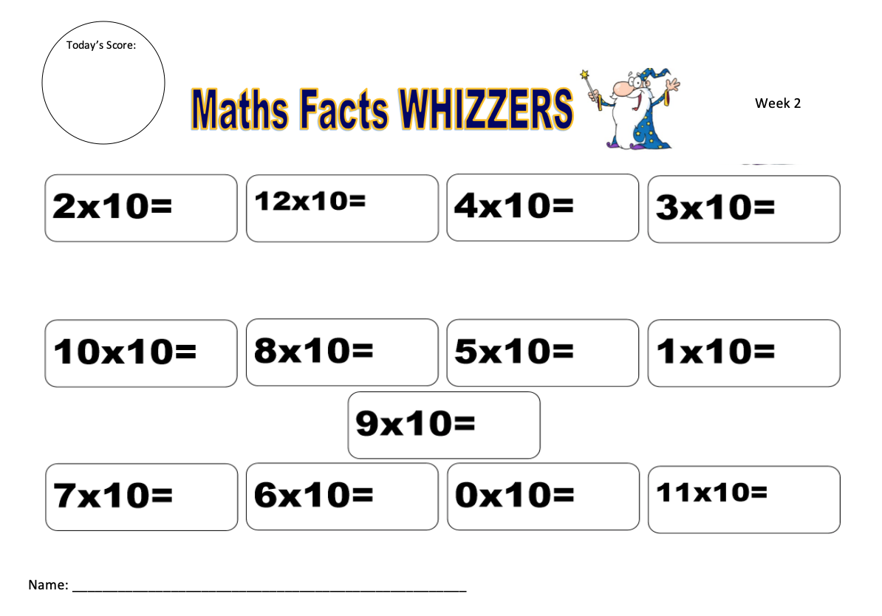
Sheet 1
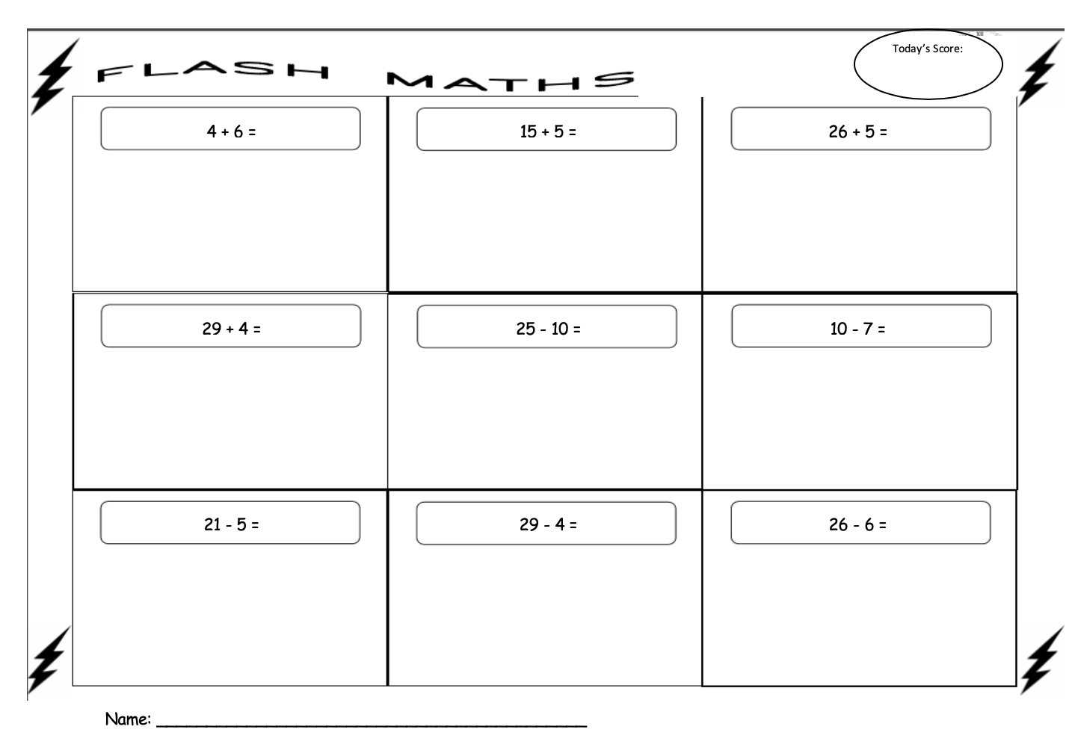
Sheet 2
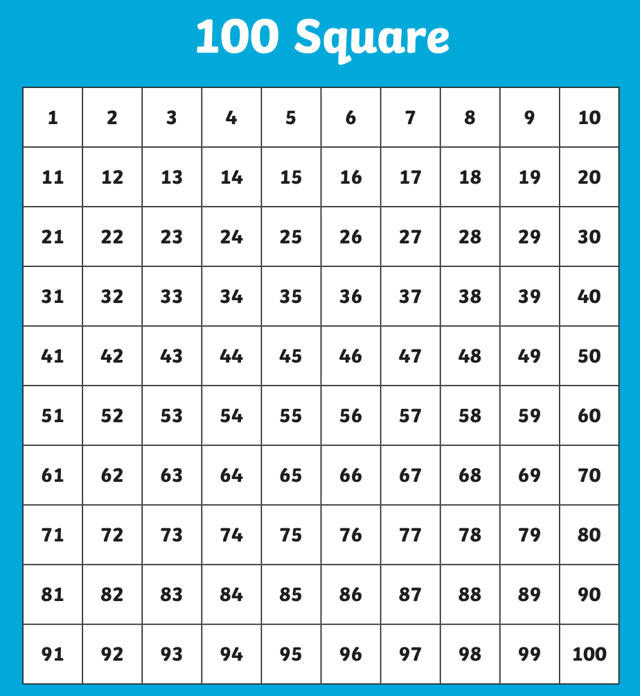
Sheet 3

Sheet 4

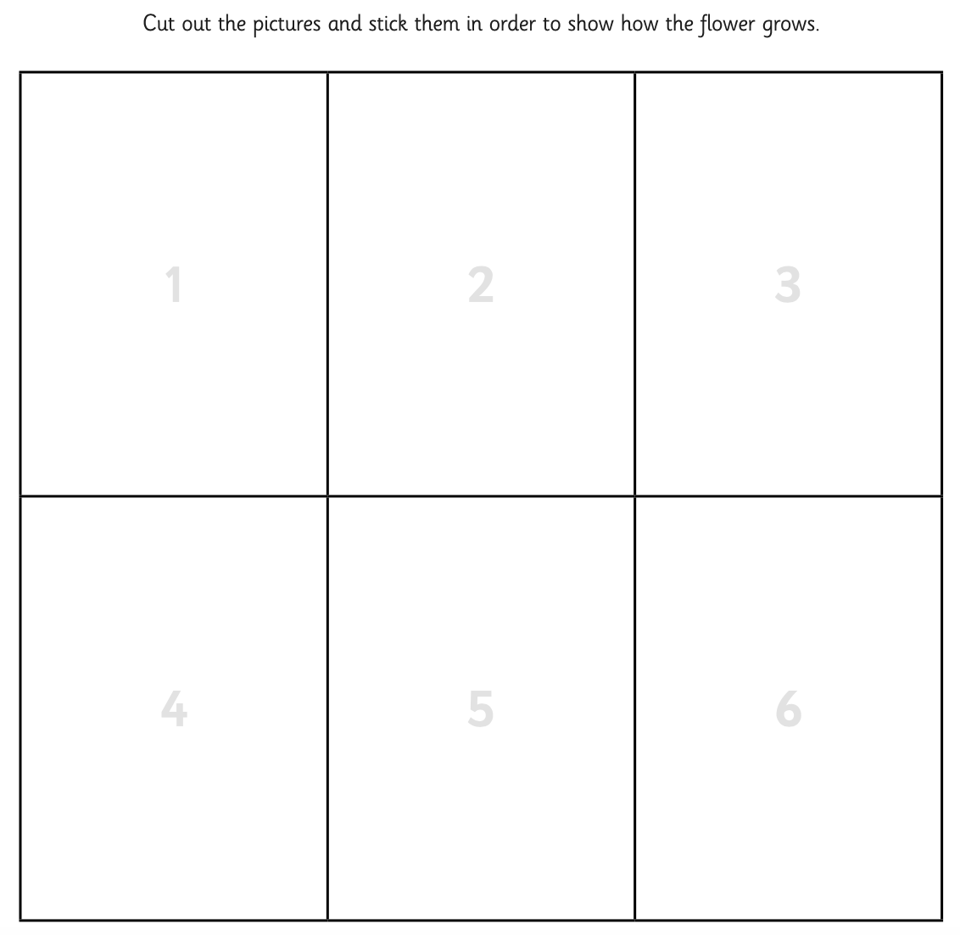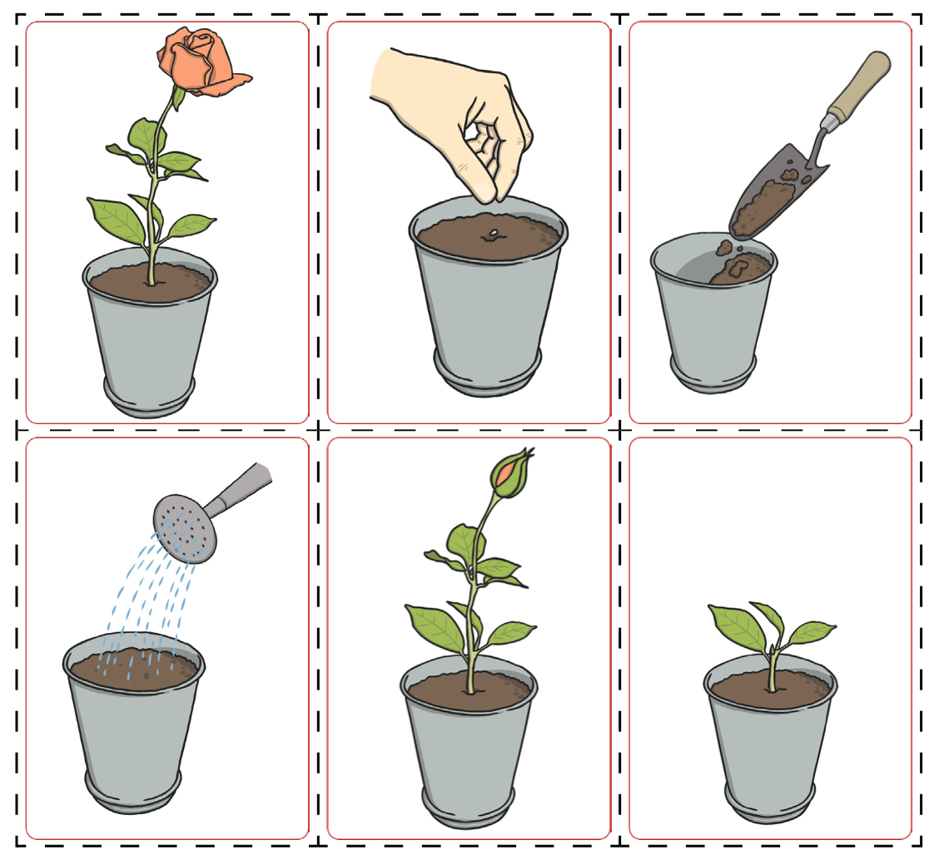
Sheet 5 - a
Sheet 5 - b
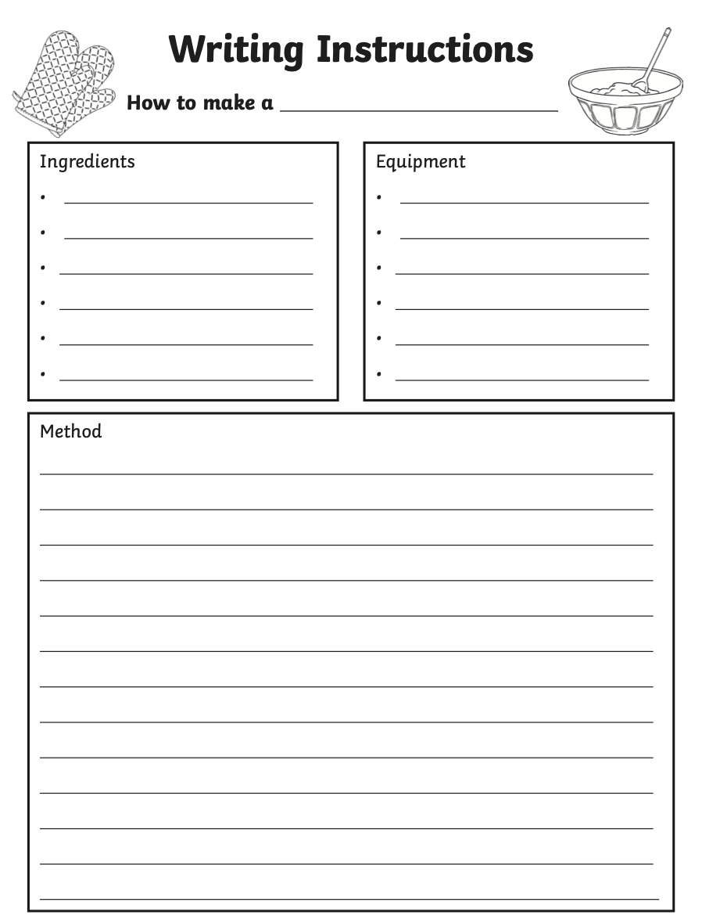
Sheet 6

