Hello Year 1!

We are already at Week 3 of Summer 1 and we are now in May! Well done, you are all doing fantastic.

I am loving seeing all of your hard work. I have seen work from almost all of you on Purple Mash, I am really glad this is proving to be a fun learning resource at home and a good way of communicating on 2Email. Thank you to those children who have sent in photos, they bring a big smile to my face and any photos I receive I will upload to the blog for friends to see as well.

If you would like to send me a photo of home learning or any activities you are doing the best way is to email the school email - enquiries@marshlane.derbyshire.sch.uk - and this will then be passed on to me. If you do email photos I will be posting them to the blog, if you don’t want them on the blog then please let me know.
Any questions please comment on the blog or email me through 2Email on Purple Mash and I will get back to you asap.
A note to parents: Thank you Y1 parents! You are all doing an amazing job. Remember, these overviews are just to give an idea of what children would be learning about if schools were open. A few parents have messaged to say they’re doing a lot of reading and life skills, that is fab! Any and all work at home is brilliant, learning outside is wonderful too.
Missing you all lots and lots.
Don’t forget to have fun!

Miss Marsland xx

(see overview below)
NAVIGATORS - YEAR 1 – Summer 1, Week 3
4/5/20
 | 9.00 – 9.15 | 9.15 – 9.35 | 9.35 – 10.00 | 10.00 – 10.35 | 10.35 – 10.50 | 10.55 – 11.55 | 12 - 1 | 12.55 – 2.55
MON | Practice spellings – focus on ‘tch’  https://www.twinkl.co.uk/resource/t-l-52881-year-1-spelling-practice-ch-sound-spelt-tch-homework-activity-sheet | Phonics  Phase 5  https://new.phonicsplay.co.uk/resources/phase/3/sentence-substitution-ph3  Phase 5 Reading Robots (Phonics Play)  -Read the word on the robot (real and nonsense words)  -Can you explain what the word means?  -Extension – can you use the word in a sentence and write it down?  Login details:  Username: march20  Password: home  OR  Online lessons with Letters & Sounds | Reading – Starry Eyed Stan  https://www.twinkl.co.uk/resource/t-l-54487-starry-eyed-stan-differentiated-reading-comprehension-activity  Read the story, discuss what happens.  Discuss any words children are unsure of meaning. | Handwriting – (see more downloads and select precursive)  https://www.twinkl.co.uk/resource/t-l-4089-ks1-key-words-handwriting-practice-worksheets  OR  https://www.letterjoin.co.uk  Login to Letter-Join  Details on 2Email on Purple Mash. | B R E A K | Literacy – To spot features of a character description  Recap on The Gruffalo – can you remember your actions?  https://www.youtube.com/watch?v=s8sUPpPc8Ws  Today I would like you to look at the description of The Gruffalo – I mention it in the recipe video - Miss Marsland Gruffalo Crumble Video.  Can you spot the different features used e.g. adjectives.  Can you re-write the description using different adjectives?  Start an amazing adjective jar, write down different exciting adjectives that you can use later when writing your own character description! | L U N C H | 1 - 2  Maths –  Maths whizzers – 1 minute timer to answer 10 times table questions. See Sheet 1 below the overview.  Flash maths – addition & subtraction questions. See Sheet 2 below the overview. (Chn can use objects, number lines & numicon if available, I have also included a 100 square - see Sheet 3) |  |  | 2 - 3  OUTDOOR PE –  Get outside if you can. Remember to warm up and cool down.  Try Joe Wick’s 5 minute workouts on Twinkl.  This half term we were going to start a simplified version of the team game – Tag Rugby. If you have lots of people at home you could try and play with them – learn the rules here:  https://d2cx26qpfwuhvu.cloudfront.net/premier/wp-content/uploads/2016/09/23114412/STCO-Practical.pdf
TUES | Practice spellings | Phonics  Phase 5  https://new.phonicsplay.co.uk/resources/phase/3/sentence-substitution-ph3  Phase 5 Reading Robots (Phonics Play)  -Read the word on the robot (real and nonsense words)  -Can you explain what the word means?  -Extension – can you use the word in a sentence and write it down?  Login details:  Username: march20  Password: home  OR  Online lessons with Letters & Sounds | Reading – Starry Eyed Stan  Read the story again. Spot different features used – speech, punctuation, adjectives etc. | Handwriting – carry on from Monday |  | Literacy –  Recap on The Gruffalo – can you remember your actions?  https://www.youtube.com/watch?v=s8sUPpPc8Ws  Today I would like you to create your own creature to live in your enchanted woodland that you have been making in art.  Think about what they look like, their personality, where they live.  First draw your creature and label with adjectives and nouns.  Then can you make your creature? Use lego, play-doh, clay – anything you have at home!  You could even paint your creature using paint at home or on Purple Mash! |  | 1 - 2  Music – Make your own instruments & rhythm  https://www.twinkl.co.uk/resource/starry-eyed-stan-making-musical-instruments-powerpoint-and-activity-pack-t-or-1309  https://www.twinkl.co.uk/resource/starry-eyed-stan-making-music-powerpoint-and-activity-pack-t-or-1302  Linked to the reading this week – Starry Eyed Stan  (this will continue for the next few weeks) |  | 2 - 3  Science: To identify and describe different common flowers, plants & trees  I have seen lots of work for Science, labelling and writing about plants on Purple Mash which is brilliant! I would love for you to create some artwork to help identify and describe different flowers, plants and trees.  There are some great nature art ideas here:  https://www.teachprimary.com/learning_resources/view/ks1-and-ks2-art-be-inspired-by-nature  I love the shadow drawings, particularly if it’s a nice sunny day. After drawing the plant’s shadow you could then discuss the plant’s features and describe them.  Any art you do, please feel free to send me photos! I look forward to seeing what you have been up to.
WED | Practice spellings | Phonics  Phase 5  https://new.phonicsplay.co.uk/resources/phase/3/sentence-substitution-ph3  Phase 5 Reading Robots (Phonics Play)  -Read the word on the robot (real and nonsense words)  -Can you explain what the word means?  -Extension – can you use the word in a sentence and write it down?  Login details:  Username: march20  Password: home  OR  Online lessons with Letters & Sounds | Reading – Starry Eyed Stan  Read the story again and discuss the questions. How can you find the answers? Key words in the question. | Handwritng– carry on from Monday |  | Literacy –  Recap on The Gruffalo – can you remember your actions?  https://www.youtube.com/watch?v=s8sUPpPc8Ws  Today I would like you to think about the setting your creature lives in. You may want to use your enchanted woodland from art.  I would like you to draw your setting and label with adjectives and nouns. Try to use your Science knowledge, can you include some plants, flowers or trees that you have learnt about?  You could even draw your character in your setting. |  | 1 - 2  INDOOR PE –  Cosmic Yoga  https://www.youtube.com/user/CosmicKidsYoga  There are lots of different yoga videos. You might want to do one long one or lots of different short ones. | 2 – 2.30  Mindfulness – thanks to Muddy Puddles (& the lovely Sarah Seaman!)  Petal Power  “For this activity you’ll need some petals. You can buy some petals at a shop but we recommend getting children to pick them from your area. Pick a petal. You can make this a seasonal activity by picking flowers relevant to each season. Ask the children to silently enjoy the smell of petals. What colours are the petals? How do the petals feel in their hands?  Get the children to rub the petals together and watch as the water seeps out of them. Encourage the children to focus their minds on the change of colour, shape and texture of the petal when they squeeze it Hand the children a bowl and let them put the petals into it. Then give the children some time to play with them and make perfumes or potions. Finish this activity with a deep breath and a smile!”  Reading – after taking time for mindfulness, if the weather is nice read a story together outside.  2.30 – 3  Phonics  Extra phonics – try to make your phonics active! Make up your own phonics games around the house or garden. You could hide flashcards or tricky words. Make up your own song and dance using phase 3 or phase 5 sounds.  Sing and dance along –  https://www.youtube.com/watch?v=R087lYrRpgY  https://www.youtube.com/watch?v=3NOzgR1ANc4
THURS | Practice SPaG -  https://www.twinkl.co.uk/resource/t2-e-4950-year-1-adjectives-suffixes-er-and-est-activity | Phonics  FLASHCARDS  https://new.phonicsplay.co.uk/resources/phase/5/flashcards-time-challenge  Practice reading the sounds quickly.  Try flashcards for different phases and also all together.  OR  Online lessons with Letters & Sounds | Reading – Starry Eyed Stan  Read the story again and write down answers to questions.  Write down answers- try to write in full sentences and use text to spell words correctly. | Handwriting – carry on from Monday |  | Maths:  Starter - https://www.bbc.co.uk/teach/supermovers/ks1-maths-fractions-with-joe-tracini/zmjy2sg  White Rose Maths is the scheme we follow teaching Year 1 Maths – they have useful videos currently for home schooling: https://whiterosemaths.com/homelearning/year-1/  LI: To find a half  Maths sheets are on the ML website and blog – see Thursday’s sheet for today’s activity.  You can try finding a half using objects at home – half toys in a pile, half a cake, half a pizza etc. |  | 1 – 1.30  Reading – choose a book to read and record in reading record. | 1.30– 3  Art –  Enchanted Forest Small World Project: Can you decorate a plant pot and add it to your small world so that you can grow a real plant to be part of it? You could make it look like a house or den for one of your characters.  Mrs Williams x
FR I | Practice SPaG -  https://www.twinkl.co.uk/resource/t2-e-4950-year-1-adjectives-suffixes-er-and-est-activity | Phonics  FLASHCARDS  https://new.phonicsplay.co.uk/resources/phase/5/flashcards-time-challenge  Practice reading the sounds quickly.  Try flashcards for different phases and also all together.  OR  Online lessons with Letters & Sounds | Reading – choose a book to read and record in reading record. | Handwriting – carry on from Monday |  | Starter - https://www.bbc.co.uk/teach/supermovers/ks1-maths-fractions-with-joe-tracini/zmjy2sg  White Rose Maths is the scheme we follow teaching Year 1 Maths – they have useful videos currently for home schooling: https://whiterosemaths.com/homelearning/year-1/  LI: To find a half  Maths sheets are on the ML website and blog – see Friday’s sheet for today’s activity.  You could try using a mirror to see half & doubles.  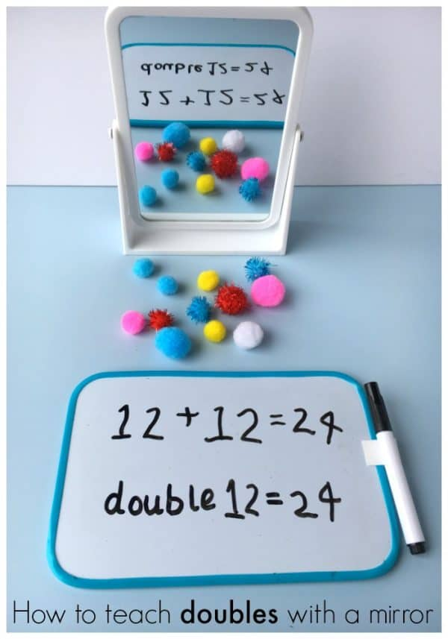 |  | 1 - 2  Computing:  Purple Mash – see 2dos – choose an activity! | 2 - 3  Golden Time  Ideas:  - Watch the Gruffalo: https://www.bbc.co.uk/iplayer/episode/b00pk64x/the-gruffalo  - Colour in woodland pictures: https://www.twinkl.co.uk/resource/t-tp-5466-woodland-animal-colouring-pages  - Play a boardgame  - Get outside – imagine you’re in an enchanted woodland!  - Have fun and enjoy your weekend

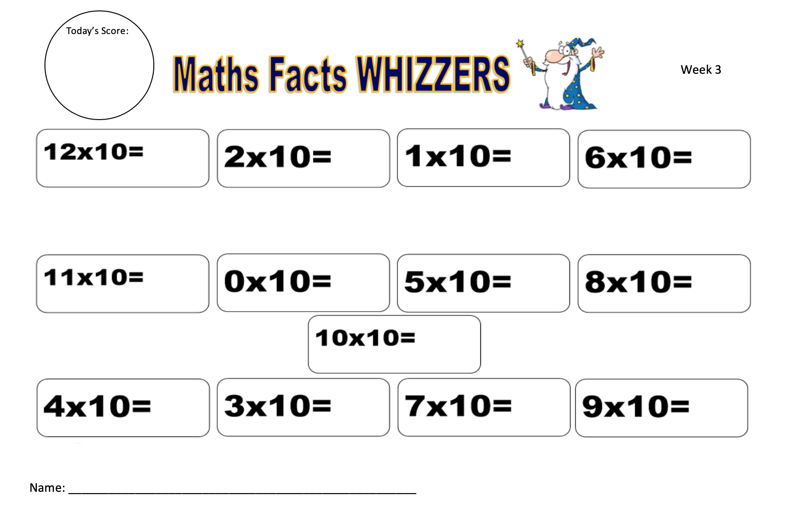
Sheet 1
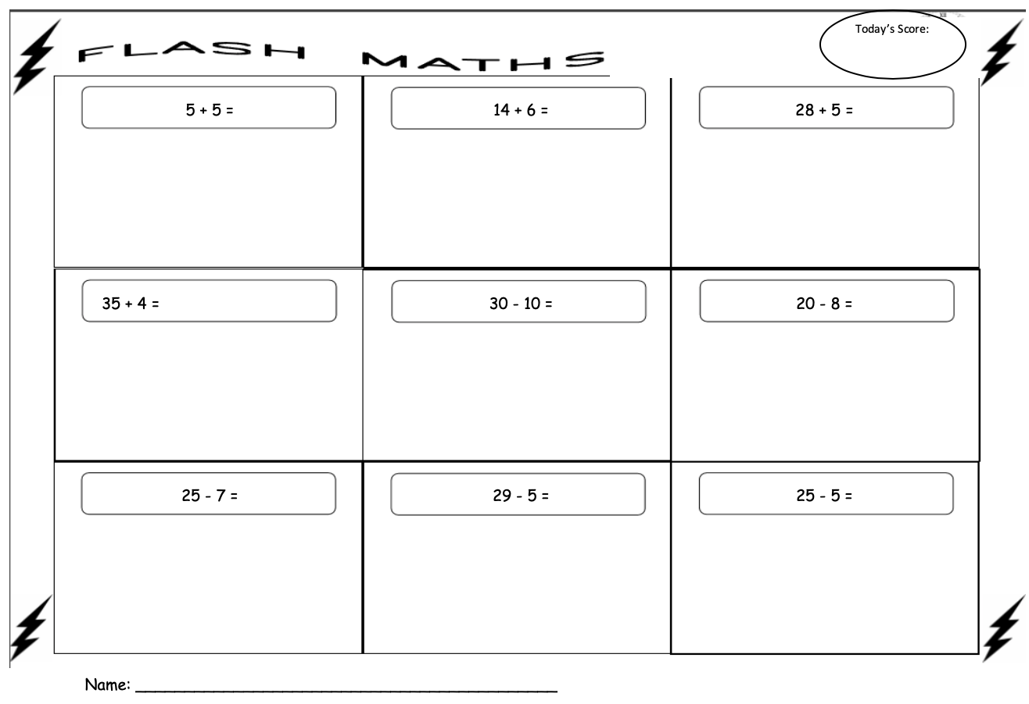
Sheet 2
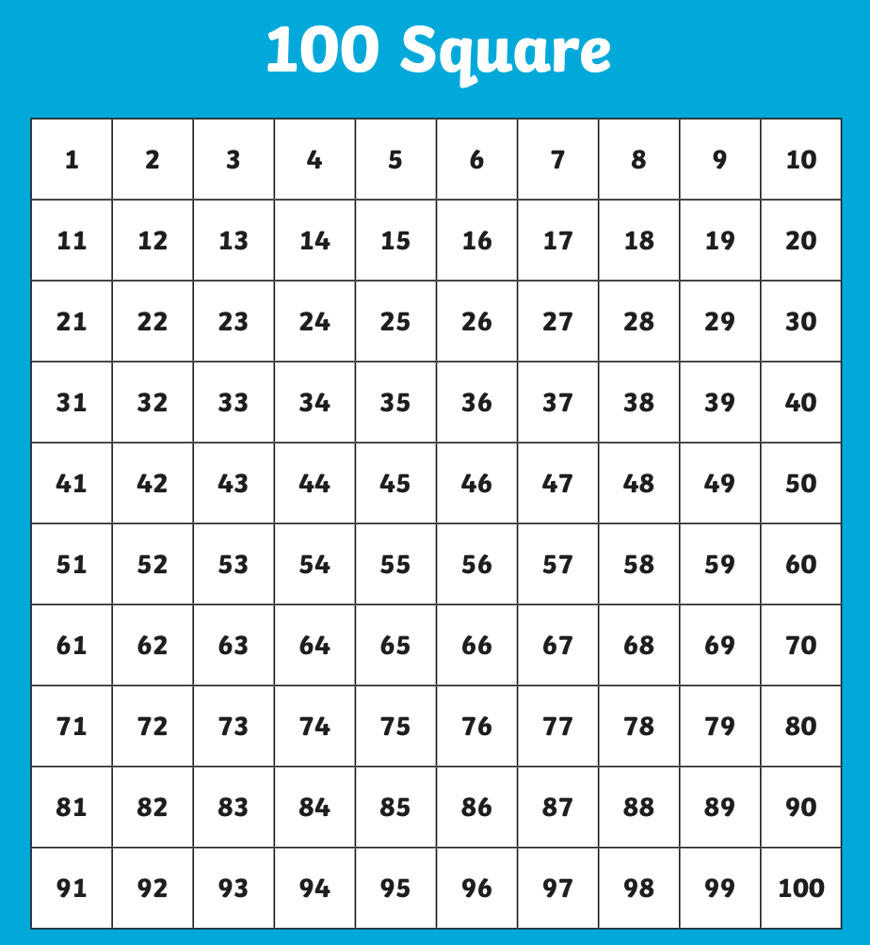
Sheet 3

Sheet 4

