Hello Year 1!

I hope you all had a lovely half term and were able to get outside and enjoy the beautiful weather! Our new topic for Summer 2 is The Wild West!
I have uploaded some activities and resources on the blog to help support your home learning for the new topic.
So grab your cowboy hat and boots, round up your horse and dust away the tumbleweeds because our Wild West adventure is about to begin! Yee-haw!

As always the overview below is just to give you an insight into some activities we would be doing in school – with the weather being so lovely it would be great to try and move your learning outside! You could practice handwriting with chalk on a pavement or patio, you could hide some tricky words around your garden to find and practice saying and spelling, you could even move your ‘classroom’ outside to complete writing or maths!

Have fun!
Miss Marsland xx

(see overview below)
NAVIGATORS - YEAR 1 – Summer 2, Week 1
1/6/20
 | 9.00 – 9.15 | 9.15 – 9.35 | 9.35 – 10.00 | 10.00 – 10.35 | 10.35 – 10.50 | 10.55 – 11.55 | 12 - 1 | 12.55 – 2.55
MON | INSET DAY |  |  |  | B R E A K | INSET DAY | L U N C H | INSET DAY
TUES | SPELLINGS –  (See sheet 5) Y1 common exception words – word search | Phonics  Online lessons with Letters & Sounds  OR  Phonics Play:  https://new.phonicsplay.co.uk  Login details:  Username: march20  Password: home | Reading –  Login to Oxford Owl:  https://www.oxfordowl.co.uk/  My class login – Username: navigators  Password:  Pass  There are a selection of different books from different reading schemes – some books have questions to discuss and answer and some have a phonics focus. | Handwriting  https://www.letterjoin.co.uk  Login to Letter-Join  Details on 2Email on Purple Mash. |  | Literacy – To label different characters with exciting adjectives and verbs  Starter – watch the opening scene of Toy Story 3 think about the different characters – how can you describe them? What are they doing?  Today you are going to label a picture of Woody with exciting adjectives and verbs in the past tense.  (See Sheet 6 for example)  (See Sheet 7 for picture, or you can draw your own) |  | 1 - 2  Music – Learn the cowboy song!  https://www.youtube.com/watch?v=WRXZwyDwSmg  Remember to sing with lots of expression and try to learn the words! |  | 2 - 3  SCIENCE  To grow your own rainbow  (See sheet 9)  For Science today you are going to grow your own rainbow! Follow the instructions – can you predict what might happen?  Can you reflect on what went well and how you could improve your rainbow?
WED | SPELLINGS –  (See sheet 5) Y1 common exception words – word search | Phonics  Online lessons with Letters & Sounds  OR  Phonics Play:  https://new.phonicsplay.co.uk  Login details:  Username: march20  Password: home | Reading –  Login to Oxford Owl:  https://www.oxfordowl.co.uk/  My class login – Username: navigators  Password:  Pass | Handwriting  https://www.letterjoin.co.uk  Login to Letter-Join  Details on 2Email on Purple Mash. |  | Literacy – To label different characters with exciting adjectives and verbs  Starter – watch the opening scene of Toy Story 3 think about the different characters – how can you describe them? What are they doing?  Today you are going to label a picture of Mr Potato Head with exciting adjectives and verbs in the past tense.  (See Sheet 6 for example)  (See Sheet 8 for picture, or you can draw your own) |  | 1 - 2  INDOOR PE –  Cosmic Yoga  https://www.youtube.com/user/CosmicKidsYoga  There are lots of different yoga videos. You might want to do one long one or lots of different short ones. | 2 – 2.30  OUTDOOR ACTIVITY –  I have uploaded on to the blog a variety of different outdoor activities to try at home.  Choose one to try!  Reading – Read a story outside  2.30 – 3  Phonics  Extra phonics – try to make your phonics active! Make up your own phonics games around the house or garden. You could hide flashcards or tricky words. Make up your own song and dance using phase 3 or phase 5 sounds.  Sing and dance along –  https://www.youtube.com/watch?v=R087lYrRpgY  https://www.youtube.com/watch?v=3NOzgR1ANc4
THURS | SPELLINGS –  (See sheet 5) Y1 common exception words – word search | Phonics  Online lessons with Letters & Sounds  OR  Phonics Play:  https://new.phonicsplay.co.uk  Login details:  Username: march20  Password: home | Reading –  Login to Oxford Owl:  https://www.oxfordowl.co.uk/  My class login – Username: navigators  Password:  Pass | Handwriting  https://www.letterjoin.co.uk  Login to Letter-Join  Details on 2Email on Purple Mash. |  | Maths:  White Rose Maths is the scheme we follow teaching Year 1 Maths – they have useful videos currently for home schooling: https://whiterosemaths.com/homelearning/year-1/  LI: To describe turns and create a treasure map  Starter -  PowerPoint on position and direction to introduce learning intention.  Complete the worksheet on the MLPS website and blog for Thursday.  Extension – create your own treasure map and use language learnt to describe how to get to the treasure! |  | 1 – 1.30  Reading – choose a book to read and record in reading record. | 1.30– 3  Art –  Create your own rainbow wind chime  Can you create your own rainbow wind chime? (see sheet 10) Follow the instructions or use your own resources. Think about what might make a noise in the wind.
FR I | SPELLINGS –  (See sheet 5) Y1 common exception words – word search | Phonics  Online lessons with Letters & Sounds  OR  Phonics Play:  https://new.phonicsplay.co.uk  Login details:  Username: march20  Password: home | Reading –  Login to Oxford Owl:  https://www.oxfordowl.co.uk/  My class login – Username: navigators  Password:  Pass | Handwriting  https://www.letterjoin.co.uk  Login to Letter-Join  Details on 2Email on Purple Mash. |  | LI: To describe the position of different pictures/objects  Starter -  https://www.bbc.co.uk/teach/supermovers/ks1-maths-position-&-direction/zhh9scw  Complete the worksheets on the MLPS website and blog for Friday. |  | 1 - 2  Computing:  Purple Mash – see 2dos – choose an activity! | 2 - 3  Golden Time  Ideas:  - Watch Toy Story or another Cowboy/ Wild West film or TV show  - Colour in cowboy pictures or draw your own!  - Play a boardgame  - Get outside – imagine you’re in the Wild West!  - Have fun and enjoy your weekend

Sheet 4

Qualitas P.E Links

Qualitas have provided some great P.E. videos to help get you active at home.

YouTube Links:

- Session 4 – Agility - https://www.youtube.com/watch?v=_4SNtCjN0o4
- Session 5 – Power - https://www.youtube.com/watch?v=PJAR1B1EVjk
- Session 6 – Reaction Speed - https://www.youtube.com/watch?v=ivTLii3Zdos
- Session 7 – Netball - https://www.youtube.com/watch?v=6pxLZPKHmFA&feature=youtu.be

Sheet 5
Sheet 6

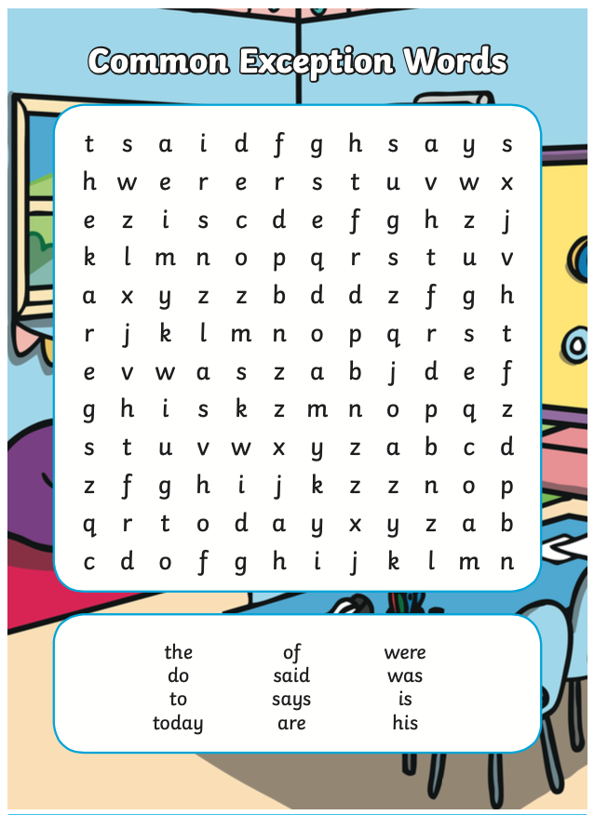
Sheet 5 - Tuesday
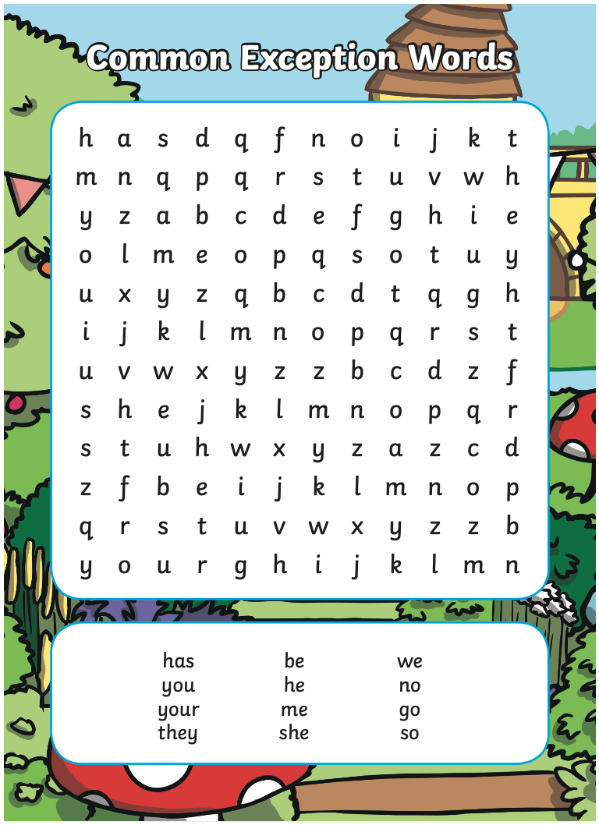
Sheet 5 - Wednesday

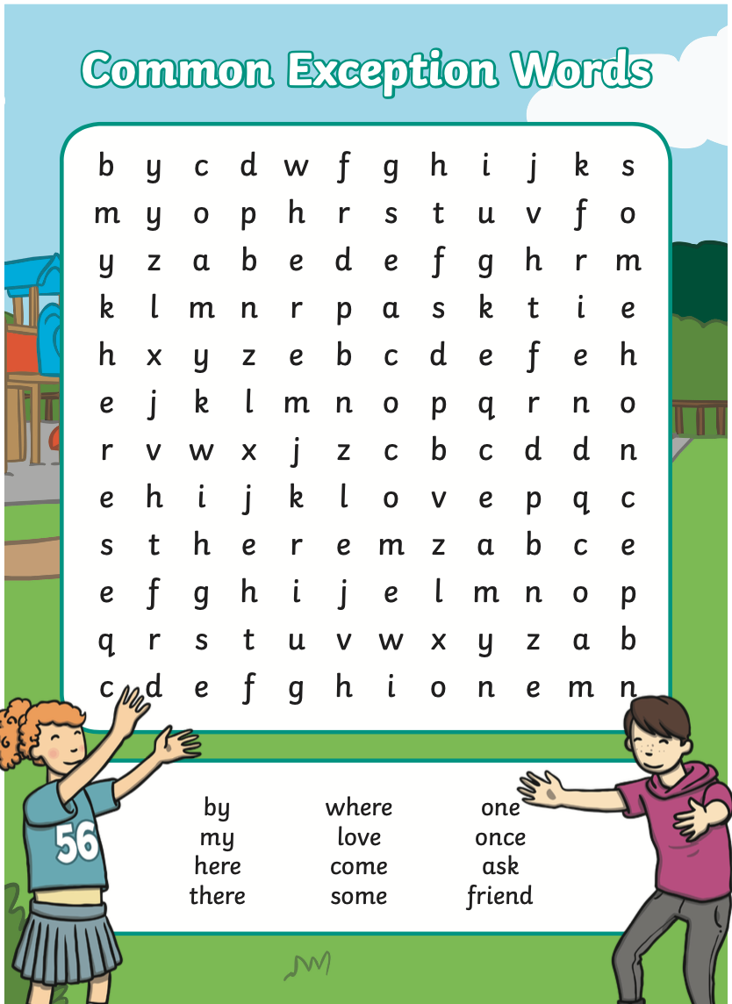
Sheet 5 - Thursday

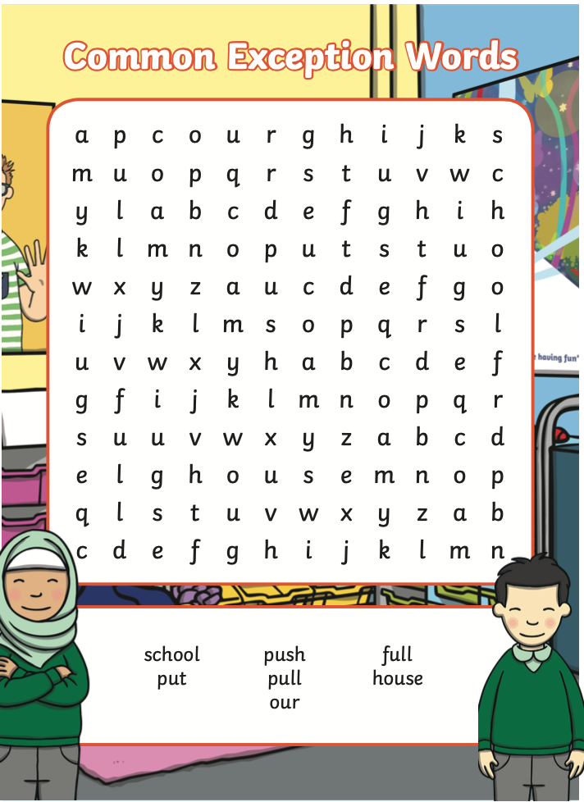
Sheet 5 - Friday

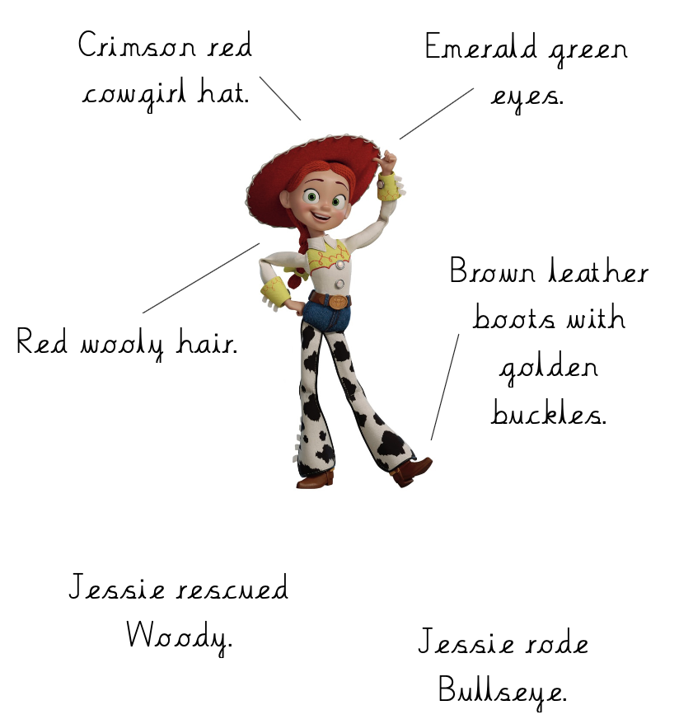
Sheet 6 – Label example

Sheet 7 – Label Woody

Sheet 8 – Label Mr Potato Head
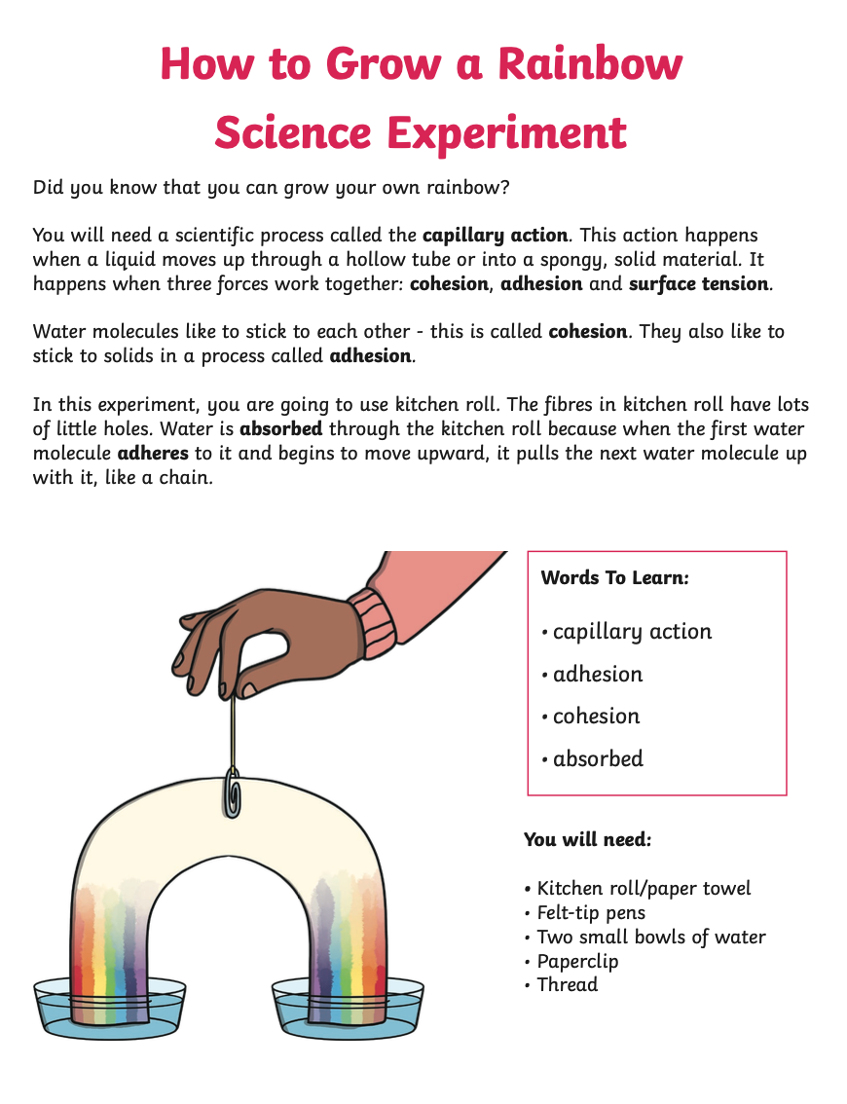

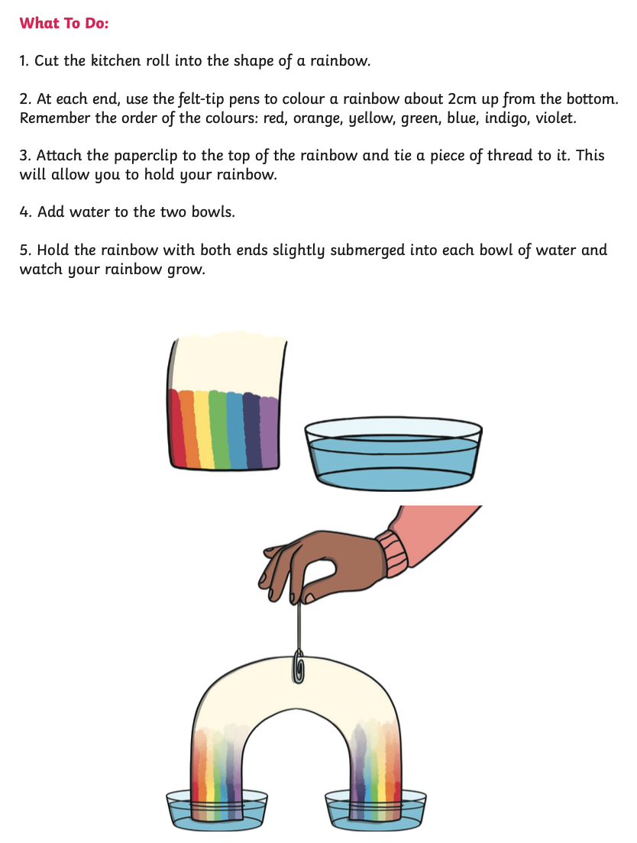
Sheet 9 – Rainbow
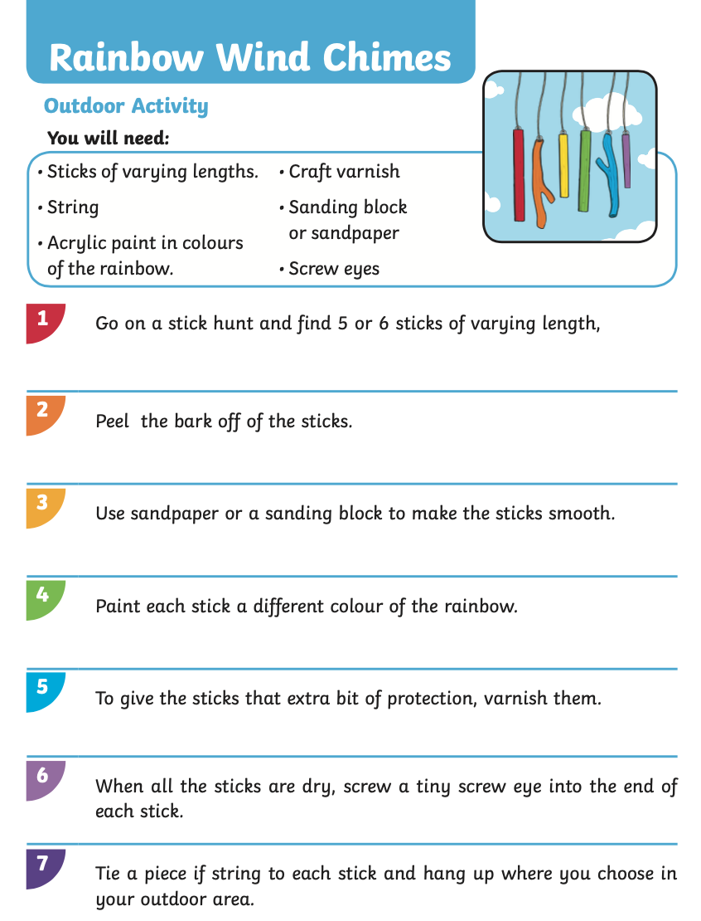
Sheet 10 – Wind Chime

