Hello Year 1!

I hope you are all really well! Missing you lots but hopefully see some of you this week!

As always, the overview below is just to give you an insight into some activities we would be doing in school but feel free to complete different activities, life skills etc.

Any questions, comments or photos please don’t hesitate to get in touch via the blog, Purple Mash or the school email.

I will continue to upload home learning but it may be in a slightly different format.

Have fun!
Miss Marsland xx

(see overview below)
NAVIGATORS - YEAR 1 – Summer 2, Week 3
15/6/20
 | 9.00 – 9.15 | 9.15 – 9.35 |  | 9.35 – 10.00 | 10.00 – 10.35 | 10.35 – 10.50 | 10.55 – 11.55 | 12 - 1 | 12.55 – 2.55
MON | SPELLING–  Practice the days of the week and the months of the year. | Phonics  Online lessons with Letters & Sounds  OR  Phonics Play:  https://new.phonicsplay.co.uk  Login details:  Username: march20  Password: home | Reading –  (See Sheet 5)  Can you read the letter and spot all the words with ‘ue’ in? How many are there? Can you circle them all then answer the questions? |  | Handwriting  https://www.letterjoin.co.uk  Login to Letter-Join  Details on 2Email on Purple Mash. | B R E A K | Literacy – To write a newspaper article about your time at home  Following on from last week, use the newspaper template (see sheet 7) or use the 2Do on Purple Mash to write about your time home schooling. Remember the newspaper features you learnt about last week.  Remember:  - Neat handwriting  - Capital letters, finger spaces & full stops  - Adjectives  - Newspaper features | L U N C H | 1 - 2  Maths –  Maths whizzers – 1 minute timer to answer 10 times table questions. See Sheet 1 below the overview.  Flash maths – addition & subtraction questions. See Sheet 2 below the overview. (Chn can use objects, number lines & numicon if available, I have also included a 100 square - see Sheet 3) |  |  | 2 - 3  OUTDOOR PE –  See Sheet 4 for P.E. links from Qualitas.
TUES | SPELLING–  Practice the days of the week and the months of the year. | Phonics  Online lessons with Letters & Sounds  OR  Phonics Play |  | Reading –  (See Sheet 5)  Can you read the letter and spot all the words with ‘au’ in? How many are there? Can you circle them all then answer the questions? | Handwriting  https://www.letterjoin.co.uk  Login to Letter-Join  Details on 2Email on Purple Mash. |  | Literacy – To write a newspaper article about your time at home  Following on from last week, use the newspaper template (see sheet 7) or use the 2Do on Purple Mash to write about your time home schooling. Remember the newspaper features you learnt about last week. |  | 1 - 2  Music – Learn the cowboy song!  https://www.youtube.com/watch?v=WRXZwyDwSmg  Remember to sing with lots of expression and try to learn the words! |  | 2 - 3  GEOGRAPHY  To learn about the different countries in the UK  BBC Bitesize video & activities –  https://www.bbc.co.uk/bitesize/articles/zdq6t39  This should be a recap lesson for most chn so see if you can impress your grown ups!
WED | SPELLING–  Practice the days of the week and the months of the year. | Phonics  Online lessons with Letters & Sounds  OR  Phonics Play |  | Reading –  (See Sheet 5)  Can you read the letter and spot all the words with ‘aw’ & ‘or’ in? How many are there? Can you circle them all then answer the questions? | Handwriting  https://www.letterjoin.co.uk  Login to Letter-Join  Details on 2Email on Purple Mash. |  | Literacy – To write a newspaper article about your time at home  Following on from last week, use the newspaper template (see sheet 7) or use the 2Do on Purple Mash to write about your time home schooling. Remember the newspaper features you learnt about last week. |  | 1 - 2  INDOOR PE –  Cosmic Yoga  https://www.youtube.com/user/CosmicKidsYoga  There are lots of different yoga videos. You might want to do one long one or lots of different short ones. | 2 – 2.30  OUTDOOR ACTIVITY –  I have uploaded on to the blog a variety of different outdoor activities to try at home.  Choose one to try!  Reading – Read a story outside  2.30 – 3  Phonics  Extra phonics – try to make your phonics active! Make up your own phonics games around the house or garden. You could hide flashcards or tricky words. Make up your own song and dance using phase 3 or phase 5 sounds.  Sing and dance along –  https://www.youtube.com/watch?v=R087lYrRpgY  https://www.youtube.com/watch?v=3NOzgR1ANc4
THURS | SPELLING–  Practice the days of the week and the months of the year. | Phonics  Online lessons with Letters & Sounds  OR  Phonics Play |  | Reading –  (See Sheet 5)  Can you read the letter and spot all the words with ‘ay’ in? How many are there? Can you circle them all then answer the questions? | Handwriting  https://www.letterjoin.co.uk  Login to Letter-Join  Details on 2Email on Purple Mash. |  | Maths:  White Rose Maths is the scheme we follow teaching Year 1 Maths – they have useful videos currently for home schooling: https://whiterosemaths.com/homelearning/year-1/  LI: To order numbers to 100  Starter -  https://www.bbc.co.uk/teach/supermovers/ks1-maths-digits-&-numbers-with-marlon-wallen/zfyjbdm  Complete the worksheets on the MLPS website and blog for Thursday. |  | 1 – 1.30  Reading – choose a book to read and record in reading record. | 1.30– 3  Art –  We Are All Different!  Can you create a self-portrait? (see sheet 6) Download the PPT to help draw or paint your own self-portrait!
FR I | SPELLING–  Practice the days of the week and the months of the year. | Phonics  Online lessons with Letters & Sounds  OR  Phonics Play |  | Reading –  (See Sheet 5)  Can you read the letter and spot all the words with a plit diagraph in? How many are there? Can you circle them all then answer the questions? | Handwriting  https://www.letterjoin.co.uk  Login to Letter-Join  Details on 2Email on Purple Mash. |  | LI: To find one more and one less (numbers to 100)  Starter -  https://www.bbc.co.uk/teach/supermovers/ks1-maths-digits-&-numbers-with-marlon-wallen/zfyjbdm  Complete the worksheets on the MLPS website and blog for Friday. |  | 1 - 2  Computing:  Purple Mash – see 2dos – choose an activity!  OR  LI: To learn about computer code  https://www.bbc.co.uk/bitesize/articles/zmp98xs | 2 - 3  Golden Time  Ideas:  - Watch Toy Story or another Cowboy/ Wild West film or TV show  - Colour in cowboy pictures or draw your own!  - Play a boardgame  - Get outside – imagine you’re in the Wild West!  - Have fun and enjoy your weekend

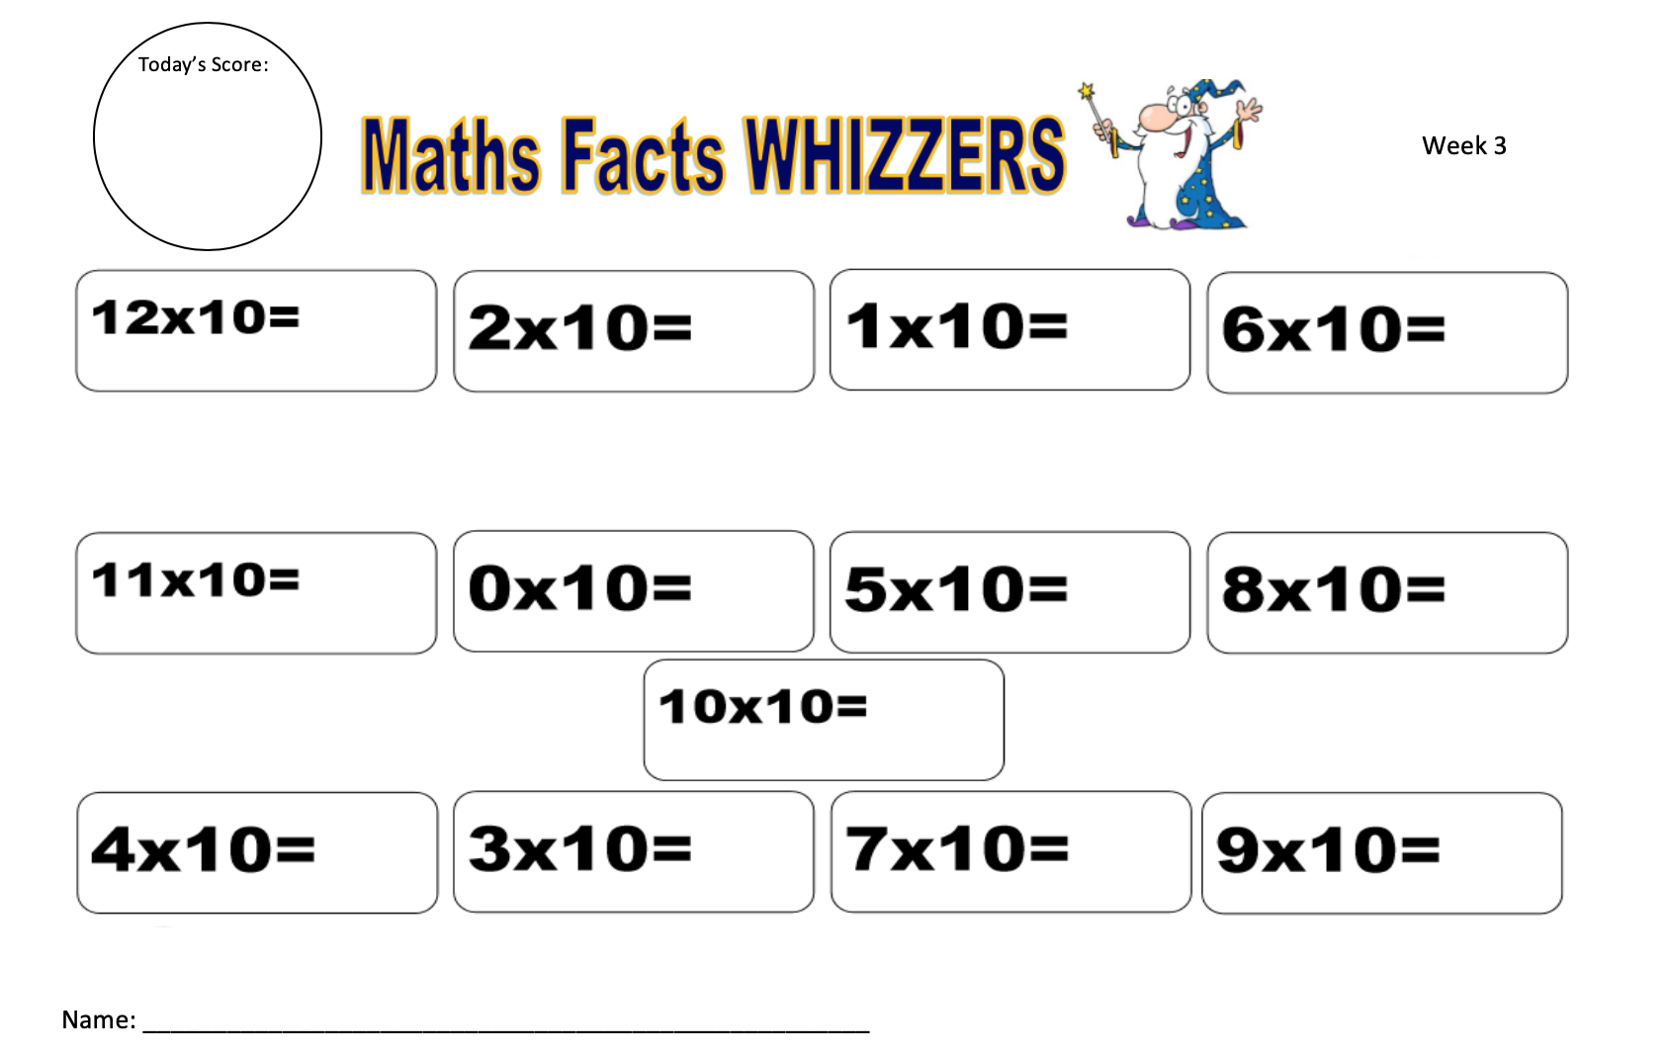
Sheet 1
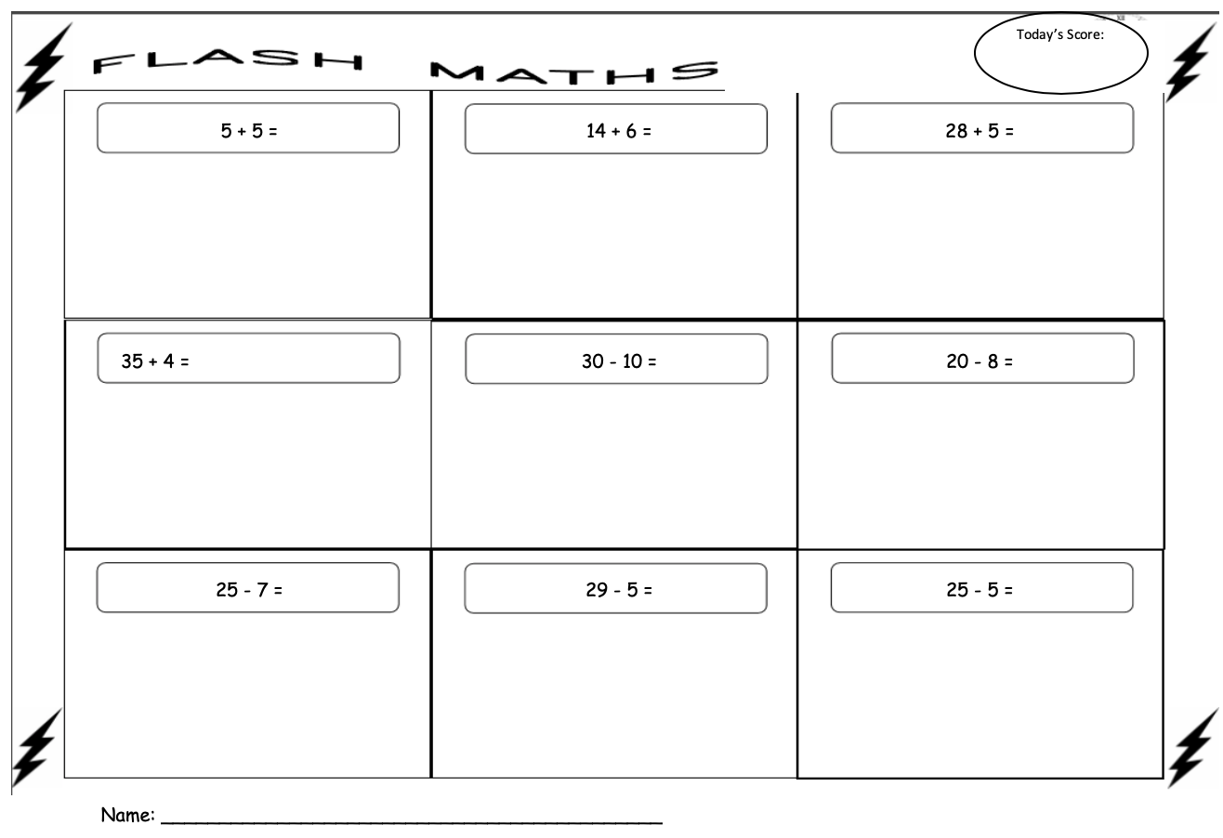
Sheet 2
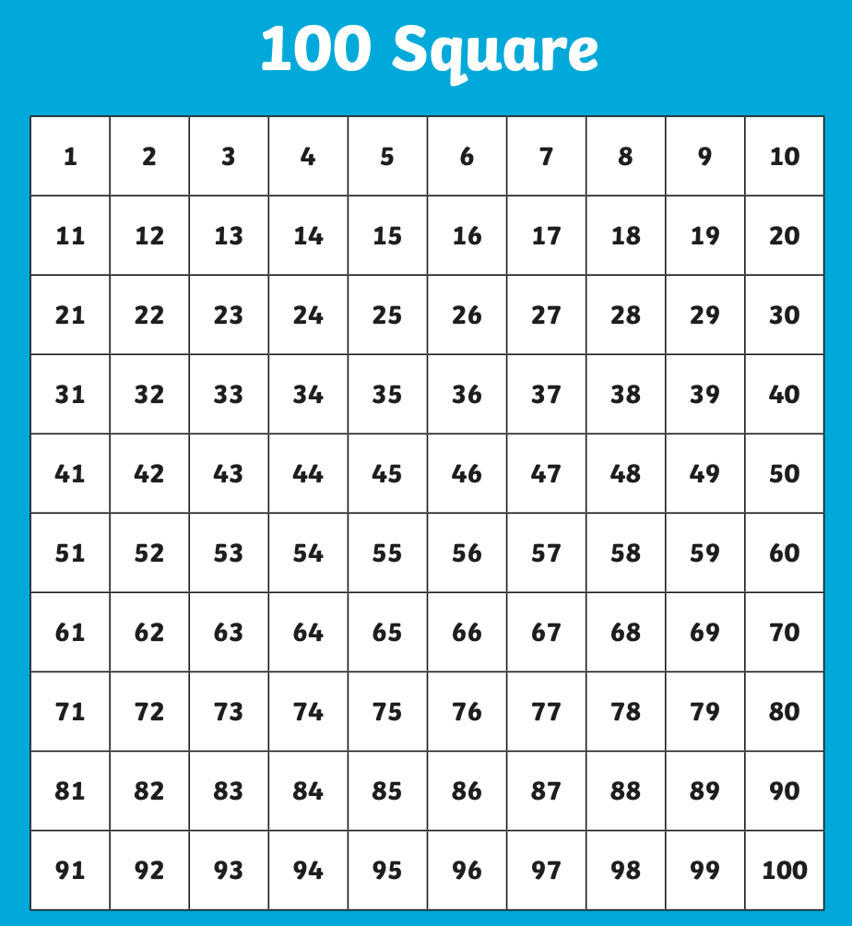
Sheet 3

Sheet 4

Qualitas P.E Links

Qualitas have provided some great P.E. videos to help get you active at home.

YouTube Links:

- Session 4 – Agility - https://www.youtube.com/watch?v=_4SNtCjN0o4
- Session 5 – Power - https://www.youtube.com/watch?v=PJAR1B1EVjk
- Session 6 – Reaction Speed - https://www.youtube.com/watch?v=ivTLii3Zdos
- Session 7 – Netball - https://www.youtube.com/watch?v=6pxLZPKHmFA&feature=youtu.be

Sheet 5
Sheet 6

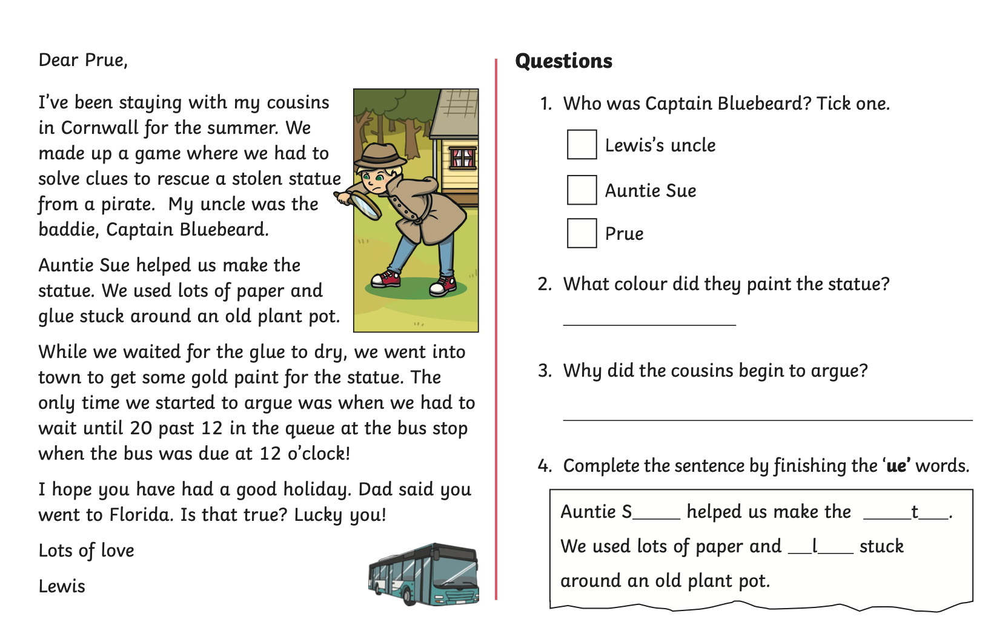
Sheet 5 – Reading Monday
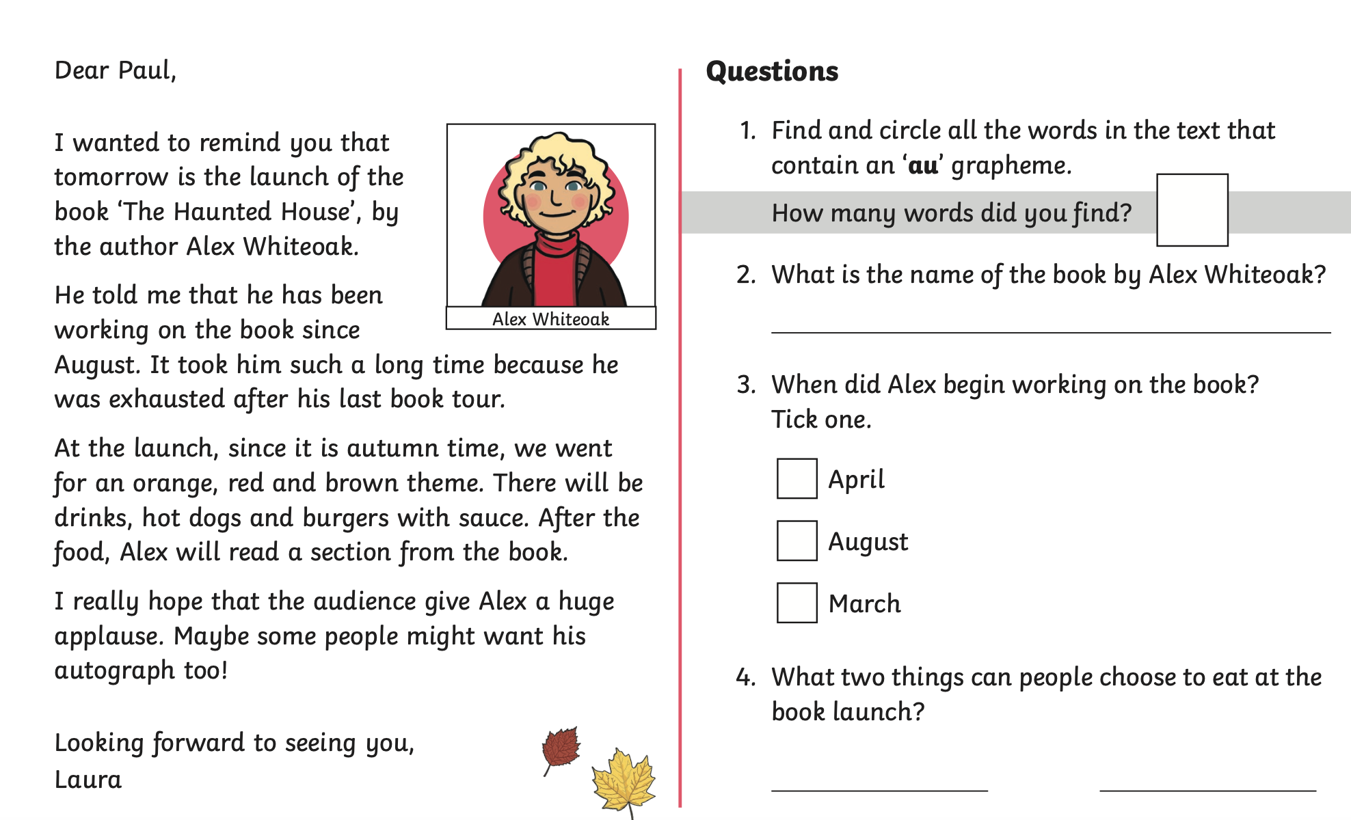
Sheet 5 - Reading Tuesday
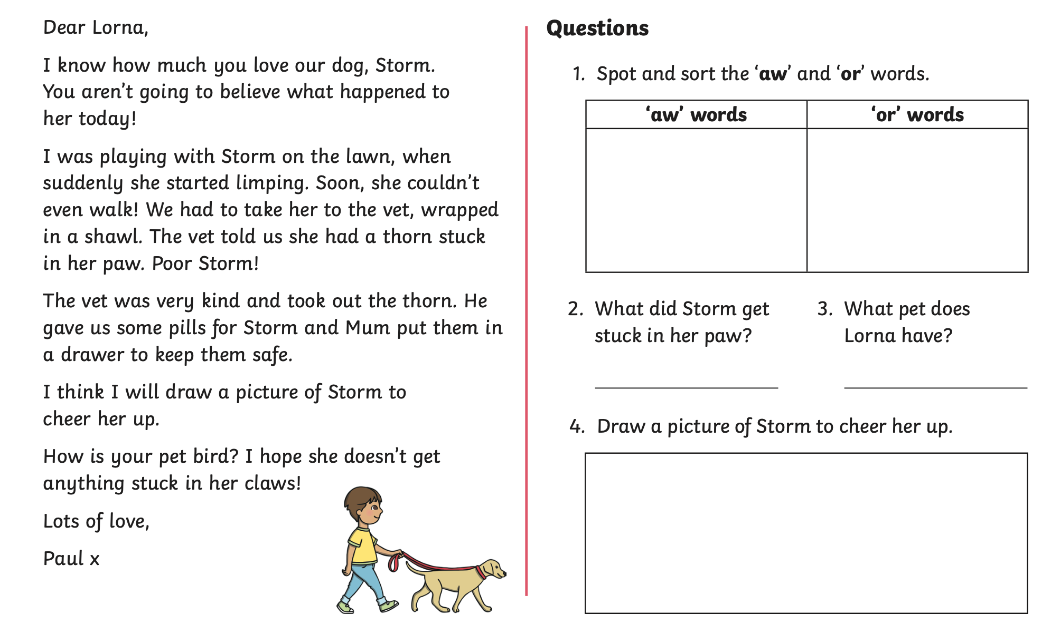
Sheet 5 – Reading Wednesday

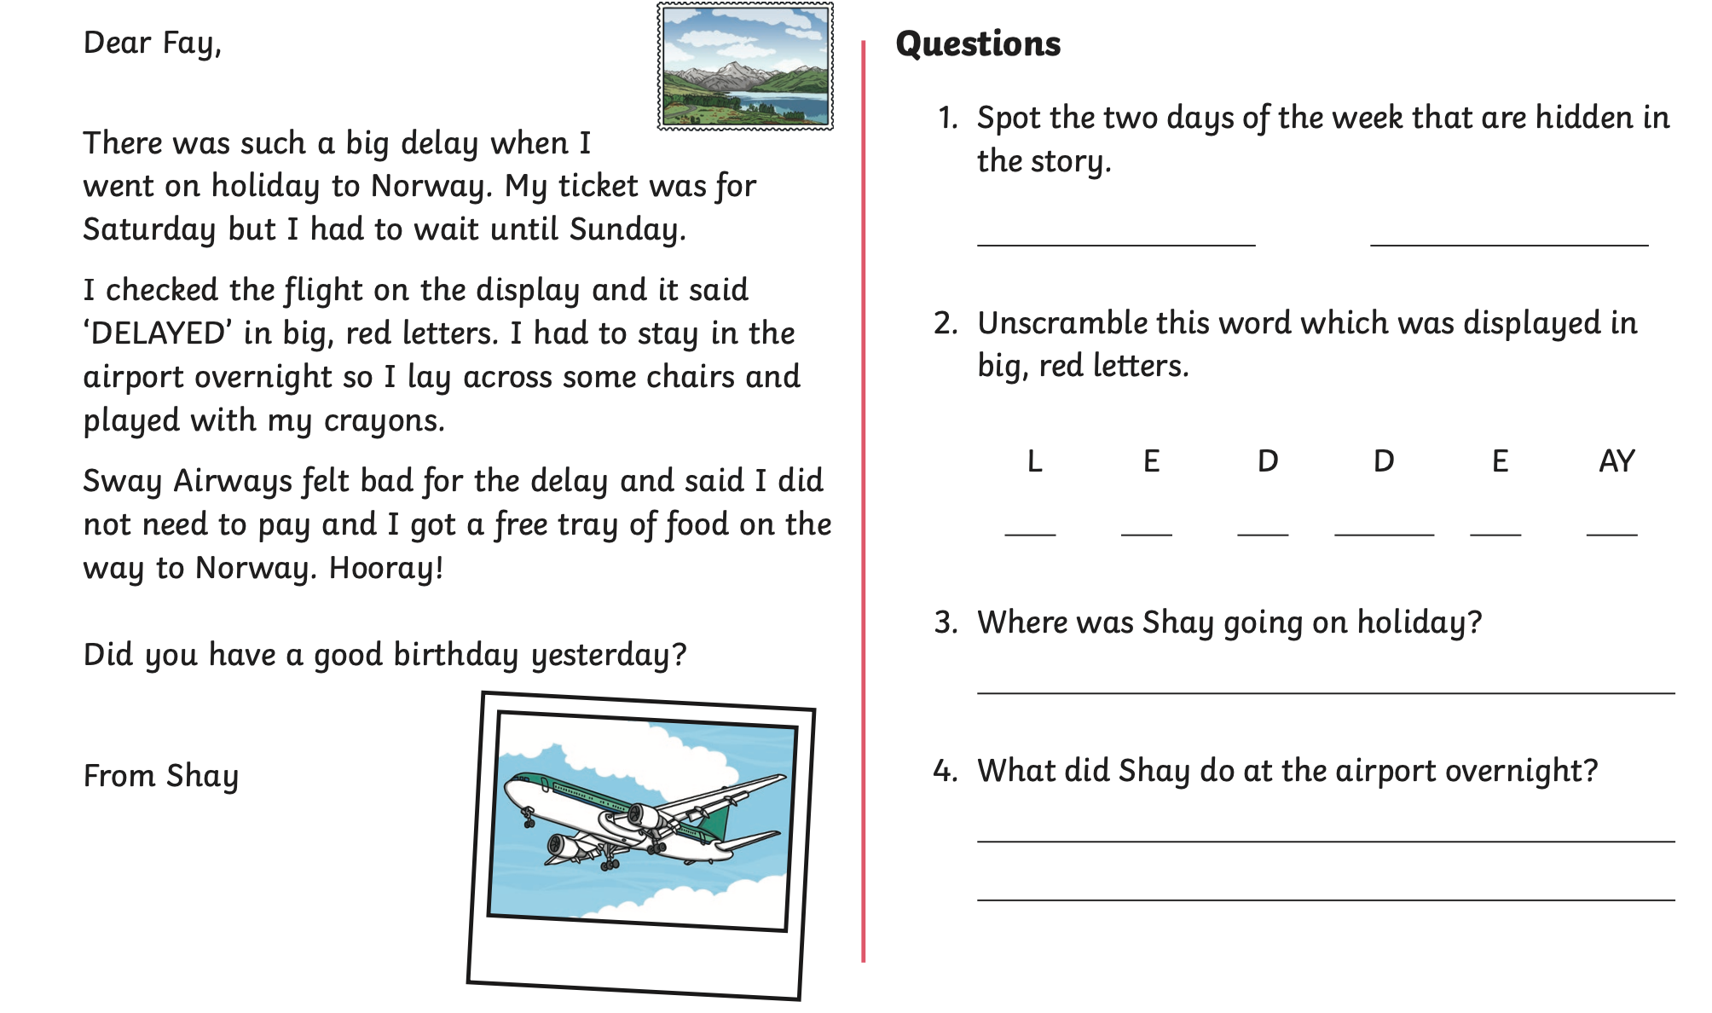
Sheet 5 – Reading Thursday

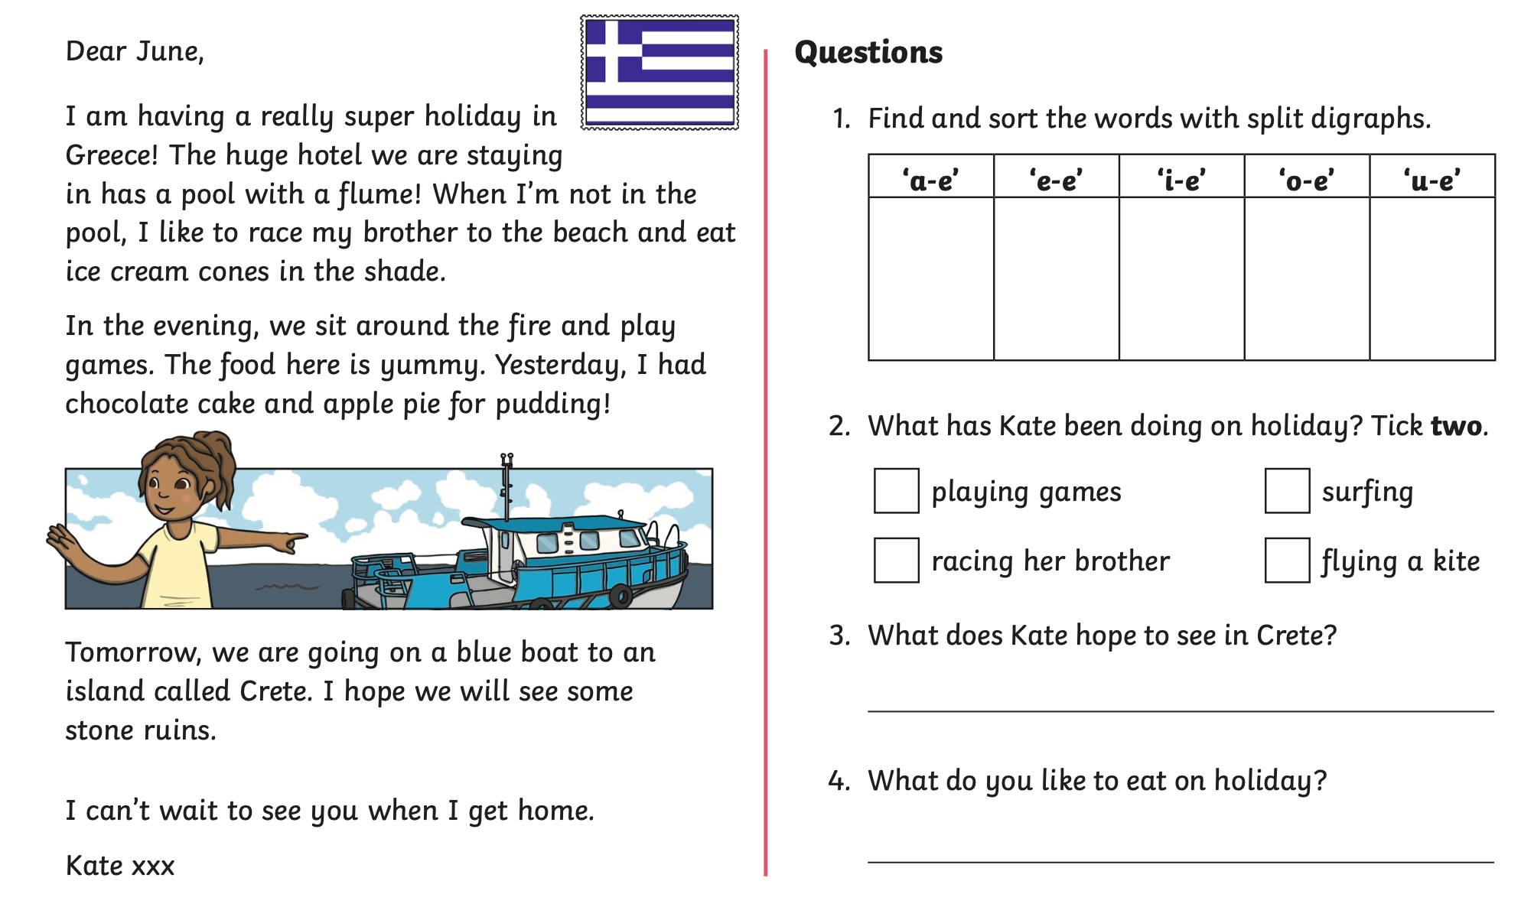
Sheet 5 – Reading Friday

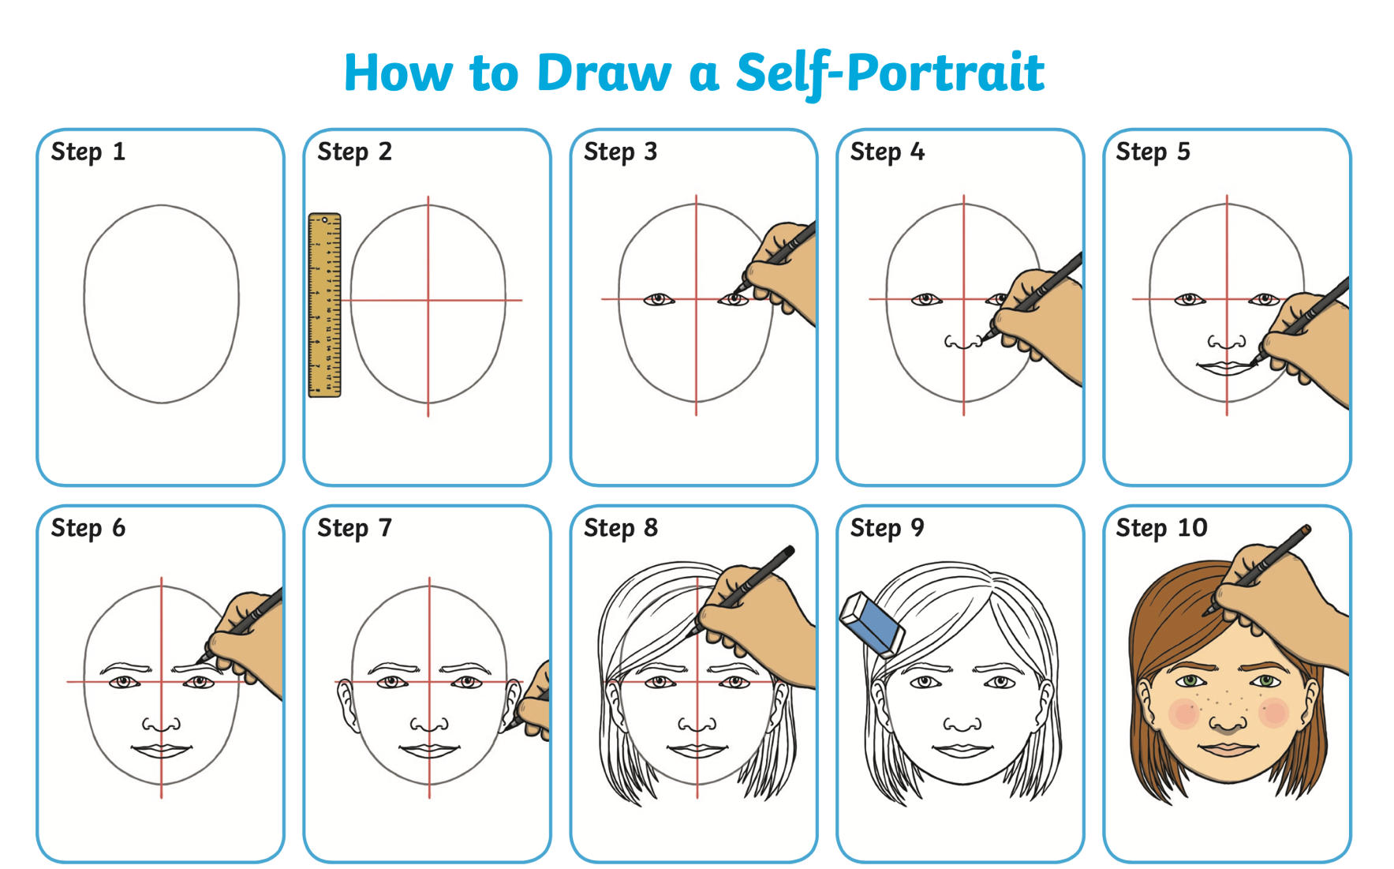
Sheet 6 – Art Self Portrait

Sheet 7 – Newspaper Article

