Hello Inventors,

Welcome to the final week of Summer Term 2. I can honestly say that I don’t know where the time has gone. It only seems like yesterday you were starting Year 2 and now you have nearly finished. I didn’t plan for us to be apart on our final week together as a class but unfortunately, due to the current situation, our time together in Year 2 was cut short, which I can honestly say is a shame.

You will notice that this week’s planning overview is different from the previous ones because I have decided, with it being the final week, to plan in different subject challenges for you to complete. For each challenge completed, I will award 10 challenge dojos. This will give you that extra push to keep earning those dojos!

I can honestly say that I have been overwhelmed with the amount of Dojos that you have been earning through your home learning work and I will sort out Dojo certificates for you which you will receive upon your return to school, if not before.

Once again, I have put some super learning onto the Marsh Lane Blog so please visit the Blog by clicking on this link http://marshlaneprimaryschool.weebly.com/ or alternatively, access it via the Marsh Lane Primary School website and click on the parents tab.

Finally, I would like to take this opportunity to say a massive thank you to the parents and carers of the Inventors for all the support over the last few years and for embracing the Womble madness! You have supported me and the children so well and I am extremely grateful for this. I will be posting a goodbye message on Class Dojo next week so I hope you can take the time out to watch it.

If you need anything in the meantime, please do not hesitate to contact me via the Class Dojo or alternatively email enquiries@marshlane.derbyshire.sch.uk and I will get back to you.

I really hope that you all have a fantastic Summer and well-deserved break. Please remember to stay safe and alert and I will see you in the new academic year when I wave to you through the Y3/Y4 door.

Mrs Womble xx

P.S: If you would like to do any learning over the Summer, I have put some files on the Marsh Lane Blog with Y2 Summer Activity Booklets for Maths and English and a Summer Holiday outdoor challenge.

Reading Challenge  Daily reading challenge:  Day 1 – Read your favourite picture book.  Day 2 – Read a poetry book.  Day 3 – Read a non-fiction book.  Day 4 – Listen to an audio story (you will find lots on You Tube or on Oxford Owl.)  Day 5 – Read an e-book using Oxford Owl.  Oxford Owl login details:  Username: Inventors2  Password: Inventors 2 | SPAG or Phonics Challenge  Re-cap the Year 2 SPAG key vocabulary and definitions (see attached worksheets below.)  Once you have re-capped the definition of the Year 2 SPAG vocabulary words, complete the KS1 SPAG worksheet (see separate attached document.)  Alternatively,  Play some Phonics based games on either Phonics Play or Phonics Bloom.  https://www.phonicsplay.co.uk/  Username: march20  Password: home  https://www.phonicsbloom.com/  Free website | Writing Challenge  Read the Native American weapons fact files (attached separately) then complete one of the writing challenges:  *Draw your favourite Native American weapon and write some labels to describe the features of it (what does it look like? What is it used for? Etc.)  **Create your own Information Booklet on the Native American Weapons, complete with sub-headings, illustrations, captions and interesting facts about them.  ***Make your own Native American Weapon then write instructions to explain the step-by-step instructions on how you made it. Try to include time conjunctions to show the order and list the equipment needed to make the weapon.  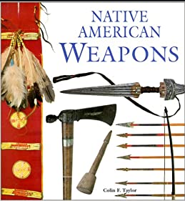

Times Table Challenge  Activity 1  Play the Monster Multiplication game on Purple Mash (it is already set as a 2Do.)  Activity 2  Play one of the times table games on Topmarks using this link:  https://www.topmarks.co.uk/maths-games/7-11-years/times-tables  *Suggested games to try - Coconut Multiples, Hit the Button, Mental Maths Train.  Activity 3  Complete the Ultimate Times Table Challenge (see sheet attached below.)  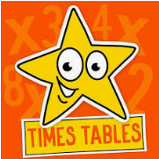 | Maths Investigation Challenge  Complete different Maths related problems to solve:  The Mystery of Peter Rabbit and the Beetroot Burglar.  (see separate attached document for Maths Investigation Challenge.)  Different Maths areas to include:  *Statistics (Bar Graphs)  *4 maths methods (+ - x ÷)  *Different ways of making 50  *Counting in steps of 2’s, 3’s, 5’s and 10’s  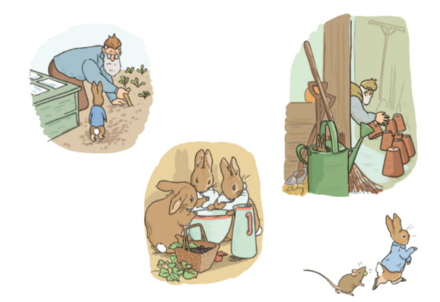 | PSHE Challenge  Read the From KS1 to KS2 Transition Booklet (attached separately) with your grown-up. This booklet will not give you all the answers about the Y3/Y4 class but it should provide you with some more information about Key Stage 2 which you might not have known already.  Mr Harling will be your new teacher in September and I know that he can’t wait to teach you all. To help Mr Harling, please complete the All About Me flower or football (attached below) and either email to the enquiries@marshlane.derbyshire.sch.uk or send it to me via Class Dojo.  I will pass these on to Mr Harling so that he can start to get to know you all a bit better.

Virtual Sports Day Challenge  Normally this time of year in school we would have done our annual Sports Day. Unfortunately, this year because of the current situation, we have been unable to do it in school. However…  Qualitas have launched their Virtual Sports Day Challenge.  Feel up for it?  First, watch the Qualitas video on You Tube by clicking on the following link which will show you the different sporting challenges.  https://www.youtube.com/watch?v=CpFCTRxgqRk&feature=youtu.be  After watching the video, set up your own Virtual Sports Day. Why not get some family members involved too!  Please see attached sheet below for recording your score and the score of your fellow competitors.  Who will win your first virtual sports day? | Art  Continuing with our Native American part of the Wild West topic, please complete one of the following Art activities:  *Use some paint to paint a Native American picture.  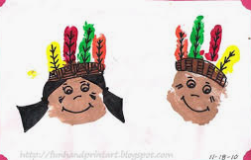  **Use some recyclable materials and rice or pasta to create a Native American rainstick.  ***Do some wool weaving on 2 crossed lollipop sticks to create a Native American Mexican Eye. Add some string to it and put it up as a decoration.  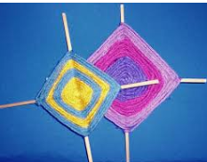 | Geography  Ever wondered what the difference is between a village, a town and a city?  Watch the BBC Bitesize video called Geography KS1/KS2: Cities, Towns and Villages using this link:  https://www.bbc.co.uk/teach/class-clips-video/geography-ks1--ks2-cities-towns-villages/zjn492p  On the BBC Bitesize website there are a list of questions for discussion after you have watched the video.  Create a poster (split preferably into 3) to show and detail the main differences between a village, a city and a town.  Alternatively, create an information text detailing the differences between a village, a city and a town.
SPAG Year 2 Vocabulary Mats – Page 1

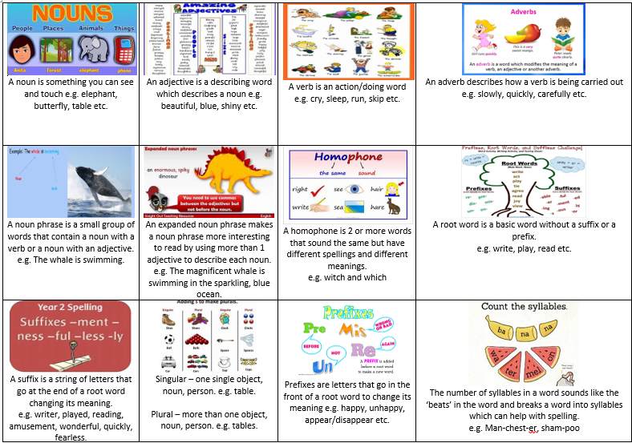
SPAG Year 2 Vocabulary Mats – Page 2

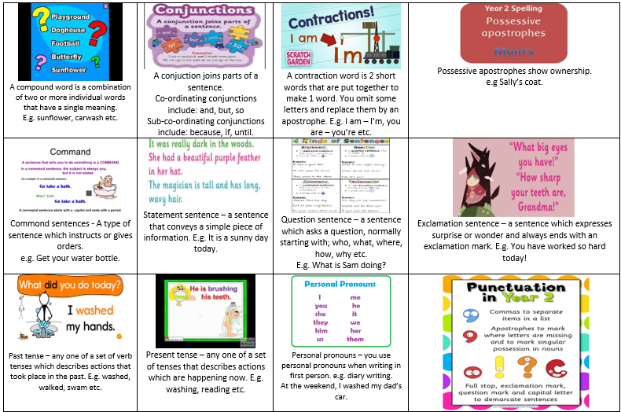

Maths – Ultimate Times Table Challenge Sheet
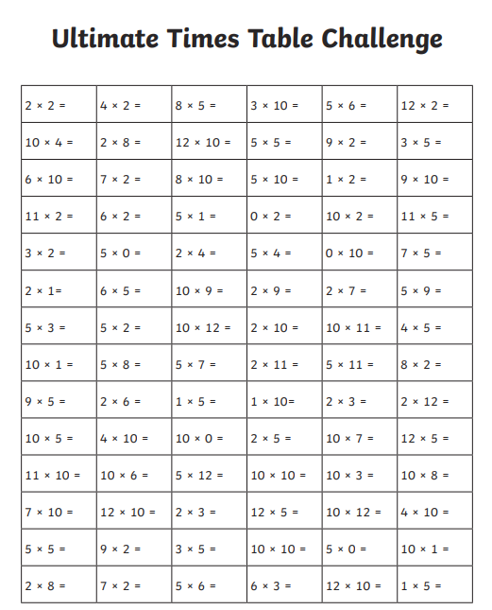

PSHE Challenge – All About Me – Flower

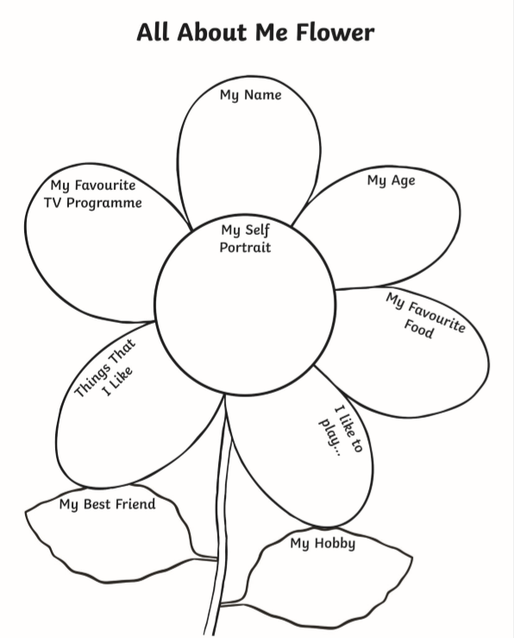
PSHE Challenge – All About Me - Football

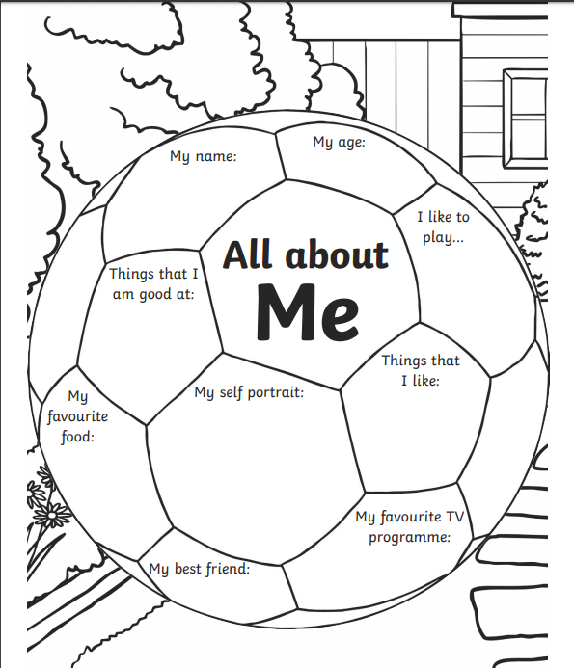
Virtual Sports Day Challenge – Score Sheet

